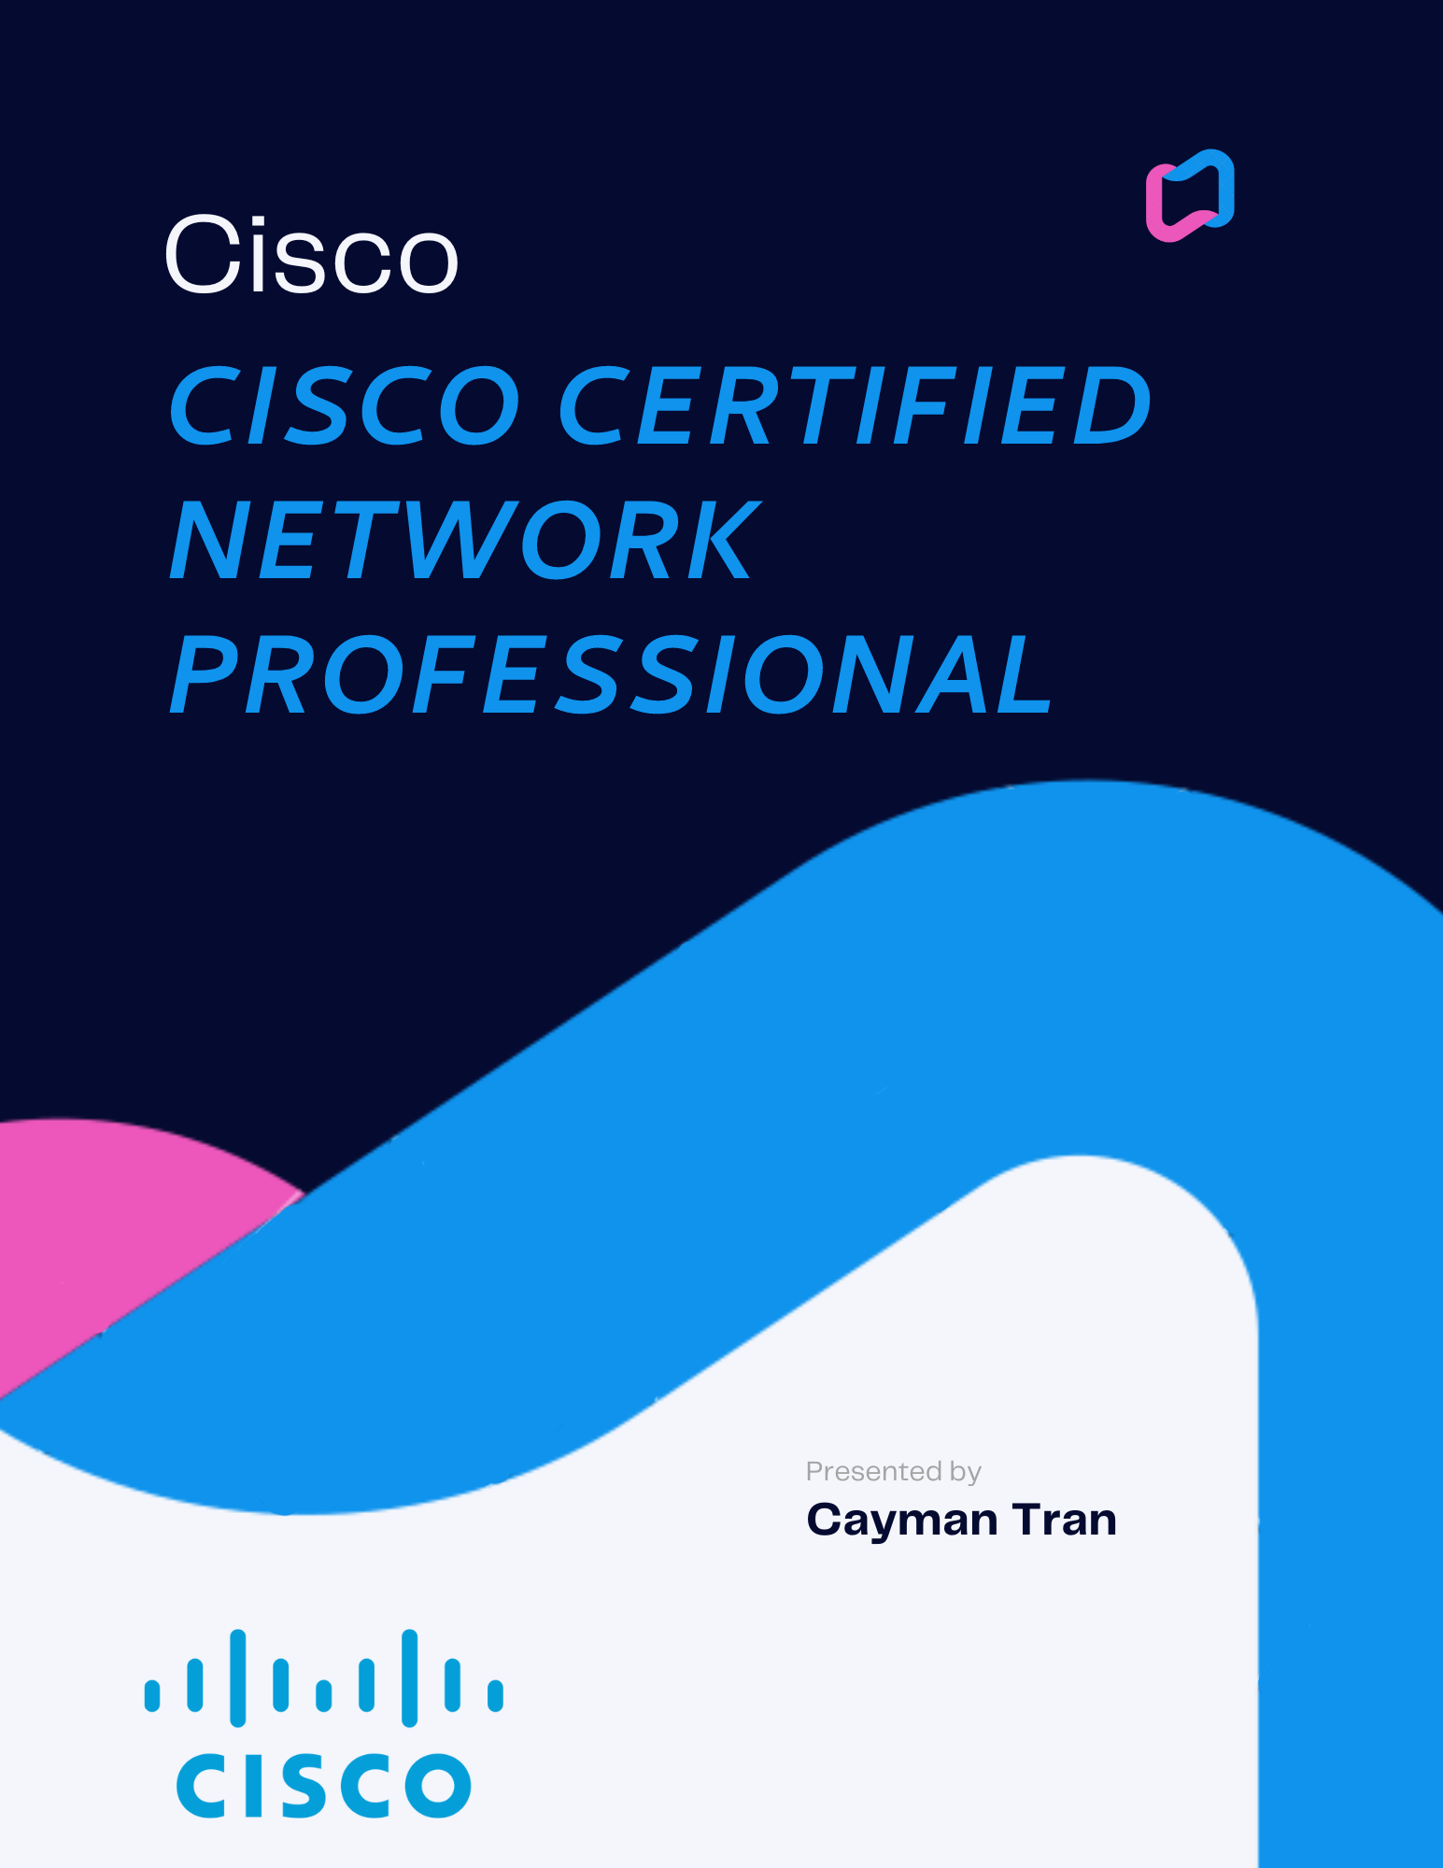

**OVERVIEW**

**-------------------------------------**

* **SINGLE-AREA OSPF**
* **MULTI-AREA OSPF**
* **INTERNAL BORDER GATEWAY PROTOCOL**
* **EIGRP-BGP-OSPF**
* **VOICE OVER IP**
* **VIRTUAL ROUTING & FORWARDING**
* **AMAZON WEB SERVICES CLOUD FOUNDATIONS**
* **MULTI-PROTOCOL LABEL SWICHING**

**-------------------------------------**

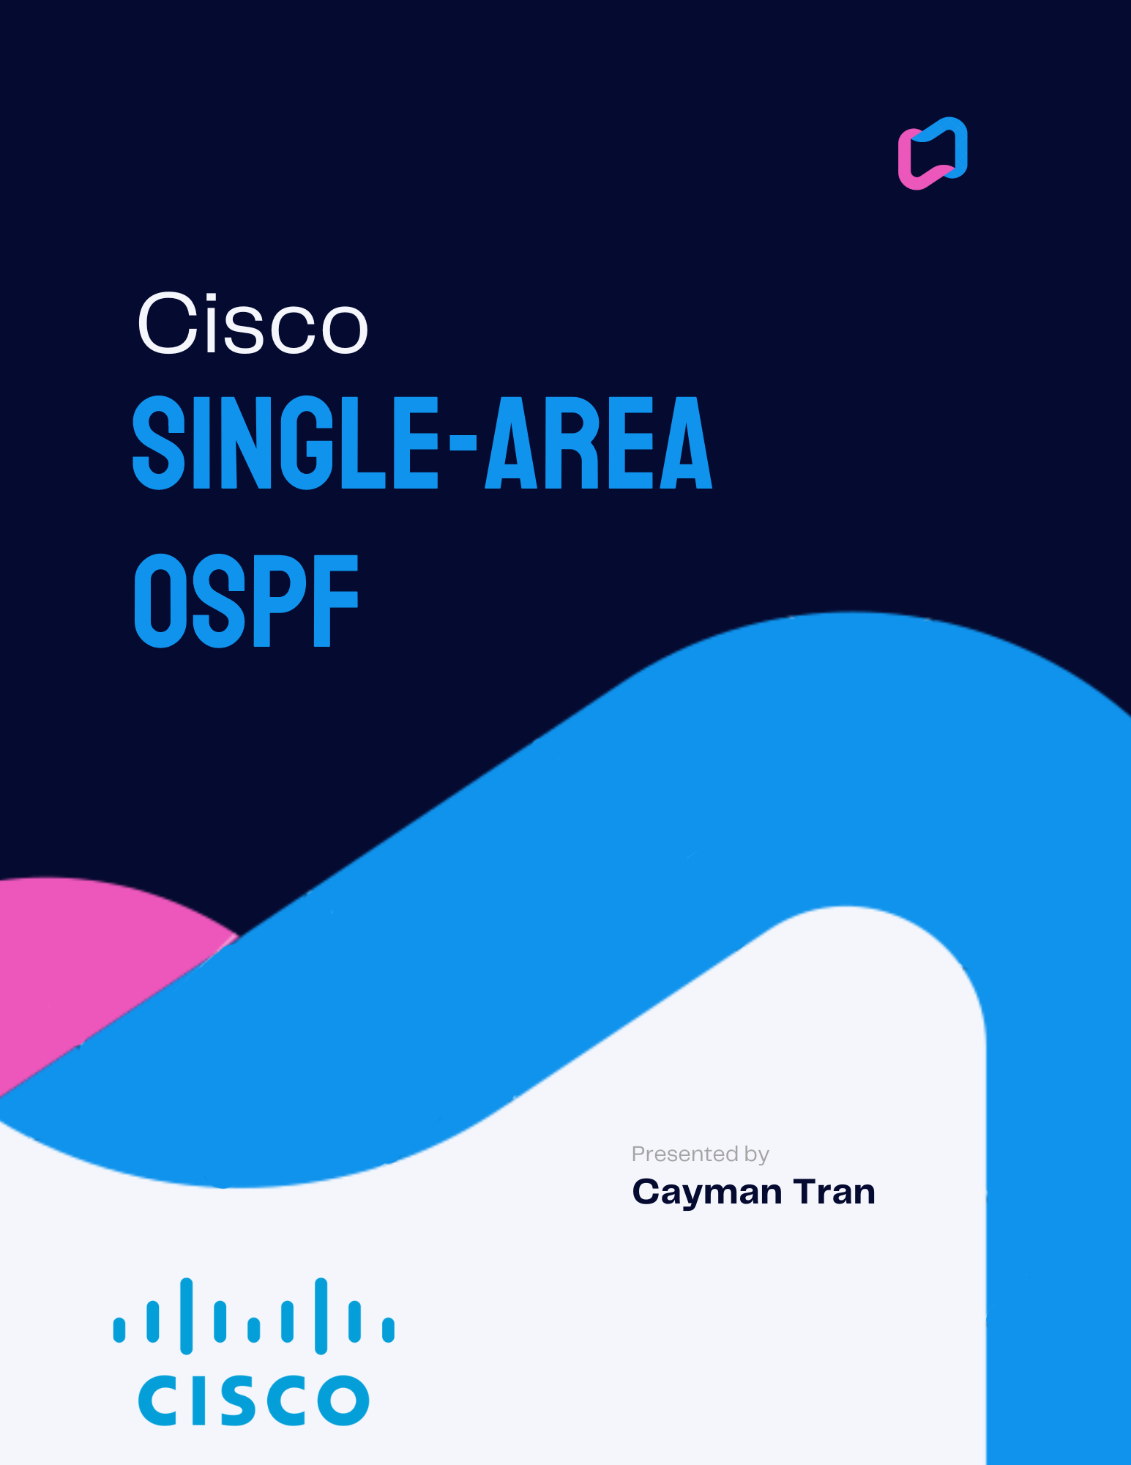

**NETWORK TOPOLOGY**

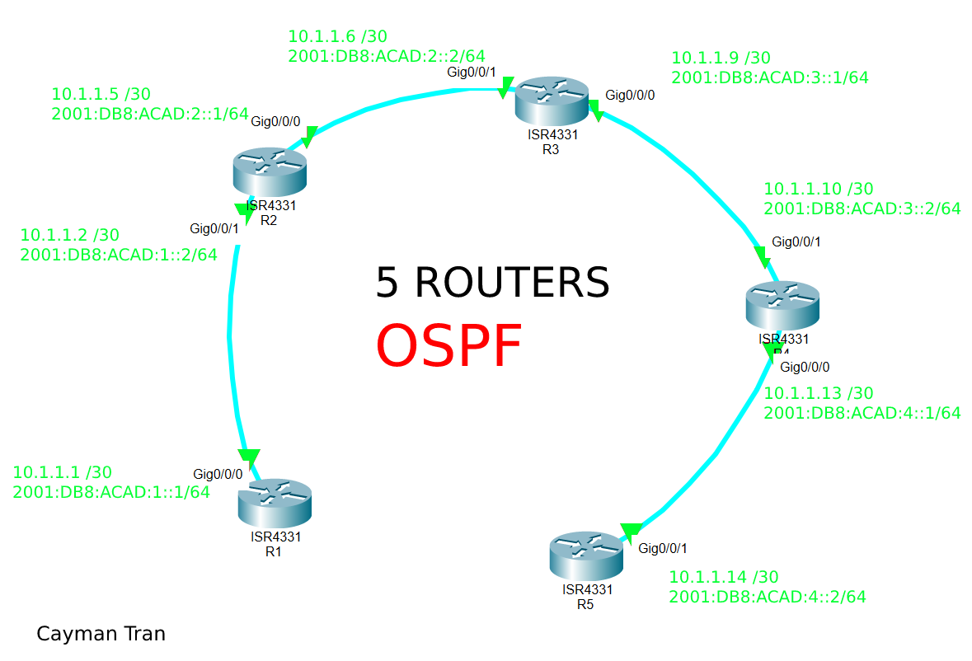

BACKGROUND INFORMATION

OSPF (Open Shortest Path First) developed by IETF in 1989, is a routing protocol for IP networks. It is more commonly used in larger networks with data (packets) travelling through lots of paths or routers. OSPF is autonomous in that it automatically detects changes in the topology (the network) and is fast converging. It works by automatically forming adjacencies with neighboring routers and it shares that information with other routers across the network. Another feature of OSPF is that it provides loop-free paths, meaning that topologies that have loops, or routers in networks that have paths back to itself, packets won’t get stuck in a loop, and it will send packets directly to the intended destination. This makes OSPF more efficient than static routing.

SUMMARY

I had set up basic commands like passwords and no ip domain-lookup, then on each interface for every router, was added an IPv4 and IPv6 address used in the 10.1.1.0 /30 subnets. I then used the router OSPF 1 command with area 0. I used the IP router command to confirm OSPF worked.

COMMANDS

Some new commands are:

Ipv6 ospf [process-id]

CONFIGURATIONS

Passwords: cisco/class

R1

version 15.5

service timestamps debug datetime msec

service timestamps log datetime msec

service password-encryption

no platform punt-keepalive disable-kernel-core

hostname R1

boot-start-marker

boot-end-marker

vrf definition Mgmt-intf

address-family ipv4

exit-address-family

address-family ipv6

exit-address-family

enable secret 5 $1$hMzO$OvYrilYuD9jmsbmKRLwaM0

no aaa new-model

no ip domain lookup

ipv6 unicast-routing

subscriber templating

multilink bundle-name authenticated

license udi pid ISR4321/K9 sn FDO21482HZX

spanning-tree extend system-id

redundancy

mode none

vlan internal allocation policy ascending

interface GigabitEthernet0/0/0

description To R2 /1

ip address 10.1.1.1 255.255.255.252

ip ospf 1 area 0

negotiation auto

ipv6 address FE80::2 link-local

ipv6 address 2001:DB8:ACAD:1::1/64

ipv6 ospf 1 area 0

interface GigabitEthernet0/0/1

no ip address

shutdown

negotiation auto

ipv6 address FE80::1 link-local

interface Serial0/1/0

no ip address

shutdown

interface Serial0/1/1

no ip address

shutdown

interface GigabitEthernet0

vrf forwarding Mgmt-intf

no ip address

shutdown

negotiation auto

interface Vlan1

no ip address

shutdown

router ospf 1

router-id 10.0.0.1

network 10.1.1.0 0.0.0.3 area 0

ip forward-protocol nd

no ip http server

no ip http secure-server

ip tftp source-interface GigabitEthernet0

ipv6 router ospf 1

router-id 1.1.1.1

control-plane

line con 0

password 7 05080F1C2243

login

stopbits 1

line aux 0

stopbits 1

line vty 0 4

login

End

R2

version 15.5

service timestamps debug datetime msec

service timestamps log datetime msec

service password-encryption

no platform punt-keepalive disable-kernel-core

hostname R2

boot-start-marker

boot-end-marker

vrf definition Mgmt-intf

address-family ipv4

exit-address-family

address-family ipv6

exit-address-family

enable secret 5 $1$NeDj$EpcRPhNsKHz8MOy3vUAXS1

no aaa new-model

no ip domain lookup

ipv6 unicast-routing

subscriber templating

multilink bundle-name authenticated

license udi pid ISR4321/K9 sn FDO21482DWJ

spanning-tree extend system-id

redundancy

mode none

vlan internal allocation policy ascending

interface GigabitEthernet0/0/0

description to R3 /1

ip address 10.1.1.5 255.255.255.252

ip ospf 2 area 0

negotiation auto

ipv6 address FE80::2 link-local

ipv6 address 2001:DB8:ACAD:2::1/64

ipv6 ospf 1 area 0

interface GigabitEthernet0/0/1

description to R1 /0

ip address 10.1.1.2 255.255.255.252

ip ospf 2 area 0

negotiation auto

ipv6 address FE80::1 link-local

ipv6 address 2001:DB8:ACAD:1::2/64

ipv6 ospf 1 area 0

interface Serial0/1/0

no ip address

shutdown

interface Serial0/1/1

no ip address

shutdown

interface GigabitEthernet0

vrf forwarding Mgmt-intf

no ip address

shutdown

negotiation auto

interface Vlan1

no ip address

shutdown

router ospf 2

router-id 10.0.0.2

network 10.1.1.0 0.0.0.3 area 0

network 10.1.1.4 0.0.0.3 area 0

router ospf 1

ip forward-protocol nd

no ip http server

no ip http secure-server

ip tftp source-interface GigabitEthernet0

ipv6 router ospf 1

router-id 2.2.2.2

control-plane

line con 0

password 7 070C285F4D06

login

stopbits 1

line aux 0

stopbits 1

line vty 0 4

login

End

R3

version 15.5

service timestamps debug datetime msec

service timestamps log datetime msec

service password-encryption

no platform punt-keepalive disable-kernel-core

hostname R3

boot-start-marker

boot-end-marker

vrf definition Mgmt-intf

address-family ipv4

exit-address-family

address-family ipv6

exit-address-family

enable secret 5 $1$PXvA$wdUTBwmmNH2SiEb8p7xLq0

no aaa new-model

no ip domain lookup

ipv6 unicast-routing

subscriber templating

vtp domain cisco

vtp mode transparent

multilink bundle-name authenticated

license udi pid ISR4321/K9 sn FDO214420HW

spanning-tree extend system-id

redundancy

mode none

vlan internal allocation policy ascending

interface GigabitEthernet0/0/0

description To R4 /1

ip address 10.1.1.9 255.255.255.252

ip ospf 3 area 0

negotiation auto

ipv6 address FE80::2 link-local

ipv6 address 2001:DB8:ACAD:3::1/64

ipv6 ospf 1 area 0

interface GigabitEthernet0/0/1

description to R2 /0

ip address 10.1.1.6 255.255.255.252

ip ospf 3 area 0

negotiation auto

ipv6 address FE80::1 link-local

ipv6 address 2001:DB8:ACAD:2::2/64

ipv6 ospf 1 area 0

interface Serial0/1/0

no ip address

shutdown

interface Serial0/1/1

no ip address

shutdown

interface GigabitEthernet0

vrf forwarding Mgmt-intf

no ip address

shutdown

negotiation auto

interface Vlan1

no ip address

shutdown

router ospf 3

router-id 10.0.0.3

network 10.1.1.4 0.0.0.3 area 0

network 10.1.1.8 0.0.0.3 area 0

ip forward-protocol nd

no ip http server

no ip http secure-server

ip tftp source-interface GigabitEthernet0

ipv6 router ospf 1

router-id 3.3.3.3

control-plane

line con 0

password 7 00071A150754

login

stopbits 1

line aux 0

stopbits 1

line vty 0 4

login

End

R4

version 15.5

service timestamps debug datetime msec

service timestamps log datetime msec

service password-encryption

no platform punt-keepalive disable-kernel-core

hostname R4

boot-start-marker

boot-end-marker

vrf definition Mgmt-intf

address-family ipv4

exit-address-family

address-family ipv6

exit-address-family

enable secret 5 $1$ZHlz$BJJKmPpOoit6jYlpDL1oE.

no aaa new-model

no ip domain lookup

ipv6 unicast-routing

subscriber templating

vtp domain cisco

vtp mode transparent

multilink bundle-name authenticated

license udi pid ISR4321/K9 sn FDO214421D1

spanning-tree extend system-id

redundancy

mode none

vlan internal allocation policy ascending

interface GigabitEthernet0/0/0

description To R5 /1

ip address 10.1.1.13 255.255.255.252

ip ospf 4 area 0

negotiation auto

ipv6 address FE80::2 link-local

ipv6 address 2001:DB8:ACAD:4::1/64

ipv6 ospf 1 area 0

interface GigabitEthernet0/0/1

description to R3 /0

ip address 10.1.1.10 255.255.255.252

ip ospf 4 area 0

negotiation auto

ipv6 address FE80::1 link-local

ipv6 address 2001:DB8:ACAD:3::2/64

ipv6 ospf 1 area 0

interface Serial0/1/0

no ip address

shutdown

interface Serial0/1/1

no ip address

shutdown

interface GigabitEthernet0

vrf forwarding Mgmt-intf

no ip address

shutdown

negotiation auto

interface Vlan1

no ip address

shutdown

router ospf 4

router-id 10.0.0.4

network 10.1.1.8 0.0.0.3 area 0

network 10.1.1.12 0.0.0.3 area 0

ip forward-protocol nd

no ip http server

no ip http secure-server

ip tftp source-interface GigabitEthernet0

ipv6 router ospf 1

router-id 4.4.4.4

control-plane

line con 0

password 7 094F471A1A0A

login

stopbits 1

line aux 0

stopbits 1

line vty 0 4

login

End

R5

version 16.9

service timestamps debug datetime msec

service timestamps log datetime msec

service password-encryption

platform qfp utilization monitor load 80

platform punt-keepalive disable-kernel-core

hostname R5

boot-start-marker

boot-end-marker

vrf definition Mgmt-intf

address-family ipv4

exit-address-family

address-family ipv6

exit-address-family

enable secret 5 $1$JS4A$/z63zJd7HE1evrbD7Bt1a1

no aaa new-model

no ip domain lookup

login on-success log

subscriber templating

ipv6 unicast-routing

multilink bundle-name authenticated

crypto pki trustpoint TP-self-signed-859896477

enrollment selfsigned

subject-name cn=IOS-Self-Signed-Certificate-859896477

revocation-check none

rsakeypair TP-self-signed-859896477

license udi pid ISR4321/K9 sn FLM240608PJ

no license smart enable

diagnostic bootup level minimal

spanning-tree extend system-id

redundancy

mode none

interface GigabitEthernet0/0/0

no ip address

negotiation auto

interface GigabitEthernet0/0/1

description to R4 /0

ip address 10.1.1.14 255.255.255.252

ip ospf 5 area 0

negotiation auto

ipv6 address FE80::1 link-local

ipv6 address 2001:DB8:ACAD:4::2/64

ipv6 ospf 1 area 0

interface GigabitEthernet0/1/0

no ip address

shutdown

negotiation auto

interface GigabitEthernet0/1/1

no ip address

shutdown

negotiation auto

interface GigabitEthernet0

vrf forwarding Mgmt-intf

no ip address

shutdown

negotiation auto

router ospf 5

router-id 10.0.0.1

network 10.1.1.12 0.0.0.3 area 0

ip forward-protocol nd

ip http server

ip http authentication local

ip http secure-server

ip tftp source-interface GigabitEthernet0

ipv6 router ospf 1

router-id 5.5.5.5

control-plane

line con 0

password 7 14141B180F0B

login

transport input none

stopbits 1

line aux 0

stopbits 1

line vty 0 4

login

End

**SHOW IP ROUTE**

R1

IPV4

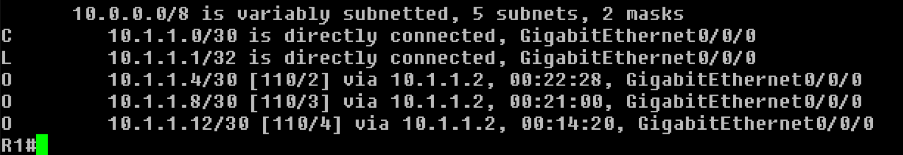

IPV6

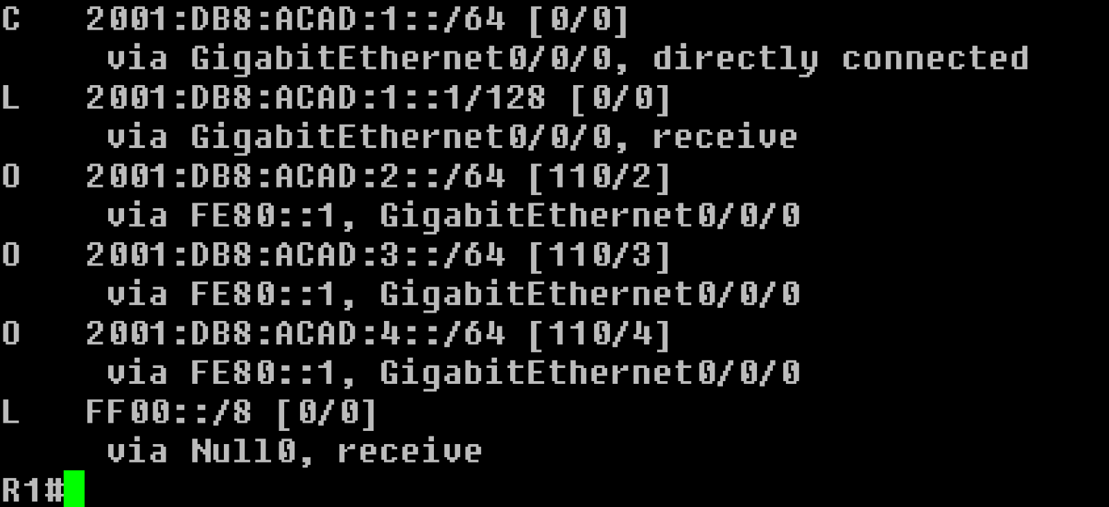

R2

IPV4

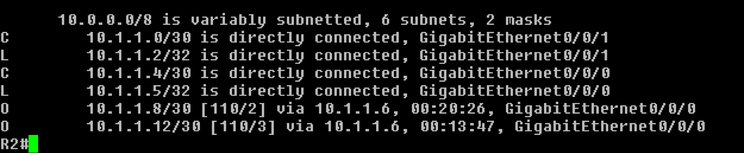

IPV6

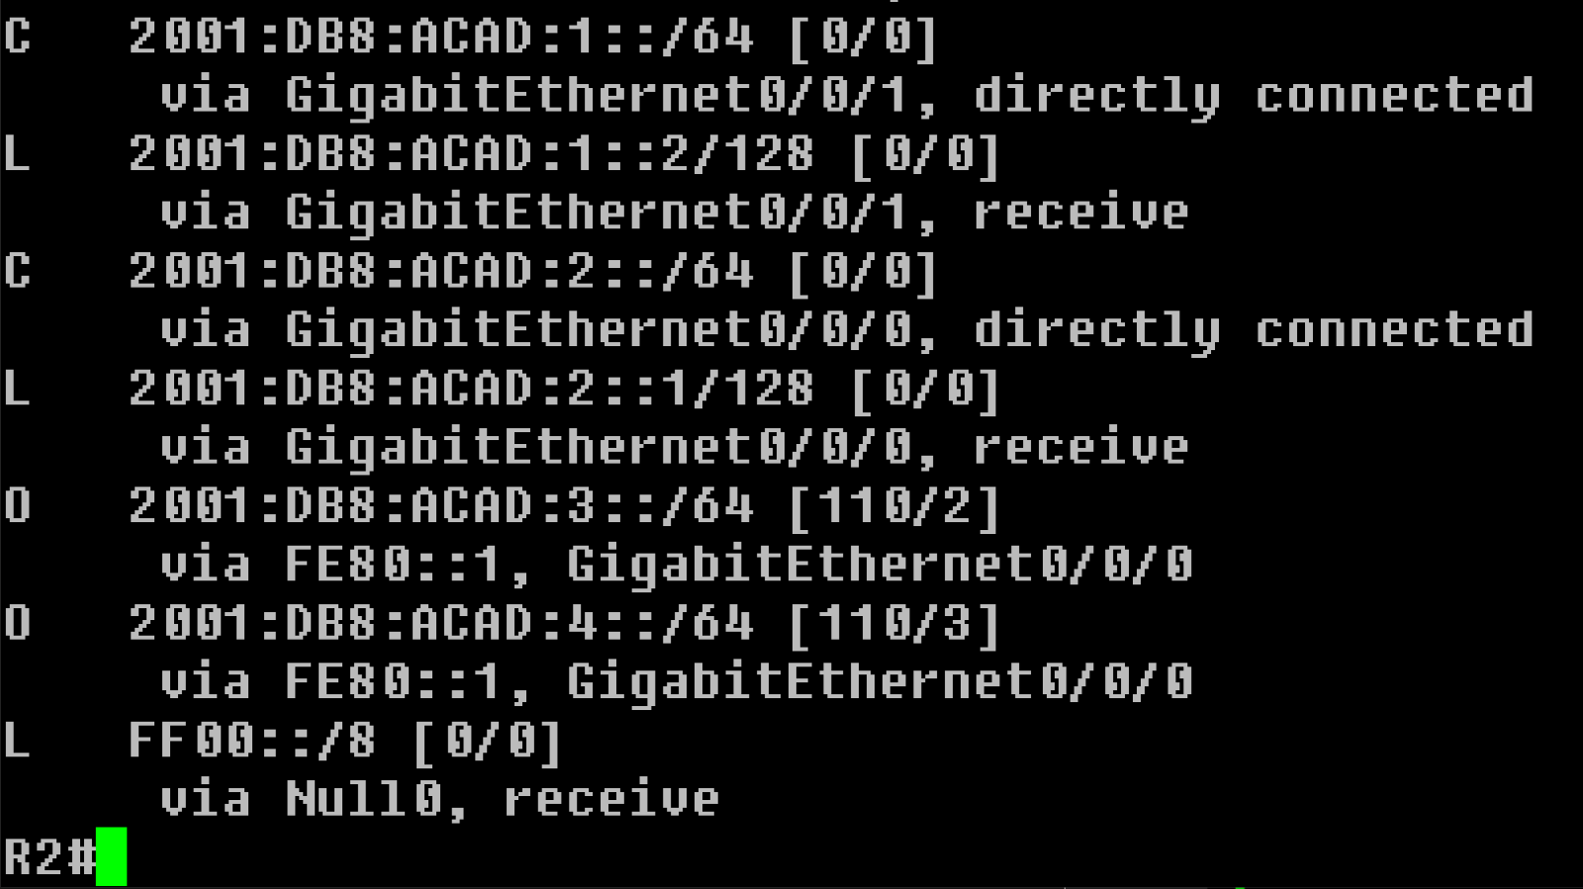

R3

IPV4

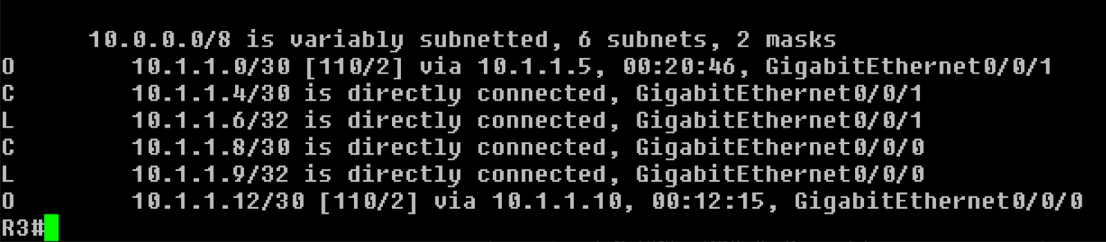

IPV6

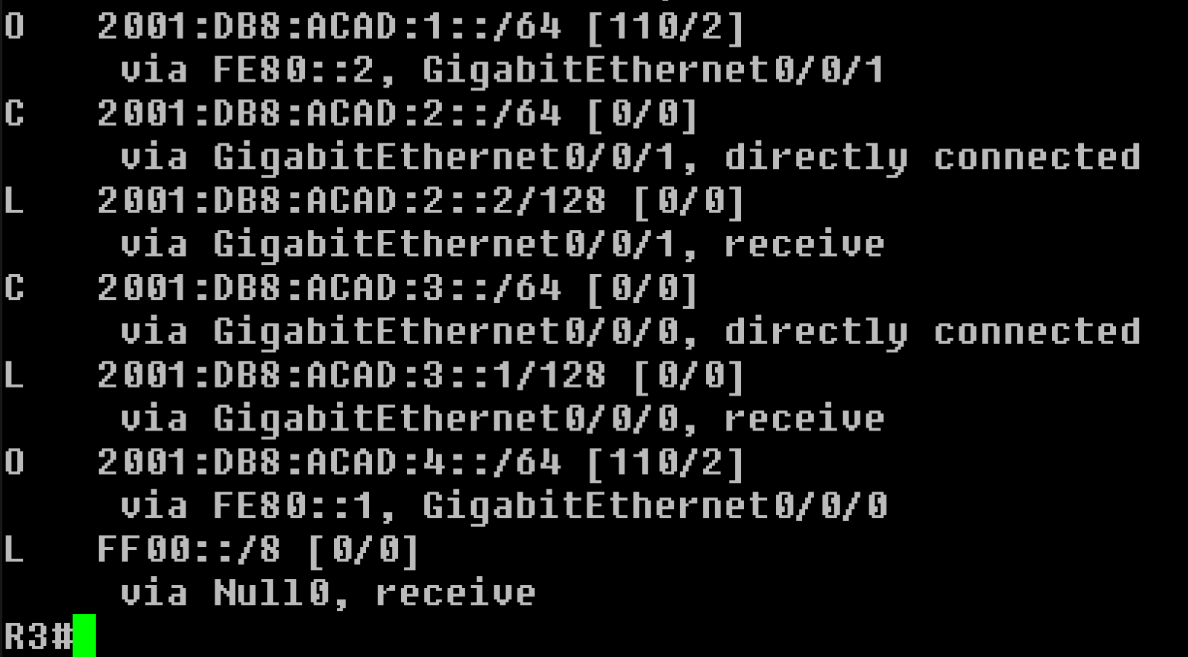

R4

IPV4

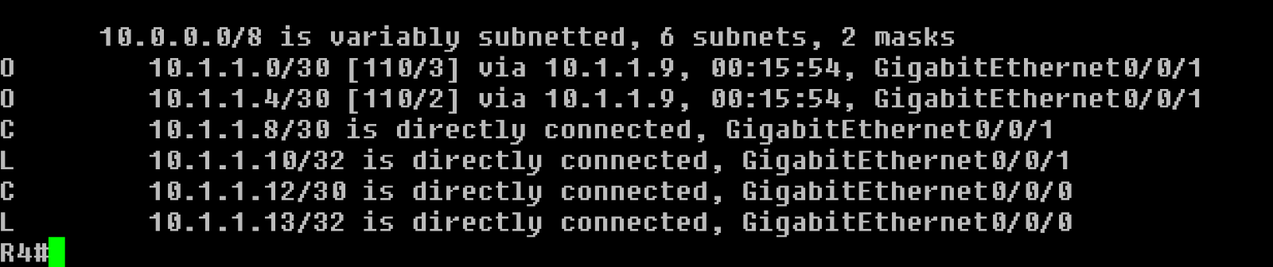

IPV6

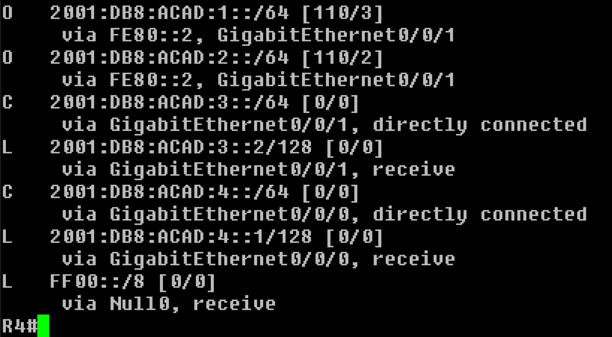

R5

IPV4

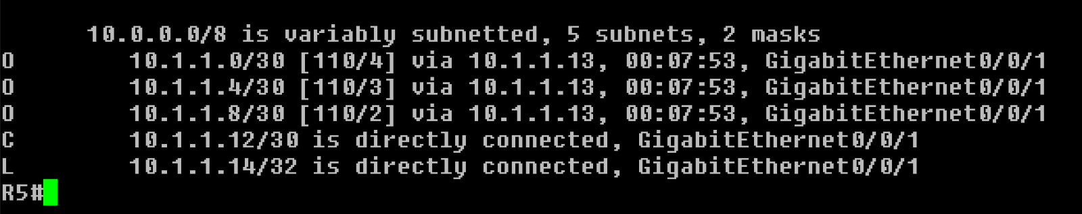

IPV6

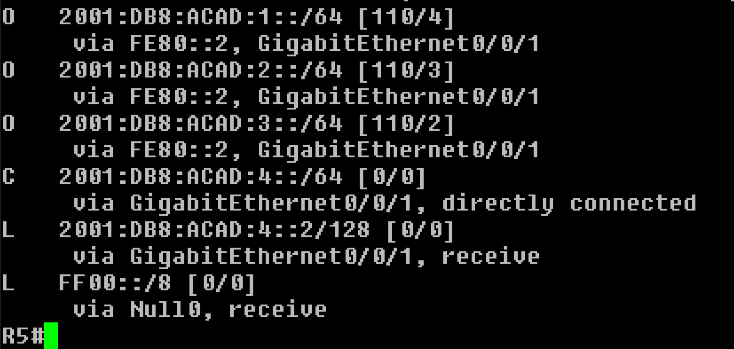

**PROBLEMS I ENCOUNTERED**

IPv6 initially did not want to work, but after finding some commands missing and searching up how to IPv6 OSPF, it had worked.

**CONCLUSION**

Overall OSPF is helpful for your network, but the most troublesome part to set up maybe IPv6.

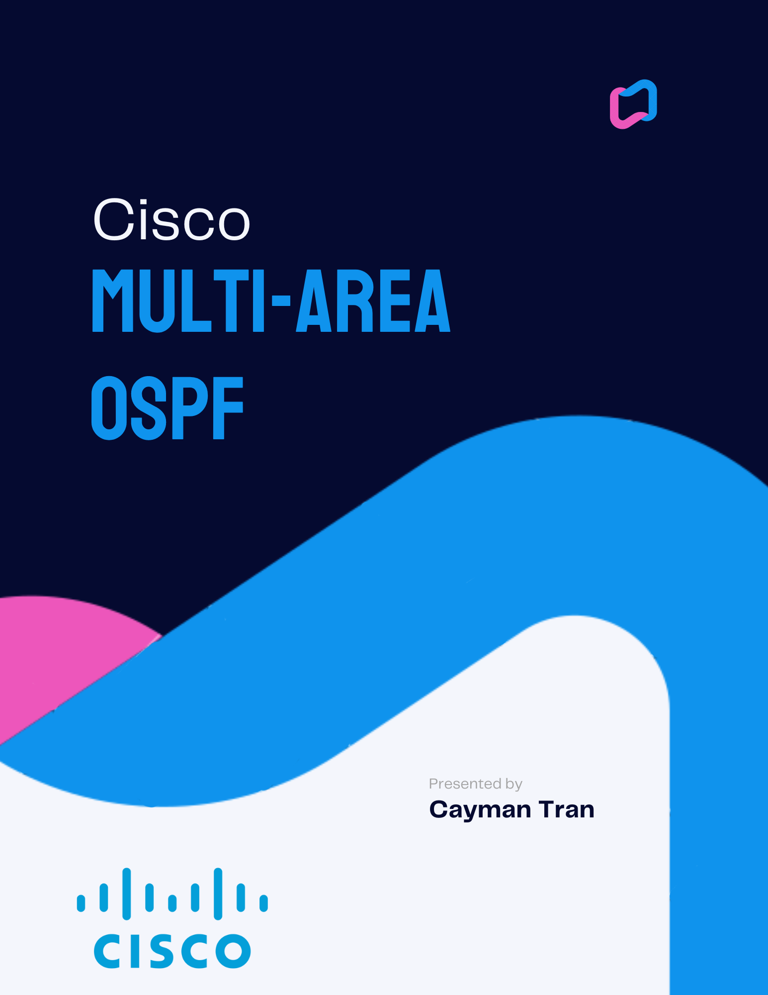

**NETWORK TOPOLOGY**

MULTIAREA OSPF 6 ROUTERS + 2 PCS

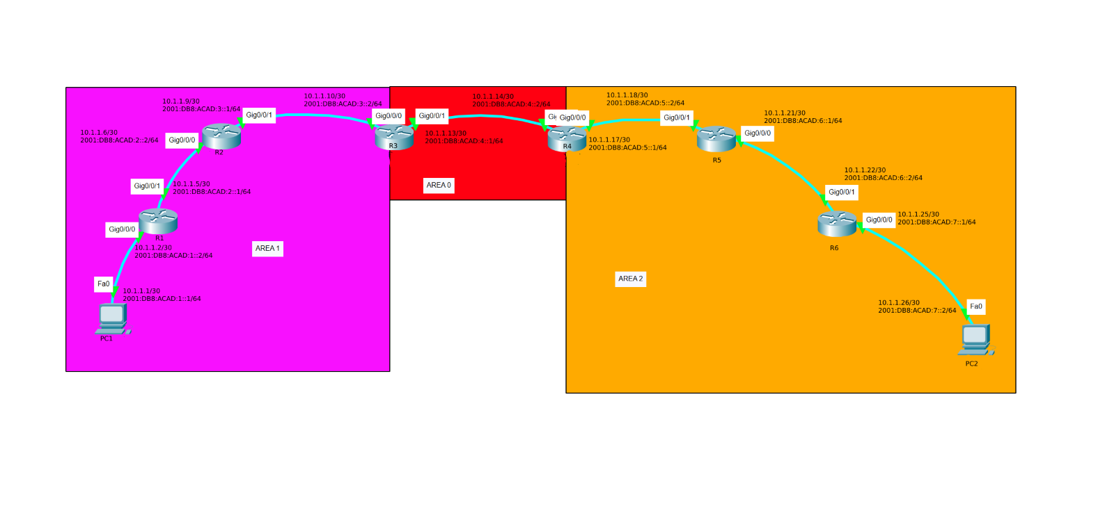

BACKGROUND INFORMATION

In this lab I implemented Multi-Area OSPF instead of Single-Area OSPF. What it does is it divides our network into multiple areas, it uses smaller routing tables, meaning each router requires to know less IP addresses, which reduces processing and memory overhead. It also reduces calculations that the routers must do to find the shortest path through the network. This means that using Multi-Area OSPF would be more efficient for large networks than Single Area.

SUMMARY

Our setup was very similar to our previous OSPF lab, instead I added another router, and two PCs. I added IPv4 and IPv6 addresses to each Router and host and set up OSPF. Except in this Lab, I changed the areas to their respective areas shown in the Topology above. At the end, I ran commands such as show ip route and show ipv6 route to see the connects the routers have confirm OSPF is working.

COMMANDS

Some new commands are:

Ipv6 ospf [process-id] (either 0-2 for different areas)

CONFIGURATIONS

Passwords: cisco/class

R1

version 15.5

service timestamps debug datetime msec

service timestamps log datetime msec

service password-encryption

no platform punt-keepalive disable-kernel-core

hostname R1

boot-start-marker

boot-end-marker

vrf definition Mgmt-intf

address-family ipv4

exit-address-family

address-family ipv6

exit-address-family

enable secret 5 $1$dR.M$VbBdcnIaPUovPBa2y46NC/

no aaa new-model

no ip domain lookup

ipv6 unicast-routing

subscriber templating

multilink bundle-name authenticated

license udi pid ISR4321/K9 sn FDO21482HZX

spanning-tree extend system-id

redundancy

mode none

vlan internal allocation policy ascending

interface GigabitEthernet0/0/0

ip address 10.1.1.2 255.255.255.252

ip ospf 1 area 1

no shutdown

negotiation auto

ipv6 address 2001:DB8:ACAD:1::2/64

ipv6 address FE80::1

ipv6 enable

ipv6 ospf 1 area 1

interface GigabitEthernet0/0/1

ip address 10.1.1.5 255.255.255.252

ip ospf 1 area 1

no shutdown

negotiation auto

ipv6 address 2001:DB8:ACAD:2::1/64

ipv6 address FE80::2

ipv6 enable

ipv6 ospf 1 area 1

interface Serial0/1/0

interface Serial0/1/1

interface GigabitEthernet0

vrf forwarding Mgmt-intf

no ip address

shutdown

negotiation auto

interface Vlan1

no ip address

shutdown

router ospf 1

router-id 1.1.1.1

network 10.1.1.0 0.0.0.3 area 1

network 10.1.1.4 0.0.0.3 area 1

ip forward-protocol nd

no ip http server

no ip http secure-server

ip tftp source-interface GigabitEthernet0

ipv6 router ospf 1

router-id 1.1.1.1

control-plane

line con 0

password 7 00071A150754

login

stopbits 1

line aux 0

stopbits 1

line vty 0 4

login

end

R2

version 15.5

service timestamps debug datetime msec

service timestamps log datetime msec

service password-encryption

no platform punt-keepalive disable-kernel-core

hostname R2

boot-start-marker

boot-end-marker

vrf definition Mgmt-intf

address-family ipv4

exit-address-family

address-family ipv6

exit-address-family

enable secret 5 $1$77i9$1rHfAqo5BOc05xtPGT29//

no aaa new-model

no ip domain lookup

ipv6 unicast-routing

subscriber templating

multilink bundle-name authenticated

license udi pid ISR4321/K9 sn FDO21482DWJ

spanning-tree extend system-id

redundancy

mode none

vlan internal allocation policy ascending

interface GigabitEthernet0/0/0

ip address 10.1.1.6 255.255.255.252

ip ospf 1 area 1

no shutdown

negotiation auto

ipv6 address 2001:DB8:ACAD:2::2/64

ipv6 enable

ipv6 ospf 1 area 1

interface GigabitEthernet0/0/1

ip address 10.1.1.9 255.255.255.252

ip ospf 1 area 1

no shutdown

negotiation auto

ipv6 address FE80::1

ipv6 address 2001:DB8:ACAD:3::1/64

ipv6 enable

ipv6 ospf 1 area 1

interface Serial0/1/0

no ip address

shutdown

interface Serial0/1/1

no ip address

shutdown

interface GigabitEthernet0

vrf forwarding Mgmt-intf

no ip address

shutdown

negotiation auto

interface Vlan1

no ip address

shutdown

router ospf 1

router-id 2.2.2.2

network 10.1.1.4 0.0.0.3 area 0

network 10.1.1.8 0.0.0.3 area 0

ip forward-protocol nd

no ip http server

no ip http secure-server

ip tftp source-interface GigabitEthernet0

ipv6 router ospf 1

router-id 2.2.2.2

control-plane

line con 0

password 7 045802150C2E

login

stopbits 1

line aux 0

stopbits 1

line vty 0 4

login

end

R3

version 15.5

service timestamps debug datetime msec

service timestamps log datetime msec

service password-encryption

no platform punt-keepalive disable-kernel-core

hostname R3

boot-start-marker

boot-end-marker

vrf definition Mgmt-intf

address-family ipv4

exit-address-family

address-family ipv6

exit-address-family

enable secret 5 $1$dR.M$VbBdcnIaPUovPBa2y46NC/

no aaa new-model

no ip domain lookup

ipv6 unicast-routing

subscriber templating

multilink bundle-name authenticated

license udi pid ISR4321/K9 sn FDO21482HZX

spanning-tree extend system-id

redundancy

mode none

vlan internal allocation policy ascending

interface GigabitEthernet0/0/0

ip address 10.1.1.10 255.255.255.252

ip ospf 1 area 1

no shutdown

negotiation auto

ipv6 address 2001:DB8:ACAD:3::2/64

ipv6 address FE80::1

ipv6 enable

ipv6 ospf 1 area 1

interface GigabitEthernet0/0/1

ip address 10.1.1.13 255.255.255.252

ip ospf 1 area 0

no shutdown

negotiation auto

ipv6 address 2001:DB8:ACAD:4::1/64

ipv6 address FE80::2

ipv6 enable

ipv6 ospf 1 area 0

interface Serial0/1/0

interface Serial0/1/1

interface GigabitEthernet0

vrf forwarding Mgmt-intf

no ip address

shutdown

negotiation auto

interface Vlan1

no ip address

shutdown

router ospf 1

router-id 3.3.3.3

network 10.1.1.8 0.0.0.3 area 1

network 10.1.1.12 0.0.0.3 area 0

ip forward-protocol nd

no ip http server

no ip http secure-server

ip tftp source-interface GigabitEthernet0

ipv6 router ospf 1

router-id 3.3.3.3

control-plane

line con 0

password 7 00071A150754

login

stopbits 1

line aux 0

stopbits 1

line vty 0 4

login

end

R4

version 15.5

service timestamps debug datetime msec

service timestamps log datetime msec

service password-encryption

no platform punt-keepalive disable-kernel-core

hostname R4

boot-start-marker

boot-end-marker

vrf definition Mgmt-intf

address-family ipv4

exit-address-family

address-family ipv6

exit-address-family

enable secret 5 $1$dR.M$VbBdcnIaPUovPBa2y46NC/

no aaa new-model

no ip domain lookup

ipv6 unicast-routing

subscriber templating

multilink bundle-name authenticated

license udi pid ISR4321/K9 sn FDO21482HZX

spanning-tree extend system-id

redundancy

mode none

vlan internal allocation policy ascending

interface GigabitEthernet0/0/0

ip address 10.1.1.17 255.255.255.252

ip ospf 1 area 2

no shutdown

negotiation auto

ipv6 address 2001:DB8:ACAD:5::1/64

ipv6 address FE80::1

ipv6 enable

ipv6 ospf 1 area 2

interface GigabitEthernet0/0/1

ip address 10.1.1.14 255.255.255.252

ip ospf 1 area 0

no shutdown

negotiation auto

ipv6 address 2001:DB8:ACAD:4::2/64

ipv6 address FE80::2

ipv6 enable

ipv6 ospf 1 area 0

interface Serial0/1/0

interface Serial0/1/1

interface GigabitEthernet0

vrf forwarding Mgmt-intf

no ip address

shutdown

negotiation auto

interface Vlan1

no ip address

shutdown

router ospf 1

router-id 4.4.4.4

network 10.1.1.12 0.0.0.3 area 0

network 10.1.1.16 0.0.0.3 area 2

ip forward-protocol nd

no ip http server

no ip http secure-server

ip tftp source-interface GigabitEthernet0

ipv6 router ospf 1

router-id 4.4.4.4

control-plane

line con 0

password 7 00071A150754

login

stopbits 1

line aux 0

stopbits 1

line vty 0 4

login

end

R5

version 15.5

service timestamps debug datetime msec

service timestamps log datetime msec

service password-encryption

no platform punt-keepalive disable-kernel-core

hostname R5

boot-start-marker

boot-end-marker

vrf definition Mgmt-intf

address-family ipv4

exit-address-family

address-family ipv6

exit-address-family

enable secret 5 $1$dR.M$VbBdcnIaPUovPBa2y46NC/

no aaa new-model

no ip domain lookup

ipv6 unicast-routing

subscriber templating

multilink bundle-name authenticated

license udi pid ISR4321/K9 sn FDO21482HZX

spanning-tree extend system-id

redundancy

mode none

vlan internal allocation policy ascending

interface GigabitEthernet0/0/0

ip address 10.1.1.21 255.255.255.252

ip ospf 1 area 2

no shutdown

negotiation auto

ipv6 address 2001:DB8:ACAD:6::1/64

ipv6 address FE80::2

ipv6 enable

ipv6 ospf 1 area 2

interface GigabitEthernet0/0/1

ip address 10.1.1.18 255.255.255.252

ip ospf 1 area 2

no shutdown

negotiation auto

ipv6 address 2001:DB8:ACAD:5::2/64

ipv6 address FE80::1

ipv6 enable

ipv6 ospf 1 area 2

interface Serial0/1/0

interface Serial0/1/1

interface GigabitEthernet0

vrf forwarding Mgmt-intf

no ip address

shutdown

negotiation auto

interface Vlan1

no ip address

shutdown

router ospf 1

router-id 5.5.5.5

network 10.1.1.20 0.0.0.3 area 2

network 10.1.1.16 0.0.0.3 area 2

ip forward-protocol nd

no ip http server

no ip http secure-server

ip tftp source-interface GigabitEthernet0

ipv6 router ospf 1

router-id 5.5.5.5

control-plane

line con 0

password 7 00071A150754

login

stopbits 1

line aux 0

stopbits 1

line vty 0 4

login

end

R6

version 15.5

service timestamps debug datetime msec

service timestamps log datetime msec

service password-encryption

no platform punt-keepalive disable-kernel-core

hostname R6

boot-start-marker

boot-end-marker

vrf definition Mgmt-intf

address-family ipv4

exit-address-family

address-family ipv6

exit-address-family

enable secret 5 $1$dR.M$VbBdcnIaPUovPBa2y46NC/

no aaa new-model

no ip domain lookup

ipv6 unicast-routing

subscriber templating

multilink bundle-name authenticated

license udi pid ISR4321/K9 sn FDO21482HZX

spanning-tree extend system-id

redundancy

mode none

vlan internal allocation policy ascending

interface GigabitEthernet0/0/0

ip address 10.1.1.25 255.255.255.252

ip ospf 1 area 2

no shutdown

negotiation auto

ipv6 address 2001:DB8:ACAD:7::1/64

ipv6 address FE80::2

ipv6 enable

ipv6 ospf 1 area 2

interface GigabitEthernet0/0/1

ip address 10.1.1.22 255.255.255.252

ip ospf 1 area 2

no shutdown

negotiation auto

ipv6 address 2001:DB8:ACAD:6::2/64

ipv6 address FE80::1

ipv6 enable

ipv6 ospf 1 area 2

interface Serial0/1/0

interface Serial0/1/1

interface GigabitEthernet0

vrf forwarding Mgmt-intf

no ip address

shutdown

negotiation auto

interface Vlan1

no ip address

shutdown

router ospf 1

router-id 6.6.6.6

network 10.1.1.20 0.0.0.3 area 2

network 10.1.1.24 0.0.0.3 area 2

ip forward-protocol nd

no ip http server

no ip http secure-server

ip tftp source-interface GigabitEthernet0

ipv6 router ospf 1

router-id 6.6.6.6

control-plane

line con 0

password 7 00071A150754

login

stopbits 1

line aux 0

stopbits 1

line vty 0 4

login

End

**PC TO PC PING**

**PC1**

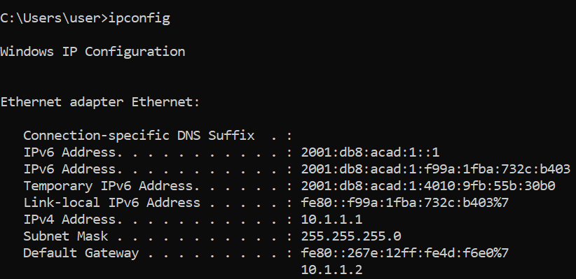

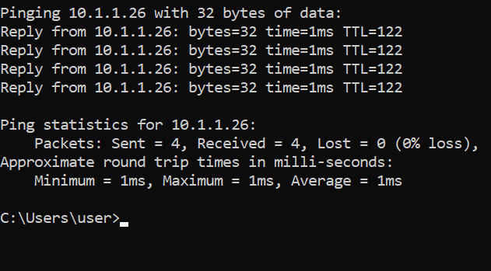

**TRACEROUTE**

From R6 to R1

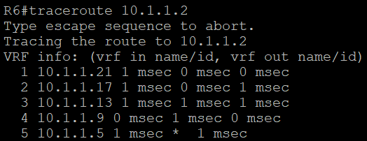

**SHOW IP ROUTE**

R1

IPV4

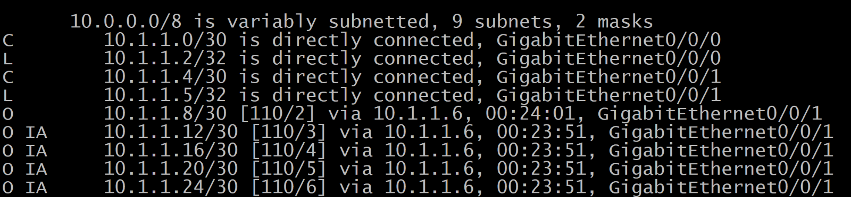

IPV6

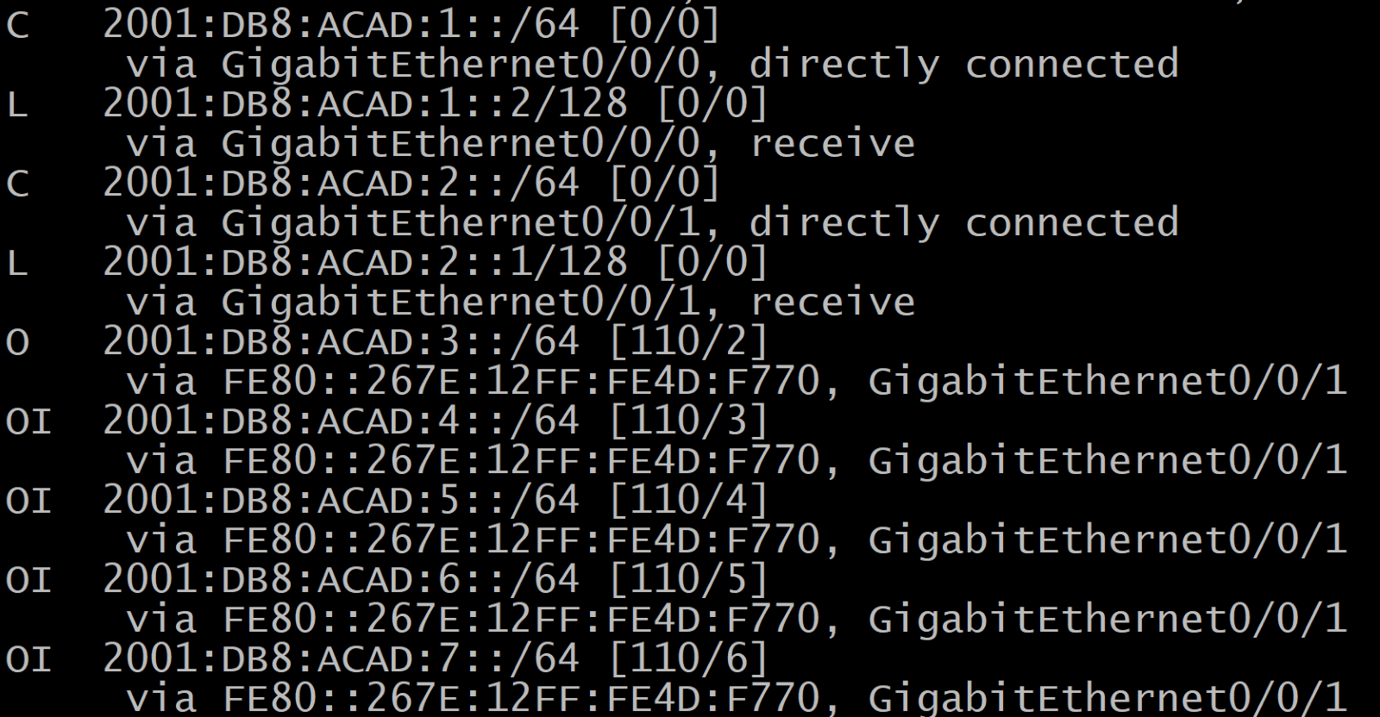

R2

IPV4

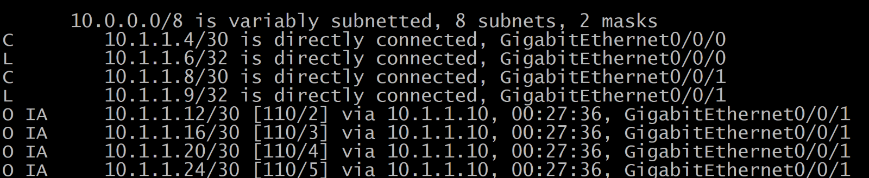

IPV6

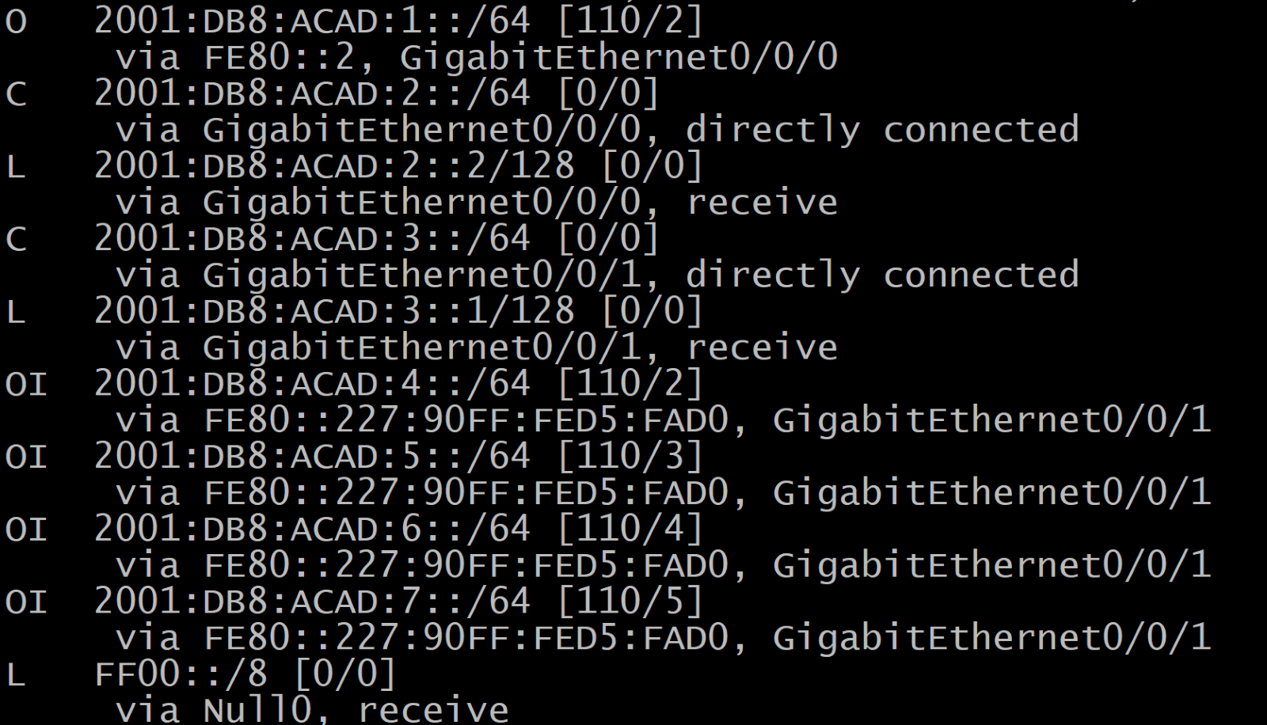

R3

IPV4

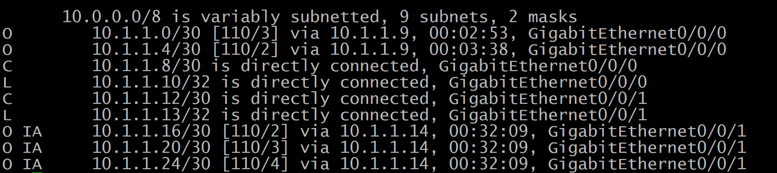

IPV6

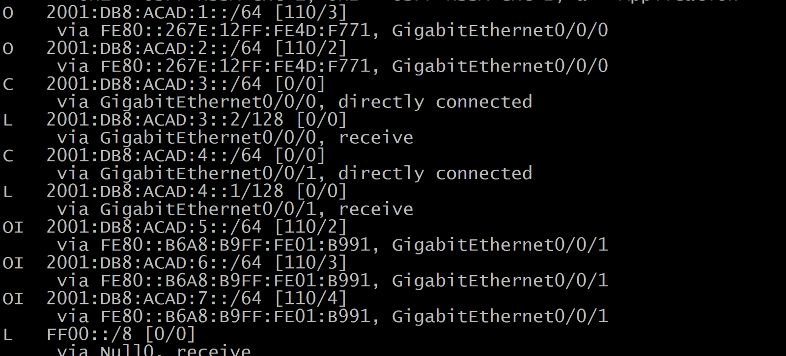

R4

IPV4

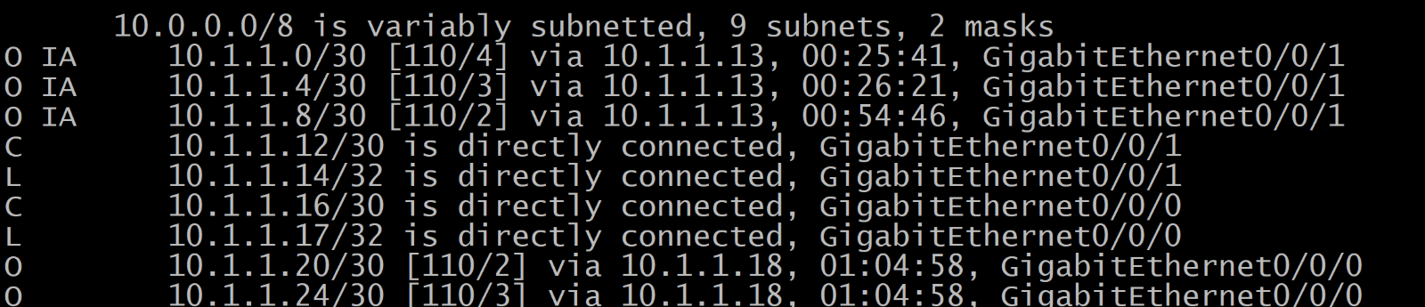

IPV6

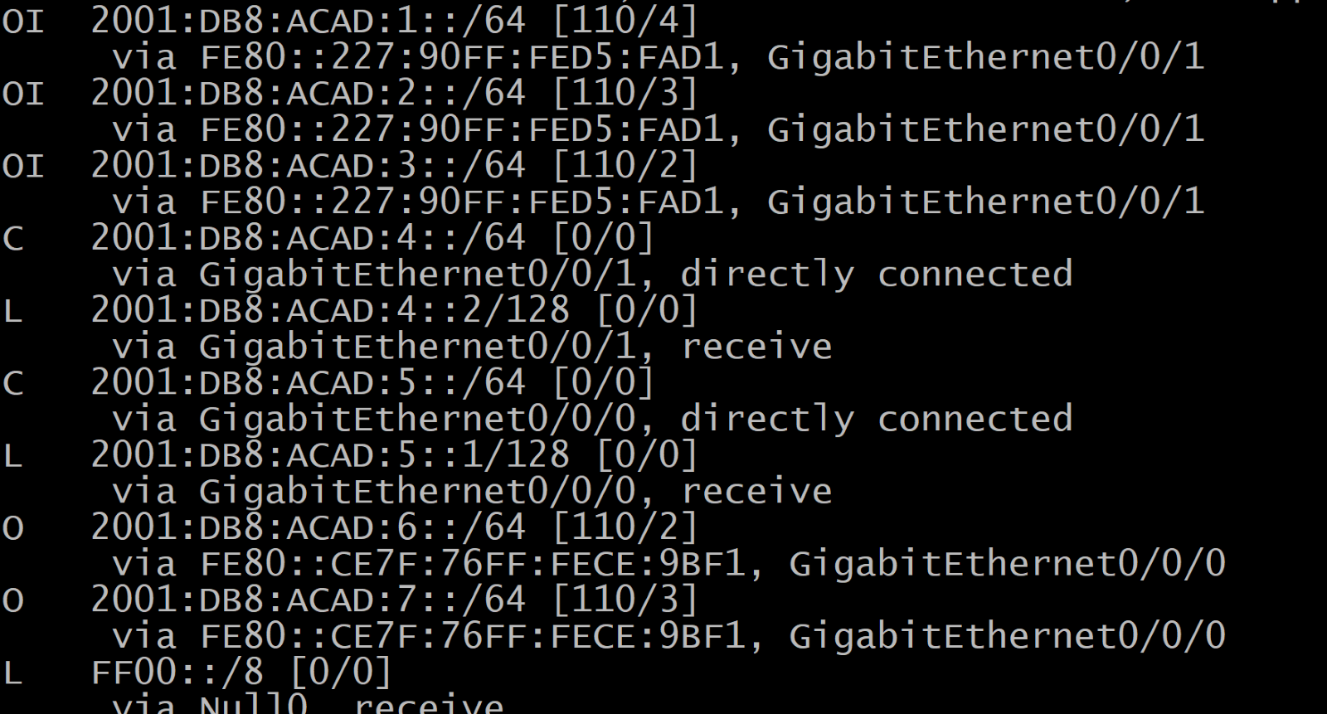

R5

IPV4

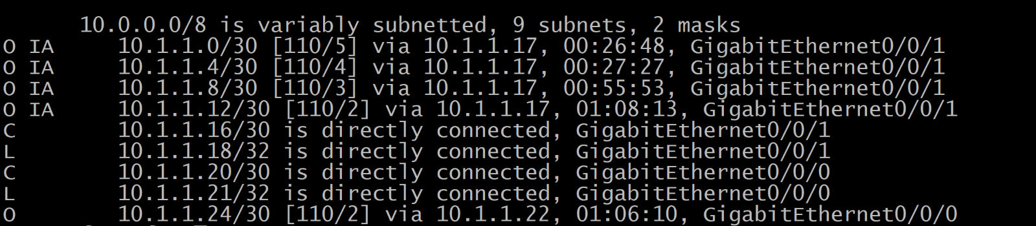

IPV6

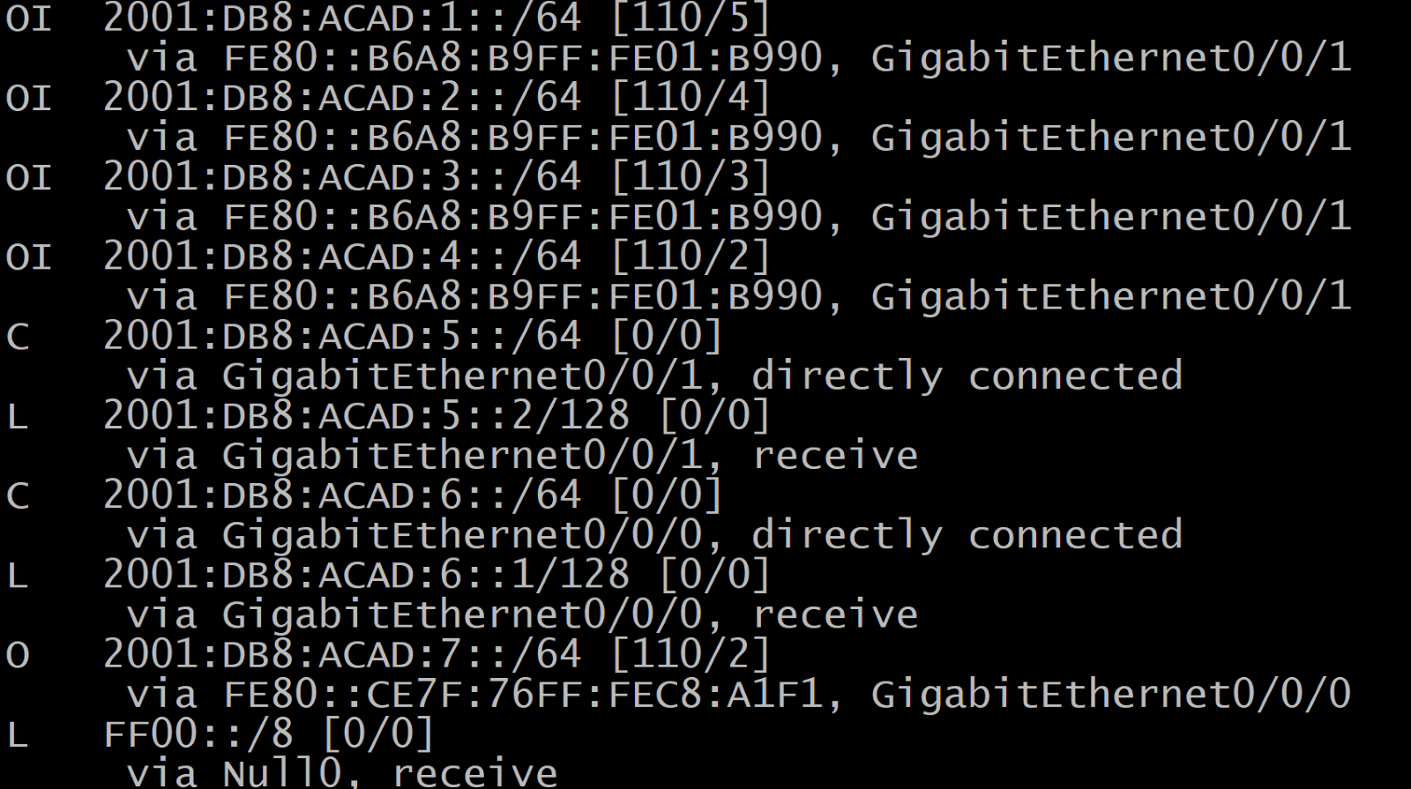

R6

IPV4

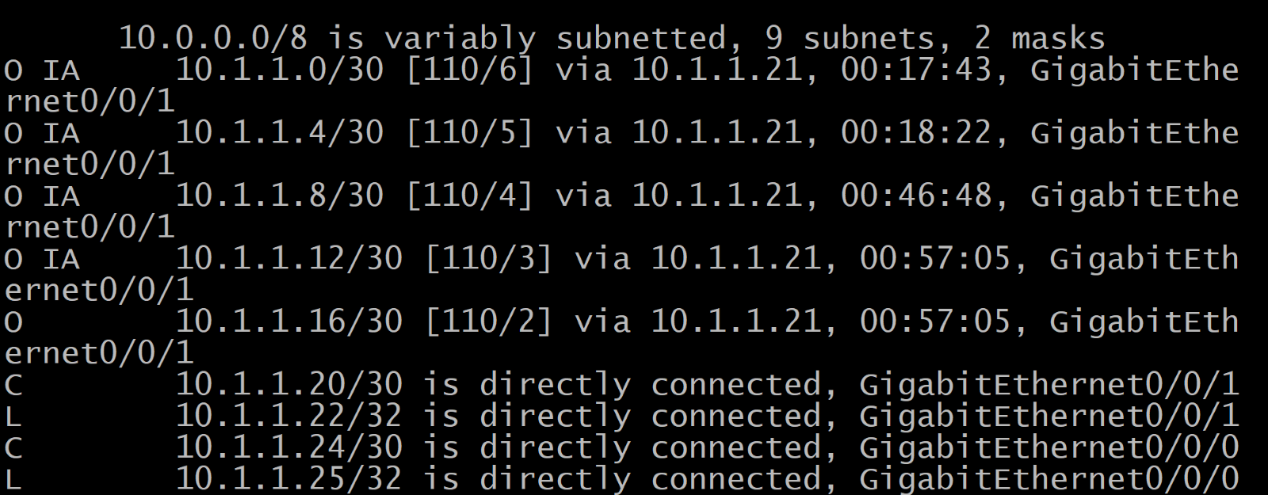

IPV6

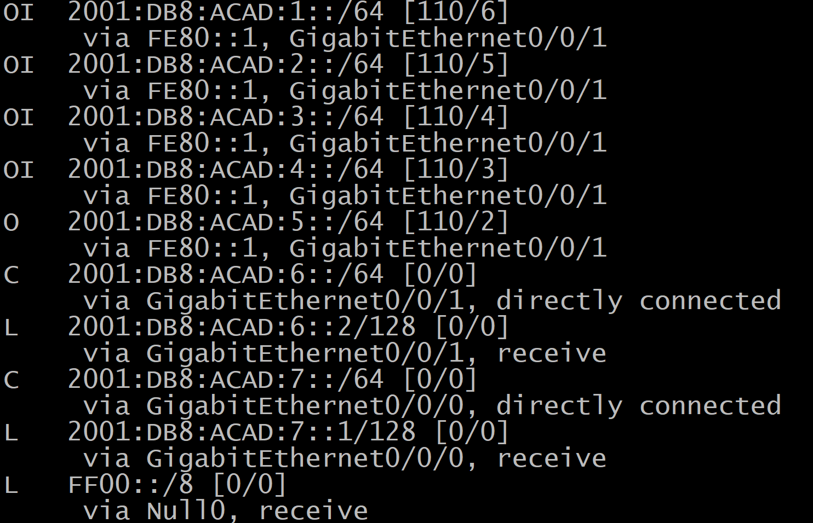

**PROBLEMS I ENCOUNTERED**

I had tried to use a subnet of /24 for the Areas, but it did not work so I switched to /30. Another problem I encountered was some of the routers could not ping it’s own IPv4 and IPv6 addresses in the interfaces. After troubleshooting, I found out that there were loading issues where some routers were it took a while for some interfaces to go up. This fixed the problem where PC1 couldn’t ping past R1’s g0/0/1, but IPv6 could. After this the network was working.

**CONCLUSION**

Although there may be problems and more trickiness to setting up your network in Multi-area OSPF, it is still very useful and worth it in larger networks and is better than single-area OSPF in smaller ones.

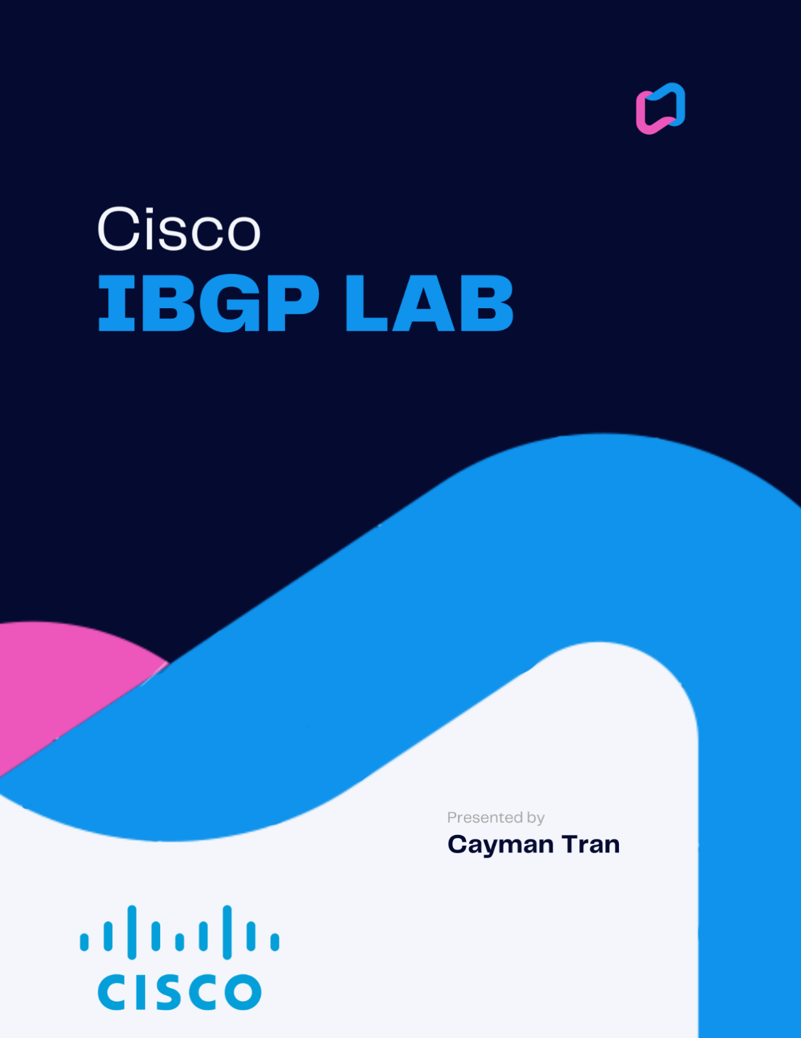

**NETWORK TOPOLOGY**

EIGRP+IBGP+OSPF 7 ROUTERS + 2 PCS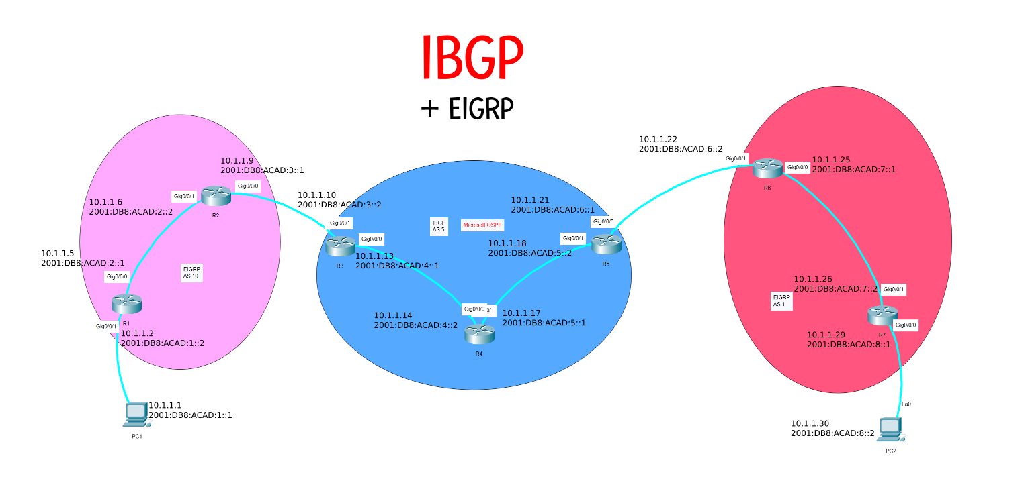

BACKGROUND INFORMATION

The two main types of Border Gateway Protocol (BGP) are External BGP (EBGP) and Internal BGP (IBGP). Both protocols are used to exchange routing information between BGP systems, but there are some key differences between the two. EBGP is used to exchange routing information between different autonomous systems (AS), while IBGP is used to exchange routing information between systems within the same AS. EBGP uses a public network for routing information exchange, while IBGP uses a private network. EBGP systems are typically configured to exchange routing information with a limited number of other systems, while IBGP systems can exchange information with a much larger number of systems. IBGP is a Distance-Vector routing protocol, which means that it uses the Bellman-Ford algorithm to calculate the shortest path to a destination. IBGP is different from other Distance-Vector routing protocols because it does not use broadcast or multicast to exchange routing information. Instead, IBGP uses unicast to exchange routing information between peers. IBGP is also different from other Distance-Vector routing protocols because it uses a hop-by-hop routing method. This means that each router in an IBGP network only knows about the next hop to a destination, and not the whole path. IBGP is a slow protocol because it uses a full mesh topology. This means that each router in an IBGP network must have a direct connection to every other router in the network. This can be expensive and difficult to manage. IBGP is also a stateful protocol, which means that it uses TCP to exchange routing information. This makes IBGP more reliable than other Distance-Vector routing protocols, but it also makes it slower.

SUMMARY

In this lab, I implemented EIGRP, BGP and OSPF. I used IBGP through OSPF for the three routers in the middle of the network and EBGP between R2 to R3 and R5 to R6. This is because they are using different AS numbers. I then used EIGRP on routers 1, 2, 6, and 7. I next started subnetting the network into /30 subnets for each connection between devices. Then I made a topology in packet tracer seen above, and configured EIGRP in areas 10 and 1, then OSPF and IBGP in area 5. I then set up EBGP between the areas. After troubleshooting connectivity problems, the network was working, and I then could ping from PC to PC.

COMMANDS

Some new commands are:

neighbor *(ipv4 or ipv6 address)* remote-as *(as-number*): this command was used in the previous lab, but this time in order to achieve EBGP or IBGP, you would either the same as-number or different as number on the respective router.

CONFIGURATIONS

Passwords: cisco/class

R1

version 16.9

service timestamps debug datetime msec

service timestamps log datetime msec

service password-encryption

platform qfp utilization monitor load 80

no platform punt-keepalive disable-kernel-core

hostname R1

boot-start-marker

boot system flash:isr4300-universalk9.16.09.08.SPA.bin

boot-end-marker

vrf definition Mgmt-intf

address-family ipv4

exit-address-family

address-family ipv6

exit-address-family

enable secret 5 $1$dR.M$VbBdcnIaPUovPBa2y46NC/

no aaa new-model

no ip domain lookup

subscriber templating

vtp domain cisco

vtp mode transparent

ipv6 unicast-routing

multilink bundle-name authenticated

license udi pid ISR4321/K9 sn FLM240608PJ

no license smart enable

diagnostic bootup level minimal

spanning-tree extend system-id

redundancy

mode none

interface GigabitEthernet0/0/0

ip address 10.1.1.5 255.255.255.252

negotiation auto

ipv6 address FE80::1 link-local

ipv6 address 2001:DB8:ACAD:2::1/64

ipv6 enable

ipv6 eigrp 10

no shutdown

interface GigabitEthernet0/0/1

ip address 10.1.1.2 255.255.255.252

negotiation auto

ipv6 address FE80::2 link-local

ipv6 address 2001:DB8:ACAD:1::2/64

ipv6 enable

ipv6 eigrp 10

no shutdown

interface GigabitEthernet0/1/0

no ip address

shutdown

negotiation auto

interface GigabitEthernet0/1/1

no ip address

shutdown

negotiation auto

interface GigabitEthernet0

vrf forwarding Mgmt-intf

no ip address

shutdown

negotiation auto

router eigrp 10

network 10.1.1.0 0.0.0.3

network 10.1.1.4 0.0.0.3

eigrp router-id 1.1.1.1

ip forward-protocol nd

no ip http server

ip http authentication local

no ip http secure-server

ip tftp source-interface GigabitEthernet0

ipv6 router eigrp 10

eigrp router-id 1.1.1.1

redistribute bgp 10 metric 10000 100 255 1 1500

control-plane

line con 0

password 7 00071A150754

login

transport input none

stopbits 1

line aux 0

stopbits 1

line vty 0 4

login

end

R2

version 15.5

service timestamps debug datetime msec

service timestamps log datetime msec

service password-encryption

no platform punt-keepalive disable-kernel-core

hostname R2

boot-start-marker

boot-end-marker

vrf definition Mgmt-intf

address-family ipv4

exit-address-family

address-family ipv6

exit-address-family

enable secret 5 $1$77i9$1rHfAqo5BOc05xtPGT29//

no aaa new-model

no ip domain lookup

ipv6 unicast-routing

subscriber templating

multilink bundle-name authenticated

license udi pid ISR4321/K9 sn FDO21482DWJ

spanning-tree extend system-id

redundancy

mode none

vlan internal allocation policy ascending

interface GigabitEthernet0/0/0

ip address 10.1.1.9 255.255.255.252

negotiation auto

ipv6 address FE80::1 link-local

ipv6 address 2001:DB8:ACAD:3::1/64

ipv6 enable

ipv6 eigrp 10

no shutdown

interface GigabitEthernet0/0/1

ip address 10.1.1.6 255.255.255.252

negotiation auto

ipv6 address FE80::2 link-local

ipv6 address 2001:DB8:ACAD:2::2/64

ipv6 enable

ipv6 eigrp 10

no shutdown

interface Serial0/1/0

no ip address

shutdown

interface Serial0/1/1

no ip address

shutdown

interface GigabitEthernet0

vrf forwarding Mgmt-intf

no ip address

shutdown

negotiation auto

interface Vlan1

no ip address

shutdown

router eigrp 10

network 10.1.1.4 0.0.0.3

network 10.1.1.8 0.0.0.3

redistribute bgp 10 metric 10000 100 255 1 1500

eigrp router-id 2.2.2.

router bgp 10

bgp router-id 2.2.2.2

no bgp log-neighbor-changes

no bgp default ipv4-unicast

neighbor 10.1.1.10 remote-as 5

neighbor 2001:DB8:ACAD:3::2 remote-as 5

address-family ipv4

network 10.1.1.8 mask 255.255.255.252

redistribute eigrp 10

neighbor 10.1.1.10 activate

exit-address-family

address-family ipv6

redistribute eigrp 10

network 2001:DB8:ACAD:2::/64

network 2001:DB8:ACAD:3::/64

neighbor 2001:DB8:ACAD:3::2 activate

exit-address-family

ip forward-protocol nd

no ip http server

no ip http secure-server

ip tftp source-interface GigabitEthernet0

ipv6 router eigrp 10

eigrp router-id 2.2.2.2

redistribute bgp 10 metric 10000 100 255 1 1500

control-plane

line con 0

password 7 045802150C2E

login

stopbits 1

line aux 0

stopbits 1

line vty 0 4

login

end

R3

version 16.9

service timestamps debug datetime msec

service timestamps log datetime msec

platform qfp utilization monitor load 80

platform punt-keepalive disable-kernel-core

hostname R3

boot-start-marker

boot-end-marker

vrf definition Mgmt-intf

address-family ipv4

exit-address-family

address-family ipv6

exit-address-family

enable secret 5 $1$dR.M$VbBdcnIaPUovPBa2y46NC/

no aaa new-model

no ip domain lookup

login on-success log

subscriber templating

vtp domain cisco

vtp mode transparent

ipv6 unicast-routing

multilink bundle-name authenticated

license udi pid ISR4321/K9 sn FDO214420HW

no license smart enable

diagnostic bootup level minimal

spanning-tree extend system-id

redundancy

mode none

interface GigabitEthernet0/0/0

ip address 10.1.1.13 255.255.255.252

ip ospf 1 area 0

negotiation auto

ipv6 address FE80::1 link-local

ipv6 address 2001:DB8:ACAD:4::1/64

ipv6 enable

ipv6 ospf 1 area 0

no shutdown

interface GigabitEthernet0/0/1

ip address 10.1.1.10 255.255.255.252

ip ospf 1 area 0

negotiation auto

ipv6 address FE80::2 link-local

ipv6 address 2001:DB8:ACAD:3::2/64

ipv6 enable

ipv6 ospf 1 area 0

no shutdown

interface Serial0/1/0

no ip address

shutdown

interface Serial0/1/1

no ip address

shutdown

interface GigabitEthernet0

vrf forwarding Mgmt-intf

no ip address

shutdown

negotiation auto

router ospfv3 1

router-id 3.3.3.3

router ospf 1

redistribute bgp 5 subnets

router-id 3.3.3.3

network 10.1.1.12 0.0.0.3 area 0

network 10.1.1.8 0.0.0.3 area 0

router bgp 5

bgp router-id 3.3.3.3

no bgp log-neighbor-changes

no bgp default ipv4-unicast

neighbor 10.1.1.9 remote-as 10

neighbor 10.1.1.14 remote-as 5

neighbor 10.1.1.18 remote-as 5

neighbor 2001:DB8:ACAD:3::1 remote-as 10

neighbor 2001:DB8:ACAD:4::2 remote-as 5

neighbor 2001:DB8:ACAD:5::2 remote-as 5

address-family ipv4

network 10.1.1.8 mask 255.255.255.252

network 10.1.1.12 mask 255.255.255.252

redistribute ospf 1

neighbor 10.1.1.9 activate

neighbor 10.1.1.14 activate

neighbor 10.1.1.18 activate

neighbor 10.1.1.18 next-hop-self

exit-address-family

address-family ipv6

redistribute ospf 1

network 2001:DB8:ACAD:3::/64

network 2001:DB8:ACAD:4::/64

neighbor 2001:DB8:ACAD:3::1 activate

neighbor 2001:DB8:ACAD:4::2 activate

neighbor 2001:DB8:ACAD:5::2 activate

neighbor 2001:DB8:ACAD:5::2 next-hop-self

exit-address-family

ip forward-protocol nd

no ip http server

ip http authentication local

no ip http secure-server

ip tftp source-interface GigabitEthernet0

ipv6 router ospf 1

router-id 3.3.3.3

redistribute bgp 5 metric 10000

control-plane

line con 0

password 7 00071A150754

login

transport input none

stopbits 1

line aux 0

stopbits 1

line vty 0 4

login

end

R4

version 16.9

service timestamps debug datetime msec

service timestamps log datetime msec

platform qfp utilization monitor load 80

platform punt-keepalive disable-kernel-core

hostname R4

boot-start-marker

boot-end-marker

vrf definition Mgmt-intf

address-family ipv4

exit-address-family

address-family ipv6

exit-address-family

no aaa new-model

login on-success log

subscriber templating

vtp domain cisco

vtp mode transparent

ipv6 unicast-routing

multilink bundle-name authenticated

license udi pid ISR4321/K9 sn FDO214421D1

no license smart enable

diagnostic bootup level minimal

spanning-tree extend system-id

redundancy

mode none

interface GigabitEthernet0/0/1

ip address 10.1.1.14 255.255.255.252

ip ospf 1 area 0

negotiation auto

ipv6 address FE80::2 link-local

ipv6 address 2001:DB8:ACAD:4::2/64

ipv6 enable

ipv6 ospf 1 area 0

no shutdown

interface GigabitEthernet0/0/0

ip address 10.1.1.17 255.255.255.252

ip ospf 1 area 0

negotiation auto

ipv6 address FE80::1 link-local

ipv6 address 2001:DB8:ACAD:5::1/64

ipv6 enable

ipv6 ospf 1 area 0

no shutdown

interface Serial0/1/0

no ip address

shutdown

interface Serial0/1/1

no ip address

shutdown

interface GigabitEthernet0

vrf forwarding Mgmt-intf

no ip address

shutdown

negotiation auto

router ospf 1

redistribute bgp 5 subnets

router-id 4.4.4.4

network 10.1.1.12 0.0.0.3 area 0

network 10.1.1.16 0.0.0.3 area 0

router bgp 5

bgp router-id 5.5.5.5

no bgp log-neighbor-changes

no bgp default ipv4-unicast

neighbor 10.1.1.13 remote-as 5

neighbor 10.1.1.18 remote-as 5

neighbor 2001:DB8:ACAD:4::1 remote-as 5

neighbor 2001:DB8:ACAD:5::2 remote-as 5

address-family ipv4

network 10.1.1.12 mask 255.255.255.252

network 10.1.1.16 mask 255.255.255.252

redistribute ospf 1

neighbor 10.1.1.13 activate

neighbor 10.1.1.18 activate

exit-address-family

address-family ipv6

redistribute ospf 1

network 2001:DB8:ACAD:4::/64

network 2001:DB8:ACAD:5::/64

neighbor 2001:DB8:ACAD:4::1 activate

neighbor 2001:DB8:ACAD:5::2 activate

exit-address-family

ip forward-protocol nd

no ip http server

ip http authentication local

no ip http secure-server

ip tftp source-interface GigabitEthernet0

ipv6 router ospf 1

router-id 4.4.4.4

redistribute bgp 5

control-plane

line con 0

transport input none

stopbits 1

line aux 0

stopbits 1

line vty 0 4

login

end

R5

version 16.9

service timestamps debug datetime msec

service timestamps log datetime msec

platform qfp utilization monitor load 80

no platform punt-keepalive disable-kernel-core

hostname R5

boot-start-marker

boot system flash:isr4300-universalk9.16.09.08.SPA.bin

boot-end-marker

vrf definition Mgmt-intf

address-family ipv4

exit-address-family

address-family ipv6

exit-address-family

no aaa new-model

no ip domain lookup

login on-success log

subscriber templating

vtp domain cisco

vtp mode transparent

ipv6 unicast-routing

multilink bundle-name authenticated

license udi pid ISR4321/K9 sn FLM240608PJ

no license smart enable

diagnostic bootup level minimal

spanning-tree extend system-id

redundancy

mode none

interface GigabitEthernet0/0/0

ip address 10.1.1.21 255.255.255.252

ip ospf 1 area 0

negotiation auto

ipv6 address FE80::1 link-local

ipv6 address 2001:DB8:ACAD:6::1/64

ipv6 enable

ipv6 ospf 1 area 0

no shutdown

interface GigabitEthernet0/0/1

ip address 10.1.1.18 255.255.255.252

ip ospf 1 area 0

negotiation auto

ipv6 address FE80::2 link-local

ipv6 address 2001:DB8:ACAD:5::2/64

ipv6 enable

ipv6 ospf 1 area 0

no shutdown

interface GigabitEthernet0/1/0

no ip address

shutdown

negotiation auto

interface GigabitEthernet0/1/1

no ip address

shutdown

negotiation auto

interface GigabitEthernet0

vrf forwarding Mgmt-intf

no ip address

shutdown

negotiation auto

router eigrp 5

network 10.1.1.20 0.0.0.3

redistribute bgp 5 metric 1000 1 255 255 1

router ospf 1

redistribute bgp 5 subnets

router-id 5.5.5.5

network 10.1.1.16 0.0.0.3 area 0

router bgp 5

bgp router-id 5.5.5.5

no bgp log-neighbor-changes

no bgp default ipv4-unicast

neighbor 10.1.1.17 remote-as 5

neighbor 10.1.1.22 remote-as 1

neighbor 10.1.1.13 remote-as 5

neighbor 2001:DB8:ACAD:5::1 remote-as 5

neighbor 2001:DB8:ACAD:6::2 remote-as 1

neighbor 2001:DB8:ACAD:4::1 remote-as 5

address-family ipv4

network 10.1.1.16 mask 255.255.255.252

network 10.1.1.20 mask 255.255.255.252

network 10.1.1.13 mask 255.255.255.252

redistribute ospf 1

neighbor 10.1.1.17 activate

neighbor 10.1.1.22 activate

neighbor 10.1.1.13 activate

neighbor 10.1.1.13 next-hop-self

exit-address-family

address-family ipv6

redistribute ospf 1

network 2001:DB8:ACAD:5::/64

network 2001:DB8:ACAD:6::/64

network 2001:DB8:ACAD:4::/64

network 2001:DB8:ACAD:7::/64

neighbor 2001:DB8:ACAD:5::1 activate

neighbor 2001:DB8:ACAD:6::2 activate

neighbor 2001:DB8:ACAD:4::1 activate

exit-address-family

ip forward-protocol nd

ip http server

ip http authentication local

ip http secure-server

ip tftp source-interface GigabitEthernet0

ipv6 router ospf 1

router-id 5.5.5.5

redistribute bgp 5 metric 10000

ipv6 router eigrp 5

eigrp router-id 5.5.5.5

control-plane

line con 0

transport input none

stopbits 1

line aux 0

stopbits 1

line vty 0 4

login

end

R6

version 16.9

service timestamps debug datetime msec

service timestamps log datetime msec

platform qfp utilization monitor load 80

platform punt-keepalive disable-kernel-core

hostname R6

boot-start-marker

boot-end-marker

vrf definition Mgmt-intf

address-family ipv4

exit-address-family

address-family ipv6

exit-address-family

no aaa new-model

login on-success log

subscriber templating

ipv6 unicast-routing

multilink bundle-name authenticated

license udi pid ISR4321/K9 sn FLM2406090M

no license smart enable

diagnostic bootup level minimal

spanning-tree extend system-id

redundancy

mode none

interface GigabitEthernet0/0/0

ip address 10.1.1.25 255.255.255.252

negotiation auto

ipv6 address FE80::1 link-local

ipv6 address 2001:DB8:ACAD:7::1/64

ipv6 enable

ipv6 eigrp 1

no shutdown

interface GigabitEthernet0/0/1

ip address 10.1.1.22 255.255.255.252

negotiation auto

ipv6 address FE80::2 link-local

ipv6 address 2001:DB8:ACAD:6::2/64

ipv6 enable

ipv6 eigrp 1

no shutdown

interface GigabitEthernet0/1/0

no ip address

shutdown

negotiation auto

interface GigabitEthernet0/1/1

no ip address

shutdown

negotiation auto

interface GigabitEthernet0

vrf forwarding Mgmt-intf

no ip address

shutdown

negotiation auto

router eigrp 1

network 10.1.1.20 0.0.0.3

network 10.1.1.24 0.0.0.3

network 10.1.1.28 0.0.0.3

eigrp router-id 6.6.6.6

redistribute bgp 1 metric 10000 100 255 1 1500

router bgp 1

bgp router-id 6.6.6.6

no bgp log-neighbor-changes

no bgp default ipv4-unicast

neighbor 10.1.1.21 remote-as 5

neighbor 2001:DB8:ACAD:6::1 remote-as 5

address-family ipv4

network 10.1.1.20 mask 255.255.255.252

redistribute eigrp 1

neighbor 10.1.1.21 activate

exit-address-family

address-family ipv6

redistribute eigrp 1

network 2001:DB8:ACAD:7::/64

network 2001:DB8:ACAD:6::/64

neighbor 2001:DB8:ACAD:6::1 activate

exit-address-family

ip forward-protocol nd

ip http server

ip http authentication local

ip http secure-server

ip tftp source-interface GigabitEthernet0

ipv6 router eigrp 1

eigrp router-id 6.6.6.6

redistribute bgp 1 metric 10000 100 255 1 1500

control-plane

line con 0

transport input none

stopbits 1

line aux 0

stopbits 1

line vty 0 4

login

end

R7

version 16.9

service timestamps debug datetime msec

service timestamps log datetime msec

platform qfp utilization monitor load 80

platform punt-keepalive disable-kernel-core

hostname R7

boot-start-marker

boot-end-marker

vrf definition Mgmt-intf

address-family ipv4

exit-address-family

address-family ipv6

exit-address-family

no aaa new-model

login on-success log

subscriber templating

ipv6 unicast-routing

multilink bundle-name authenticated

license udi pid ISR4321/K9 sn FLM2407011F

no license smart enable

diagnostic bootup level minimal

spanning-tree extend system-id

redundancy

mode none

interface GigabitEthernet0/0/0

ip address 10.1.1.29 255.255.255.252

negotiation auto

ipv6 address FE80::1 link-local

ipv6 address 2001:DB8:ACAD:8::1/64

ipv6 enable

ipv6 eigrp 1

no shutdown

interface GigabitEthernet0/0/1

ip address 10.1.1.26 255.255.255.252

negotiation auto

ipv6 address FE80::2 link-local

ipv6 address 2001:DB8:ACAD:7::2/64

ipv6 enable

ipv6 eigrp 1

no shutdown

interface GigabitEthernet0/1/0

no ip address

shutdown

negotiation auto

interface GigabitEthernet0/1/1

no ip address

shutdown

negotiation auto

interface GigabitEthernet0

vrf forwarding Mgmt-intf

no ip address

shutdown

negotiation auto

router eigrp 1

network 10.1.1.20 0.0.0.3

network 10.1.1.24 0.0.0.3

network 10.1.1.28 0.0.0.3

eigrp router-id 7.7.7.7

ip forward-protocol nd

ip http server

ip http authentication local

ip http secure-server

ip tftp source-interface GigabitEthernet0

ipv6 router eigrp 1

eigrp router-id 7.7.7.7

redistribute bgp 1 metric 10000 100 255 1 1500

control-plane

line con 0

transport input none

stopbits 1

line aux 0

stopbits 1

line vty 0 4

login

**PINGS**

PC1 To PC2

C:\Users\user>ping 10.1.1.26

Pinging 10.1.1.26 with 32 bytes of data:

Reply from 10.1.1.26: bytes=32 time=1ms TTL=249

Reply from 10.1.1.26: bytes=32 time=1ms TTL=249

Reply from 10.1.1.26: bytes=32 time=1ms TTL=249

Reply from 10.1.1.26: bytes=32 time=1ms TTL=249

Ping statistics for 10.1.1.26:

Packets: Sent = 4, Received = 4, Lost = 0 (0% loss),

Approximate round trip times in milli-seconds:

Minimum = 1ms, Maximum = 1ms, Average = 1ms

**TRACEROUTES**

R1 to R6

R1#traceroute 10.1.1.25

Type escape sequence to abort.

Tracing the route to 10.1.1.25

VRF info: (vrf in name/id, vrf out name/id)

1 10.1.1.6 1 msec 1 msec 1 msec

2 10.1.1.10 1 msec 1 msec 1 msec

3 10.1.1.14 1 msec 1 msec 1 msec

4 10.1.1.18 1 msec 1 msec 1 msec

5 10.1.1.22 1 msec

**SHOW IP ROUTE**

R1

IPV4

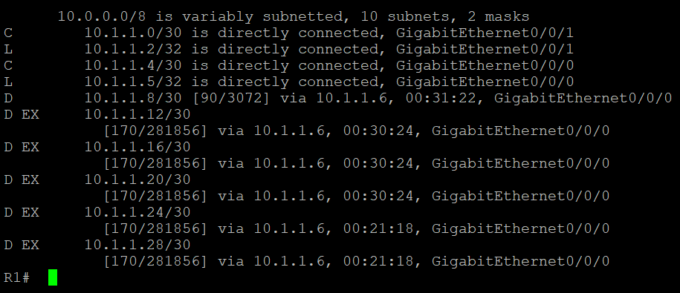

IPV6

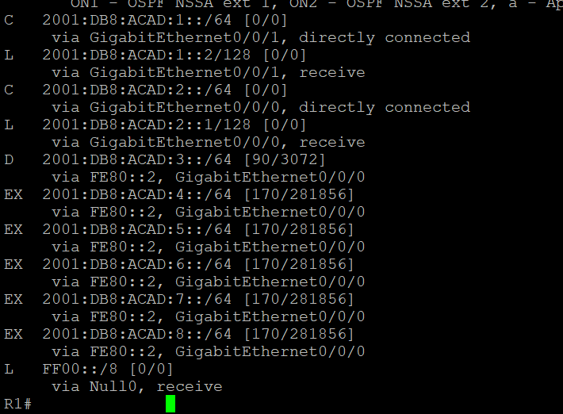

R2

IPV4+IPV6

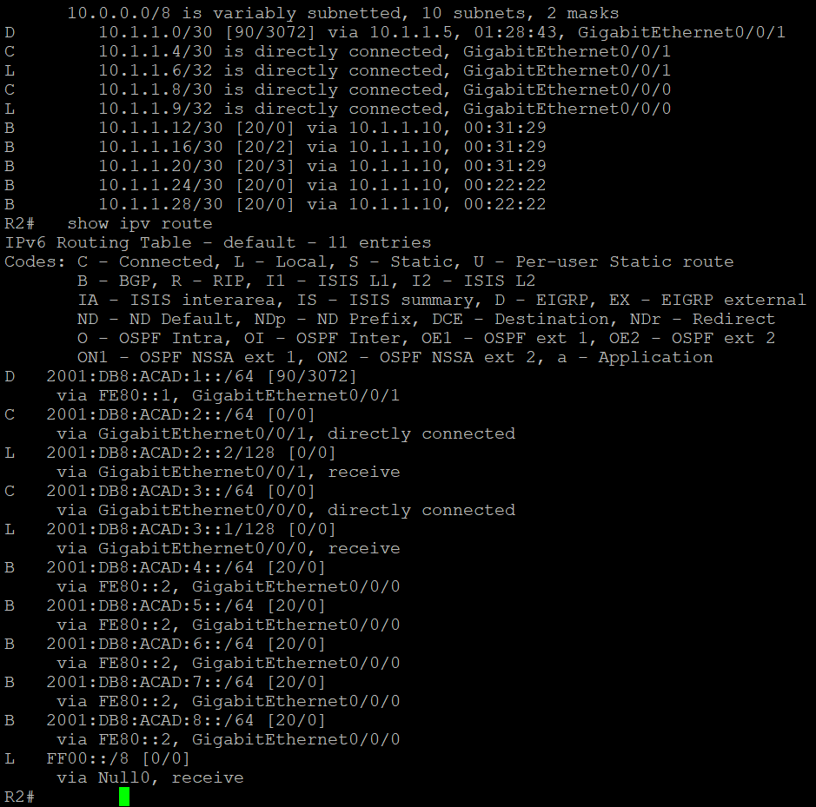

R3

IPV4

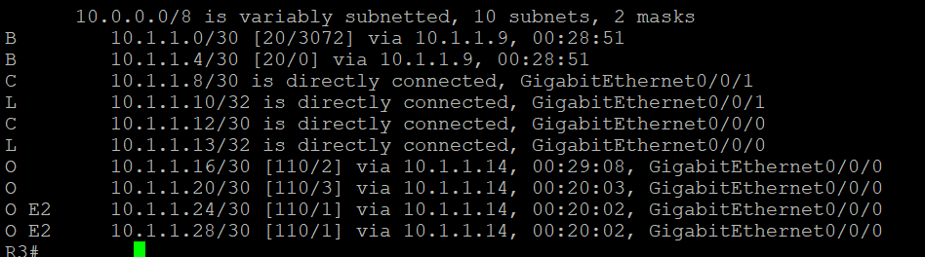

IPV6

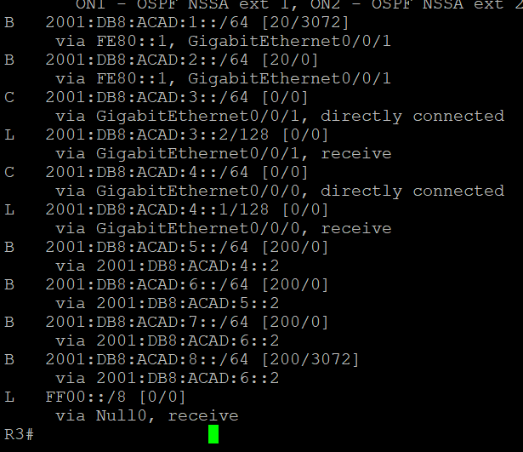

R4

IPV4

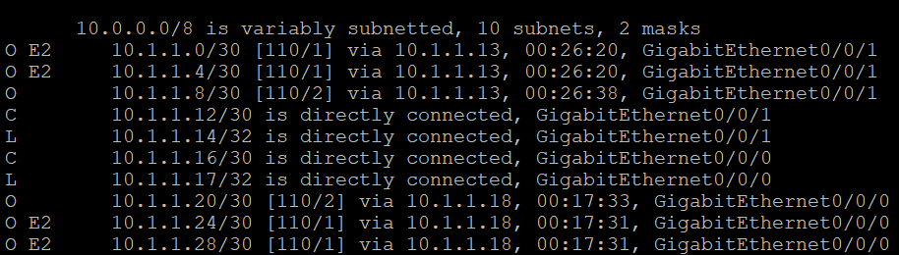

IPV6

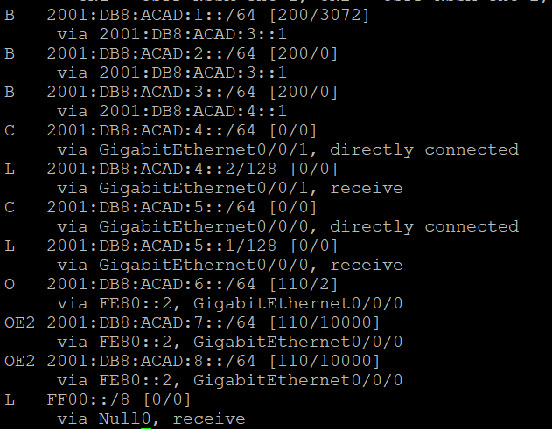

R5

IPV4

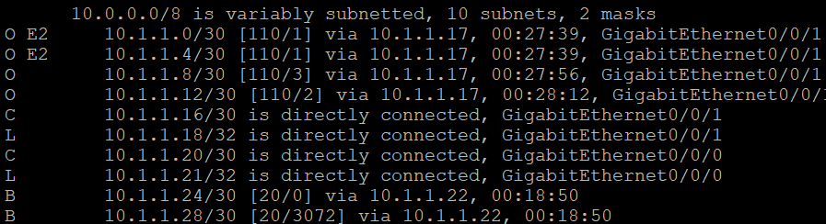

IPV6

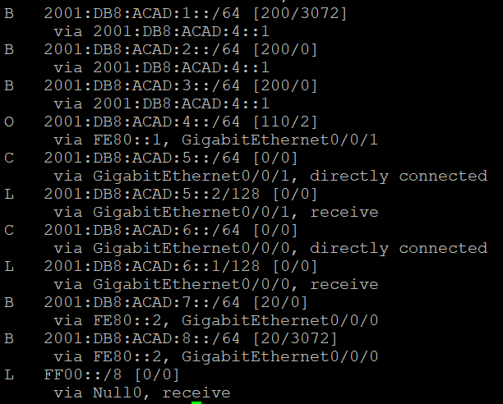

R6

IPV4+IPV6

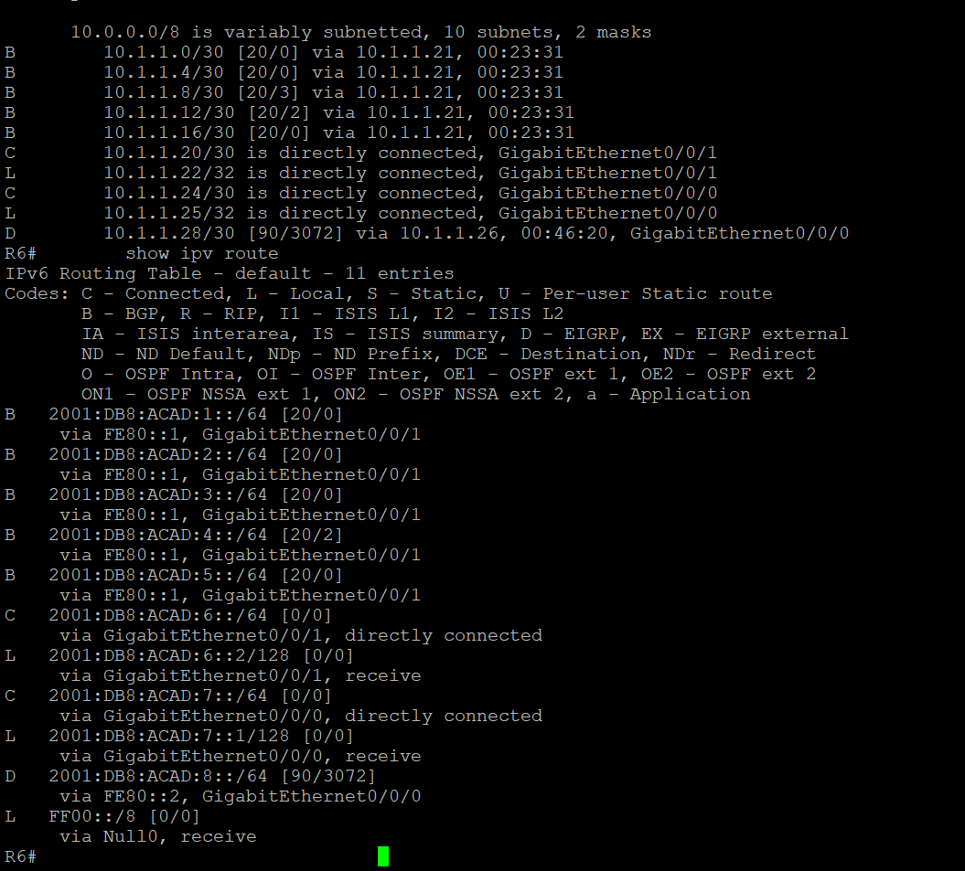

R7

IPV4+IPV6

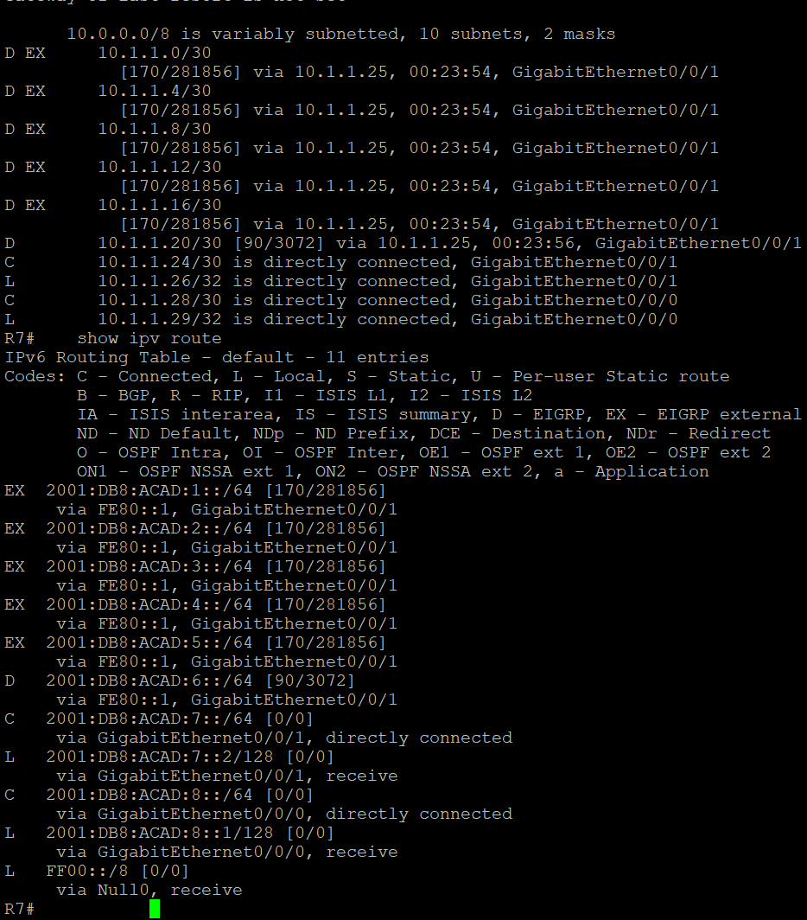

R4

show ip bgp topology

R4#show ip bgp topology *

For address family: IPv4 Unicast

BGP table version is 9, local router ID is 5.5.5.5

Status codes: s suppressed, d damped, h history, * valid, > best, i - internal,

r RIB-failure, S Stale, m multipath, b backup-path, f RT-Filter,

x best-external, a additional-path, c RIB-compressed,

t secondary path, L long-lived-stale,

Origin codes: i - IGP, e - EGP, ? - incomplete

RPKI validation codes: V valid, I invalid, N Not found

Network Next Hop Metric LocPrf Weight Path

r>i 10.1.1.0/30 10.1.1.9 3072 100 0 10 ?

r>i 10.1.1.4/30 10.1.1.9 0 100 0 10 ?

* i 10.1.1.8/30 10.1.1.13 0 100 0 i

*> 10.1.1.13 2 32768 ?

* i 10.1.1.12/30 10.1.1.13 0 100 0 i

*> 0.0.0.0 0 32768 i

*> 10.1.1.16/30 0.0.0.0 0 32768 i

*> 10.1.1.20/30 10.1.1.18 2 32768 ?

show bgp detail

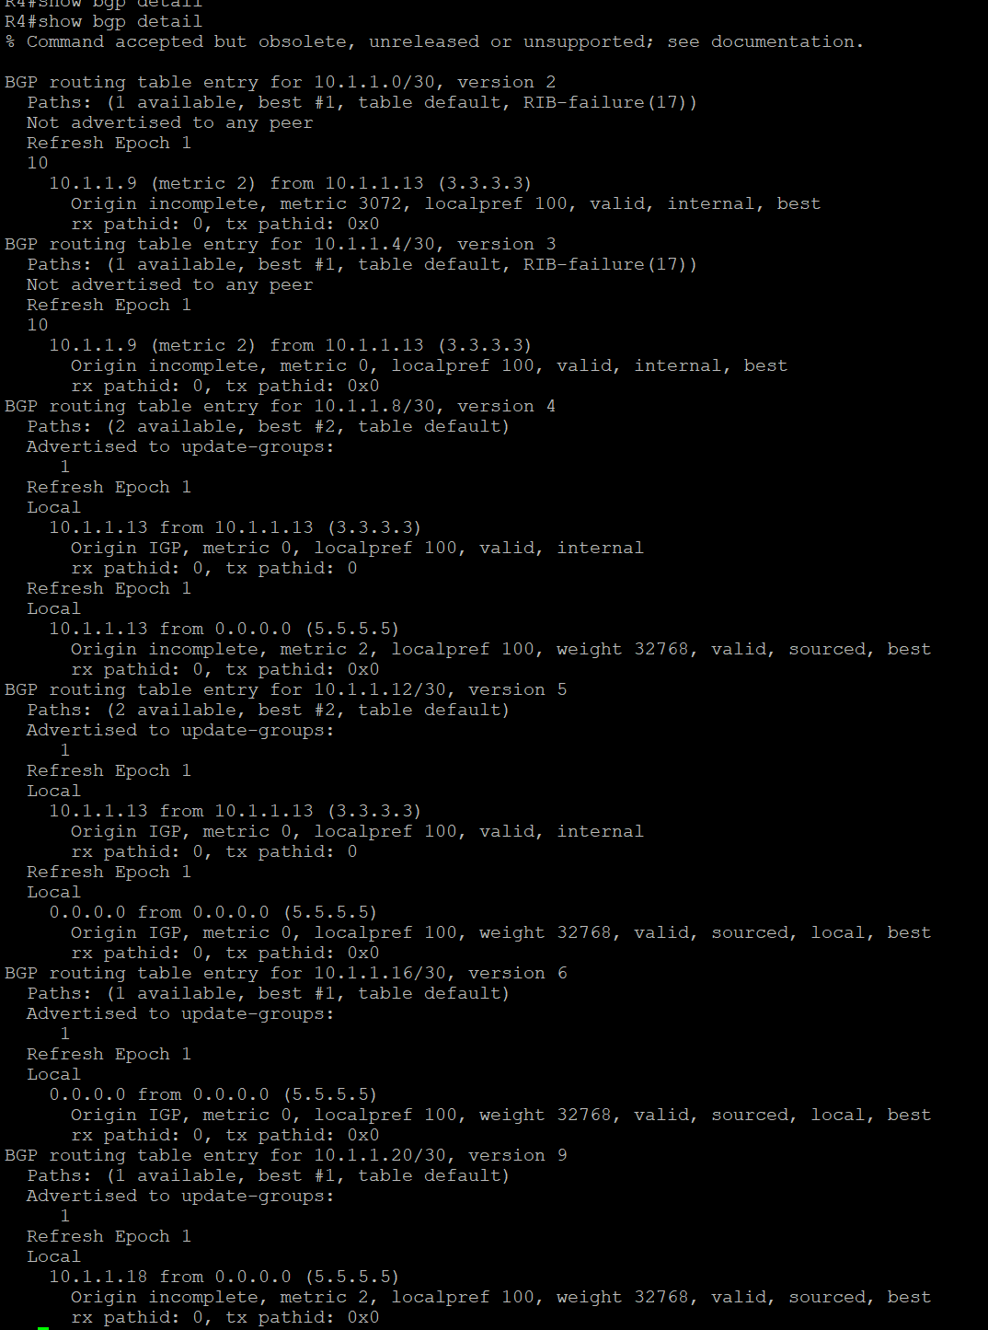

**PROBLEMS I ENCOUNTERED**

I had the routing protocols installed and the IPs, but I had trouble pinging from edge router to edge router. When dealing with a network setup with BGP and EIGRP, troubleshooting can be a bit more complicated due to the complexity of the protocols. The first step in troubleshooting a BGP or EIGRP network is to determine whether the problem is related to the protocol or something else. To do this, the administrator can check the routing table for any discrepancies, check for any configuration mistakes, and use the show command to verify whether the routes are being advertised correctly. This can be done by looking at the log files, running a traceroute or ping test, or using the show command to check the status of the routes. Using the show traceroute command, I had found that the connection with IPv6 would not reach from R1 to R7. After I carefully looked through my configuration and found that I mistakenly had some of the as-numbers and an IPv6 address incorrect. Once I fixed them, IPv6 connectivity worked.

**CONCLUSION**

Overall, troubleshooting BGP and EIGRP networks can be a complex task. It is important for network administrators to have a good understanding of the protocols and the common troubleshooting techniques.

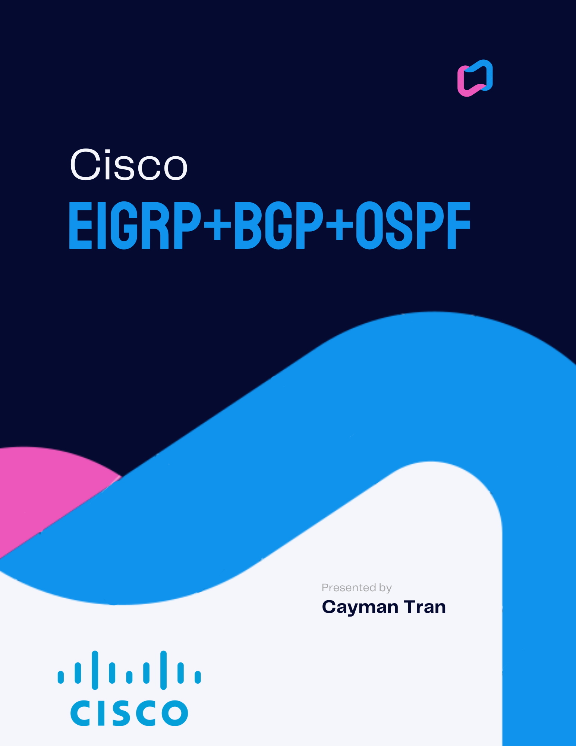

**NETWORK TOPOLOGY**

EIGRP+BGP+OSPF 6 ROUTERS + 2 PCS

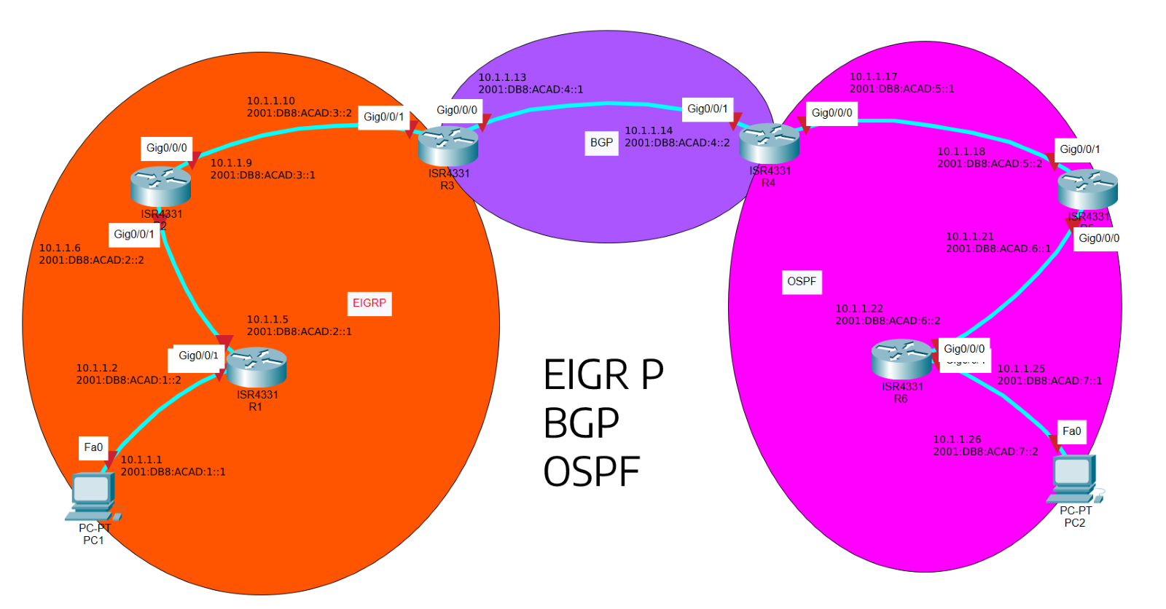

BACKGROUND INFORMATION

In this lab we implemented three routing protocols, EIGRP, BGP and OSPF. EIGRP, abbreviated from Enhanced Interior Gateway Routing Protocol, designed by Cisco Systems, replaced IGRP in 1993 because IGRP did not support classless IPv4 addresses. The main focus of EIGRP is that it uses autonomous systems to share routes with other routers, load balancing, MD5 and SHA-2 authentication, and sends topology changes. BGP, abbreviated Border Gateway Protocol, was originally designed in 1989 by three engineers on some napkins, and then later published in 2006 as version 4 on RFC. BGP also uses autonomous systems, but in BGP there is iBGP which are internal peers, and eBGP which are external peers. New routes learned from eBGP are re-advertised only to iBGP and eBGP peers, while new routes learned from iBGP are only re-advertised to eBGP peers. Some reasons why you might use multiple routing protocols in a network are because some network devices come from different vendors, some routing protocols are better updated, or you just need it to transfer packets or data differently.

SUMMARY

With a total of six routers and two hosts, the three routing protocols mentioned above, EIGRP, BGP and OSP were implemented in this lab. I started by subnetting the network into /30 subnets and made each subnet a connection between each device. Then I made a topology in packet tracer seen above, by configuring OSPF within the OSPF area, because that is what I am most familiar with, then went to BGP. I configured all necessary BGP commands, then went onto EIGRP and added all those necessary commands. After troubleshooting connectivity problems, the network was working and I could ping from PC to PC.

COMMANDS

Some new commands are:

router eigrp (*process-id) :* enables eigrp

router bgp (*as-number) :* enables bgp

ipv6 router eigrp (*as-number)*

eigrp router-id (*as-number) :* gives router id for eigrp

*address-family (ipv4 or ipv6)* : goes into configuration for protocol implementation for ipv4

redistribute (*method)* - redistributes the routing protocol

neighbor (*ip address)* remote-as (*as-number)* - tells the router its neighbor with the as number and ip address

neighbor (*ip address) activate –* activates the neighbor’s ip address

CONFIGURATIONS

Passwords: cisco/class

R1

version 15.5

service timestamps debug datetime msec

service timestamps log datetime msec

service password-encryption

no platform punt-keepalive disable-kernel-core

hostname R1

boot-start-marker

boot-end-marker

vrf definition Mgmt-intf

address-family ipv4

exit-address-family

address-family ipv6

exit-address-family

enable secret 5 $1$dR.M$VbBdcnIaPUovPBa2y46NC/

no aaa new-model

no ip domain lookup

ipv6 unicast-routing

subscriber templating

multilink bundle-name authenticated

license udi pid ISR4321/K9 sn FDO21482HZX

spanning-tree extend system-id

redundancy

mode none

vlan internal allocation policy ascending

interface GigabitEthernet0/0/0

ip address 10.1.1.2 255.255.255.252

negotiation auto

ipv6 address 2001:DB8:ACAD:1::2/64

ipv6 enable

ipv6 eigrp 1

interface GigabitEthernet0/0/1

ip address 10.1.1.5 255.255.255.252

negotiation auto

ipv6 address 2001:DB8:ACAD:2::1/64

ipv6 enable

ipv6 eigrp 1

interface Serial0/1/0

no ip address

shutdown

interface Serial0/1/1

no ip address

shutdown

interface GigabitEthernet0

vrf forwarding Mgmt-intf

no ip address

shutdown

negotiation auto

interface Vlan1

no ip address

shutdown

router eigrp 1

network 10.1.1.0 0.0.0.3

network 10.1.1.4 0.0.0.3

eigrp router-id 1.1.1.1

ip forward-protocol nd

no ip http server

no ip http secure-server

ip tftp source-interface GigabitEthernet0

ipv6 router eigrp 1

eigrp router-id 1.1.1.1

control-plane

line con 0

password 7 00071A150754

login

stopbits 1

line aux 0

stopbits 1

line vty 0 4

login

end

R2

version 15.5

service timestamps debug datetime msec

service timestamps log datetime msec

service password-encryption

no platform punt-keepalive disable-kernel-core

hostname R2

boot-start-marker

boot-end-marker

vrf definition Mgmt-intf

address-family ipv4

exit-address-family

address-family ipv6

exit-address-family

enable secret 5 $1$77i9$1rHfAqo5BOc05xtPGT29//

no aaa new-model

no ip domain lookup

ipv6 unicast-routing

subscriber templating

multilink bundle-name authenticated

license udi pid ISR4321/K9 sn FDO21482DWJ

spanning-tree extend system-id

redundancy

mode none

vlan internal allocation policy ascending

interface GigabitEthernet0/0/0

ip address 10.1.1.9 255.255.255.252

negotiation auto

ipv6 address 2001:DB8:ACAD:3::1/64

ipv6 enable

ipv6 eigrp 1

interface GigabitEthernet0/0/1

ip address 10.1.1.6 255.255.255.252

negotiation auto

ipv6 address 2001:DB8:ACAD:2::2/64

ipv6 enable

ipv6 eigrp 1

interface Serial0/1/0

no ip address

shutdown

interface Serial0/1/1

no ip address

shutdown

interface GigabitEthernet0

vrf forwarding Mgmt-intf

no ip address

shutdown

negotiation auto

interface Vlan1

no ip address

shutdown

router eigrp 1

network 10.1.1.4 0.0.0.3

network 10.1.1.8 0.0.0.3

eigrp router-id 2.2.2.2

ip forward-protocol nd

no ip http server

no ip http secure-server

ip tftp source-interface GigabitEthernet0

ipv6 router eigrp 1

eigrp router-id 2.2.2.2

control-plane

line con 0

password 7 045802150C2E

login

stopbits 1

line aux 0

stopbits 1

line vty 0 4

login

end

R3

version 15.5

service timestamps debug datetime msec

service timestamps log datetime msec

service password-encryption

no platform punt-keepalive disable-kernel-core

hostname R3

boot-start-marker

boot-end-marker

vrf definition Mgmt-intf

address-family ipv4

exit-address-family

address-family ipv6

exit-address-family

enable secret 5 $1$dR.M$VbBdcnIaPUovPBa2y46NC/

no aaa new-model

no ip domain lookup

ipv6 unicast-routing

subscriber templating

vtp domain cisco

vtp mode transparent

multilink bundle-name authenticated

license udi pid ISR4321/K9 sn FDO214420HW

spanning-tree extend system-id

redundancy

mode none

vlan internal allocation policy ascending

vlan 10,20

interface GigabitEthernet0/0/0

ip address 10.1.1.13 255.255.255.252

negotiation auto

ipv6 address FE80::1 link-local

ipv6 address 2001:DB8:ACAD:4::1/64

ipv6 enable

ipv6 eigrp 1

interface GigabitEthernet0/0/1

ip address 10.1.1.10 255.255.255.252

negotiation auto

ipv6 address 2001:DB8:ACAD:3::2/64

ipv6 enable

interface Serial0/1/0

no ip address

shutdown

interface Serial0/1/1

no ip address

shutdown

interface GigabitEthernet0

vrf forwarding Mgmt-intf

no ip address

shutdown

negotiation auto

interface Vlan1

no ip address

shutdown

router eigrp 1

network 10.1.1.8 0.0.0.3

network 10.1.1.12 0.0.0.3

redistribute static

redistribute bgp 3 metric 10000 100 255 1 1500

eigrp router-id 3.3.3.3

router bgp 3

bgp router-id 3.3.3.3

bgp log-neighbor-changes

no bgp default ipv4-unicast

neighbor 10.1.1.14 remote-as 4

neighbor 2001:DB8:ACAD:4::2 remote-as 4

address-family ipv4

network 10.1.1.8

network 10.1.1.12

redistribute eigrp 1

neighbor 10.1.1.14 activate

exit-address-family

address-family ipv6

redistribute eigrp 1

network 2001:DB8:ACAD:3::/64

network 2001:DB8:ACAD:4::/64

neighbor 2001:DB8:ACAD:4::2 activate

exit-address-family

ip forward-protocol nd

no ip http server

no ip http secure-server

ip tftp source-interface GigabitEthernet0

ipv6 router eigrp 1

eigrp router-id 3.3.3.3

redistribute bgp 3

ipv6 router eigrp 10

redistribute bgp 3 metric 10000 100 255 1 1500

control-plane

line con 0

password 7 00071A150754

login

stopbits 1

line aux 0

stopbits 1

line vty 0 4

login

end

R4

version 15.5

service timestamps debug datetime msec

service timestamps log datetime msec

service password-encryption

no platform punt-keepalive disable-kernel-core

hostname R4

boot-start-marker

boot-end-marker

vrf definition Mgmt-intf

address-family ipv4

exit-address-family

address-family ipv6

exit-address-family

enable secret 5 $1$dR.M$VbBdcnIaPUovPBa2y46NC/

no aaa new-model

no ip domain lookup

ipv6 unicast-routing

subscriber templating

vtp domain cisco

vtp mode transparent

multilink bundle-name authenticated

license udi pid ISR4321/K9 sn FDO214421D1

spanning-tree extend system-id

redundancy

mode none

vlan internal allocation policy ascending

vlan 10,20

interface GigabitEthernet0/0/0

ip address 10.1.1.17 255.255.255.252

ip ospf 1 area 0

negotiation auto

ipv6 address FE80::1 link-local

ipv6 address 2001:DB8:ACAD:5::1/64

ipv6 enable

ipv6 ospf 1 area 0

interface GigabitEthernet0/0/1

ip address 10.1.1.14 255.255.255.252

ip ospf 1 area 0

negotiation auto

ipv6 address FE80::2 link-local

ipv6 address 2001:DB8:ACAD:4::2/64

ipv6 enable

ipv6 ospf 1 area 0

interface Serial0/1/0

no ip address

shutdown

interface Serial0/1/1

no ip address

shutdown

interface GigabitEthernet0

vrf forwarding Mgmt-intf

no ip address

shutdown

negotiation auto

interface Vlan1

no ip address

shutdown

router ospf 1

router-id 4.4.4.4

redistribute bgp 4 subnets

network 10.1.1.12 0.0.0.3 area 0

network 10.1.1.16 0.0.0.3 area 0

router ospf 10

router bgp 4

bgp router-id 4.4.4.4

bgp log-neighbor-changes

no bgp default ipv4-unicast

neighbor 10.1.1.13 remote-as 3

neighbor 2001:DB8:ACAD:4::1 remote-as 3

address-family ipv4

network 10.1.1.12

network 10.1.1.12 mask 255.255.255.252

network 10.1.1.16

network 10.1.1.16 mask 255.255.255.252

redistribute ospf 1

neighbor 10.1.1.13 activate

exit-address-family

address-family ipv6

redistribute ospf 1

network 2001:DB8:ACAD:4::/64

network 2001:DB8:ACAD:5::/64

neighbor 2001:DB8:ACAD:4::1 activate

exit-address-family

ip forward-protocol nd

no ip http server

no ip http secure-server

ip tftp source-interface GigabitEthernet0

ipv6 router ospf 1

router-id 4.4.4.4

redistribute bgp 4 metric 10000

control-plane

line con 0

password 7 00071A150754

login

stopbits 1

line aux 0

stopbits 1

line vty 0 4

login

end

R5

version 16.9

service timestamps debug datetime msec

service timestamps log datetime msec

service password-encryption

platform qfp utilization monitor load 80

no platform punt-keepalive disable-kernel-core

hostname R5

boot-start-marker

boot system flash:isr4300-universalk9.16.09.08.SPA.bin

boot-end-marker

vrf definition Mgmt-intf

address-family ipv4

exit-address-family

address-family ipv6

exit-address-family

enable secret 5 $1$dR.M$VbBdcnIaPUovPBa2y46NC/

no aaa new-model

no ip domain lookup

subscriber templating

vtp domain cisco

vtp mode transparent

ipv6 unicast-routing

multilink bundle-name authenticated

crypto pki trustpoint TP-self-signed-859896477

enrollment selfsigned

subject-name cn=IOS-Self-Signed-Certificate-859896477

revocation-check none

rsakeypair TP-self-signed-859896477

license udi pid ISR4321/K9 sn FLM240608PJ

no license smart enable

diagnostic bootup level minimal

spanning-tree extend system-id

redundancy

mode none

interface GigabitEthernet0/0/0

ip address 10.1.1.21 255.255.255.252

ip ospf 1 area 0

negotiation auto

ipv6 address FE80::1 link-local

ipv6 address 2001:DB8:ACAD:6::1/64

ipv6 enable

ipv6 ospf 1 area 0

interface GigabitEthernet0/0/1

ip address 10.1.1.18 255.255.255.252

ip ospf 1 area 0

negotiation auto

ipv6 address FE80::2 link-local

ipv6 address 2001:DB8:ACAD:5::2/64

ipv6 enable

ipv6 ospf 1 area 0

interface GigabitEthernet0/1/0

no ip address

shutdown

negotiation auto

interface GigabitEthernet0/1/1

no ip address

shutdown

negotiation auto

interface GigabitEthernet0

vrf forwarding Mgmt-intf

no ip address

shutdown

negotiation auto

router ospf 1

router-id 5.5.5.5

network 10.1.1.16 0.0.0.3 area 0

network 10.1.1.20 0.0.0.3 area 0

ip forward-protocol nd

no ip http server

ip http authentication local

no ip http secure-server

ip tftp source-interface GigabitEthernet0

ipv6 router ospf 1

router-id 5.5.5.5

control-plane

line con 0

password 7 00071A150754

login

transport input none

stopbits 1

line aux 0

stopbits 1

line vty 0 4

login

end

R6

version 16.9

service timestamps debug datetime msec

service timestamps log datetime msec

service password-encryption

platform qfp utilization monitor load 80

no platform punt-keepalive disable-kernel-core

hostname R6

boot-start-marker

boot-end-marker

vrf definition Mgmt-intf

address-family ipv4

exit-address-family

address-family ipv6

exit-address-family

enable secret 5 $1$dR.M$VbBdcnIaPUovPBa2y46NC/

no aaa new-model

no ip domain lookup

login on-success log

subscriber templating

ipv6 unicast-routing

multilink bundle-name authenticated

crypto pki trustpoint TP-self-signed-4288135047

enrollment selfsigned

subject-name cn=IOS-Self-Signed-Certificate-4288135047

revocation-check none

rsakeypair TP-self-signed-4288135047

license udi pid ISR4321/K9 sn FLM2406090M

no license smart enable

diagnostic bootup level minimal

spanning-tree extend system-id

redundancy

mode none

interface GigabitEthernet0/0/0

ip address 10.1.1.22 255.255.255.252

ip ospf 1 area 0

negotiation auto

ipv6 address 2001:DB8:ACAD:6::2/64

ipv6 enable

ipv6 ospf 1 area 0

interface GigabitEthernet0/0/1

ip address 10.1.1.25 255.255.255.252

ip ospf 1 area 0

negotiation auto

ipv6 address 2001:DB8:ACAD:7::1/64

ipv6 enable

ipv6 ospf 1 area 0

interface GigabitEthernet0/1/0

no ip address

shutdown

negotiation auto

interface GigabitEthernet0/1/1

no ip address

shutdown

negotiation auto

interface GigabitEthernet0

vrf forwarding Mgmt-intf

no ip address

shutdown

negotiation auto

router ospf 1

router-id 6.6.6.6

network 10.1.1.20 0.0.0.3 area 0

network 10.1.1.24 0.0.0.3 area 0

ip forward-protocol nd

no ip http server

ip http authentication local

no ip http secure-server

ip tftp source-interface GigabitEthernet0

ipv6 router ospf 1

router-id 6.6.6.6

control-plane

line con 0

password 7 00071A150754

login

transport input none

stopbits 1

line aux 0

stopbits 1

line vty 0 4

login

end

**SHOW IP ROUTE**

R1

IPV4

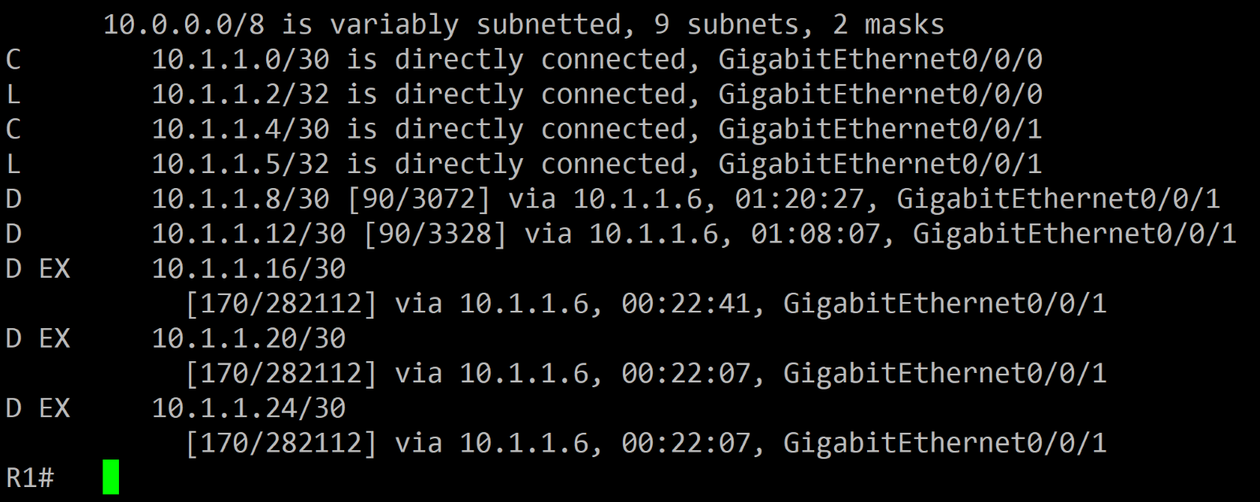

IPV6

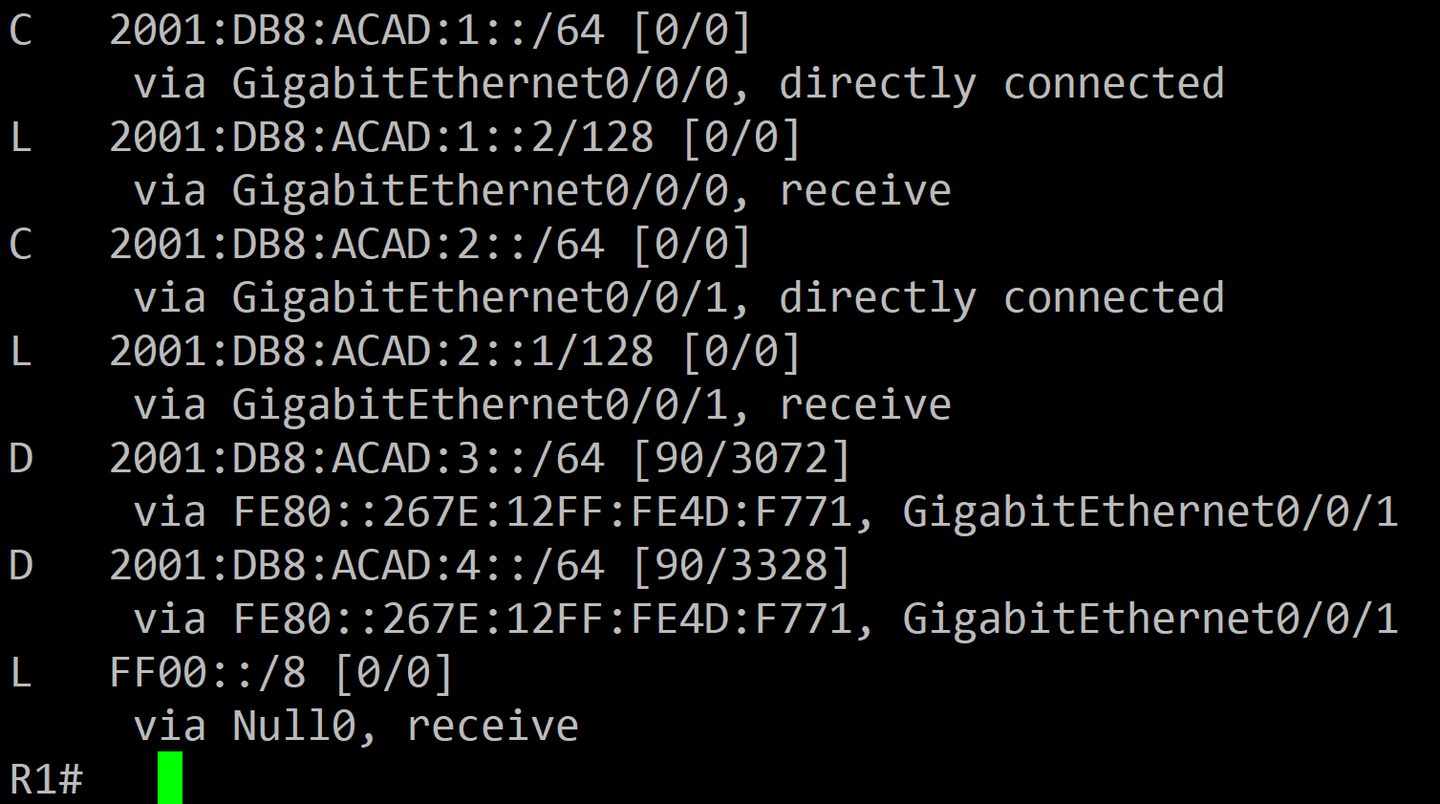

R2

IPV4

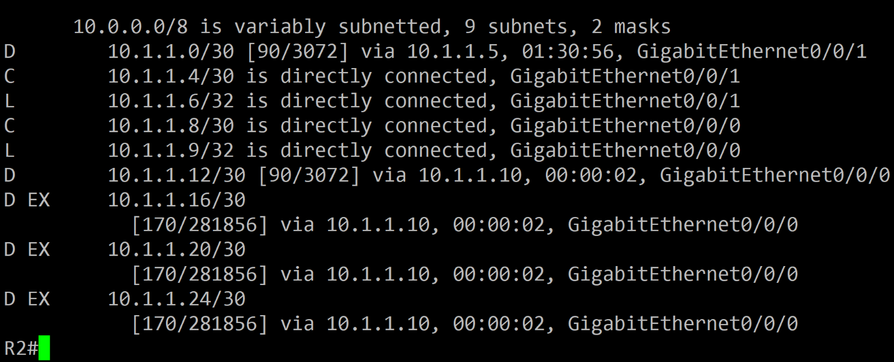

IPV6

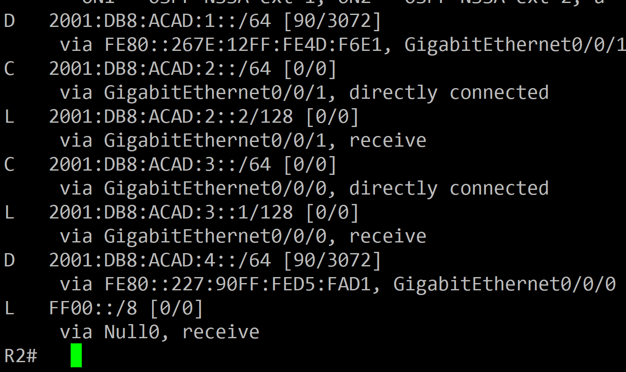

R3

IPV4

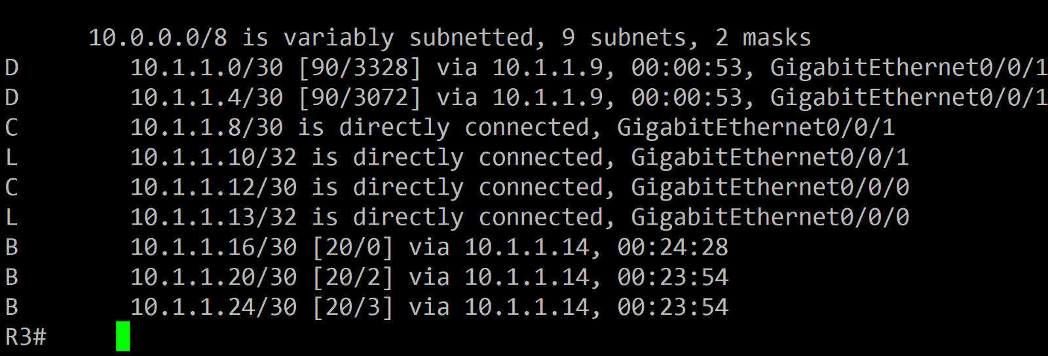

IPV6

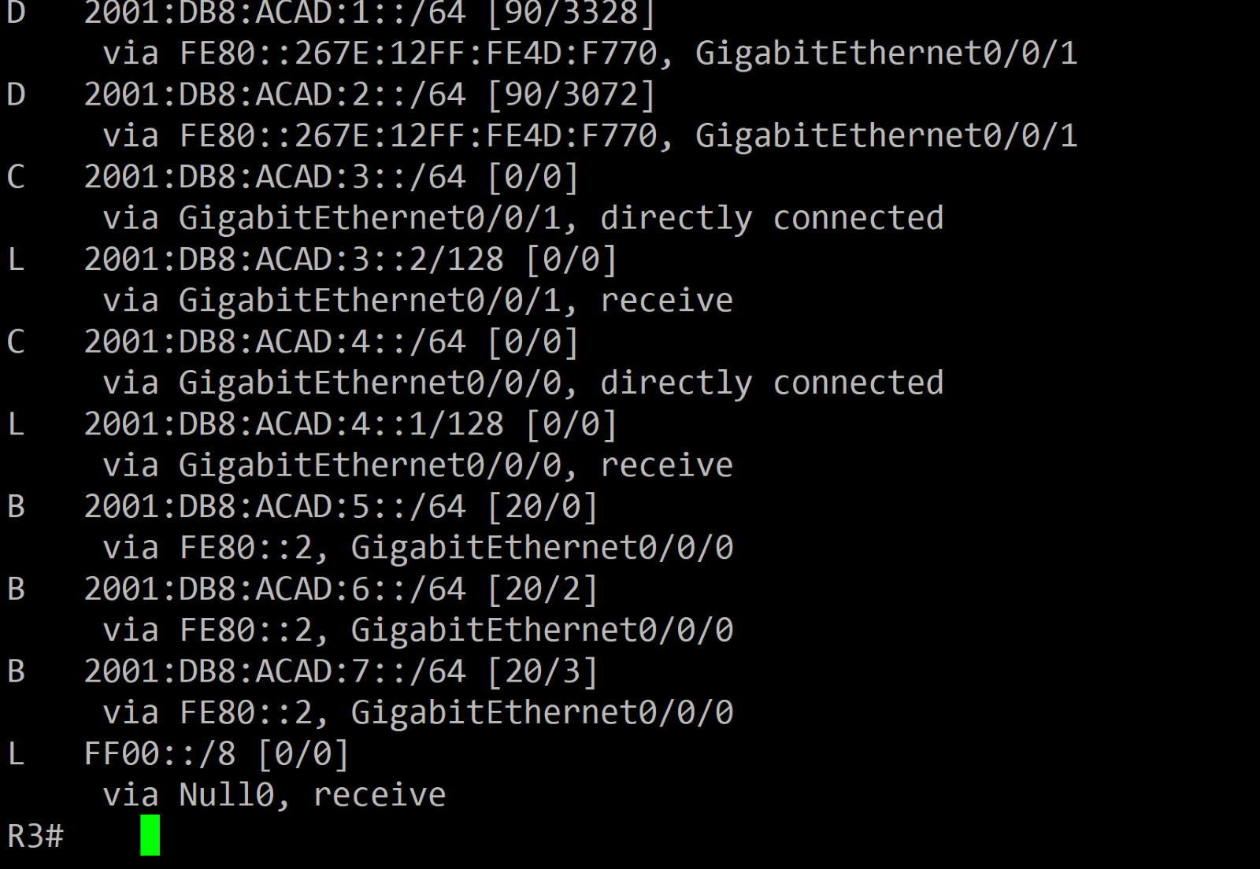

R4

IPV4

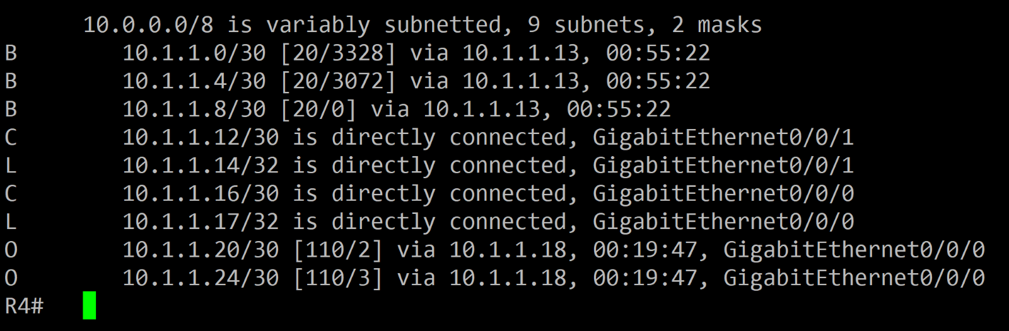

IPV6

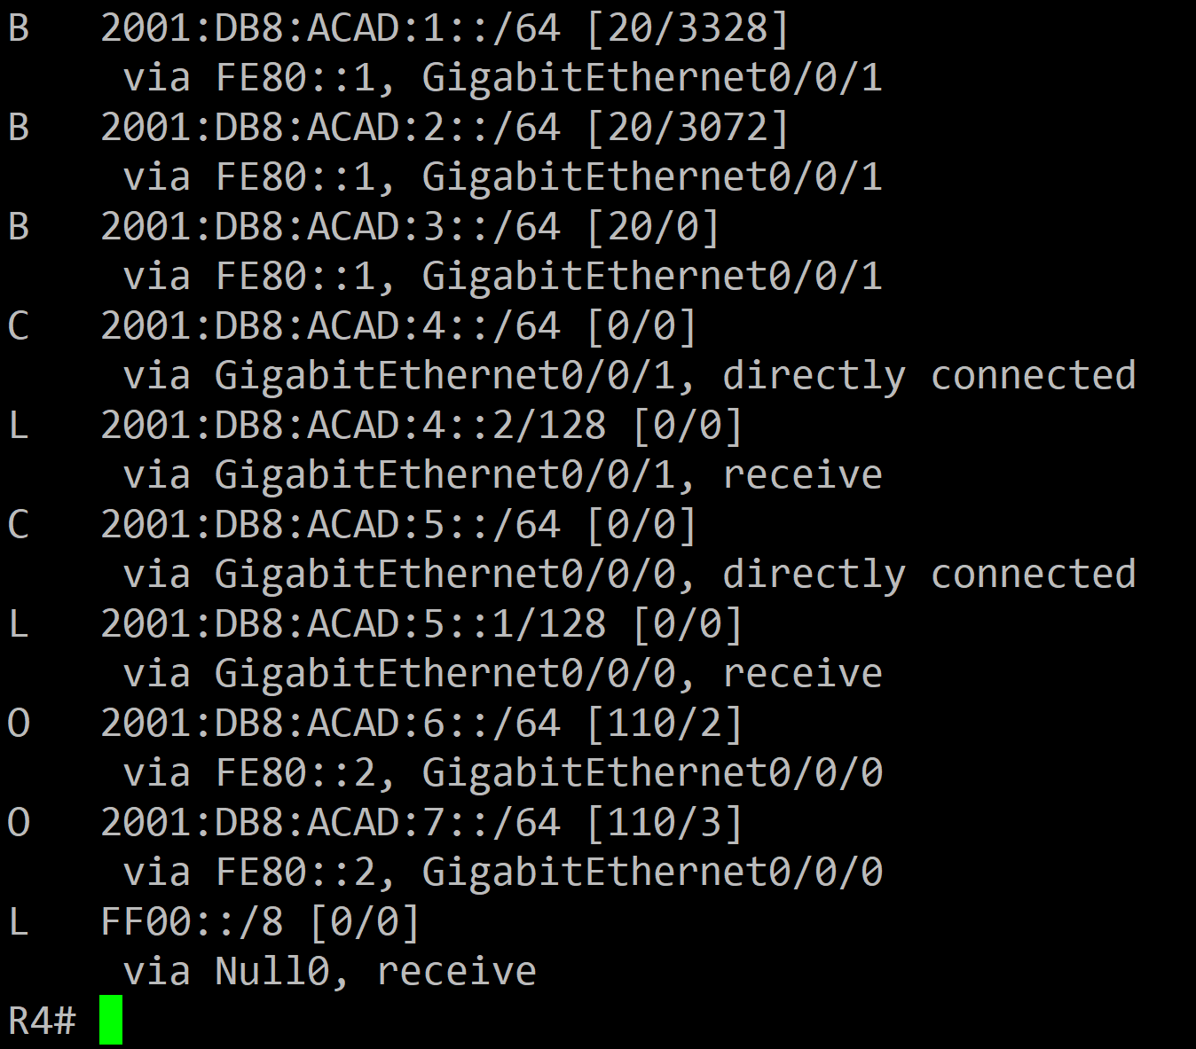

R5

IPV4

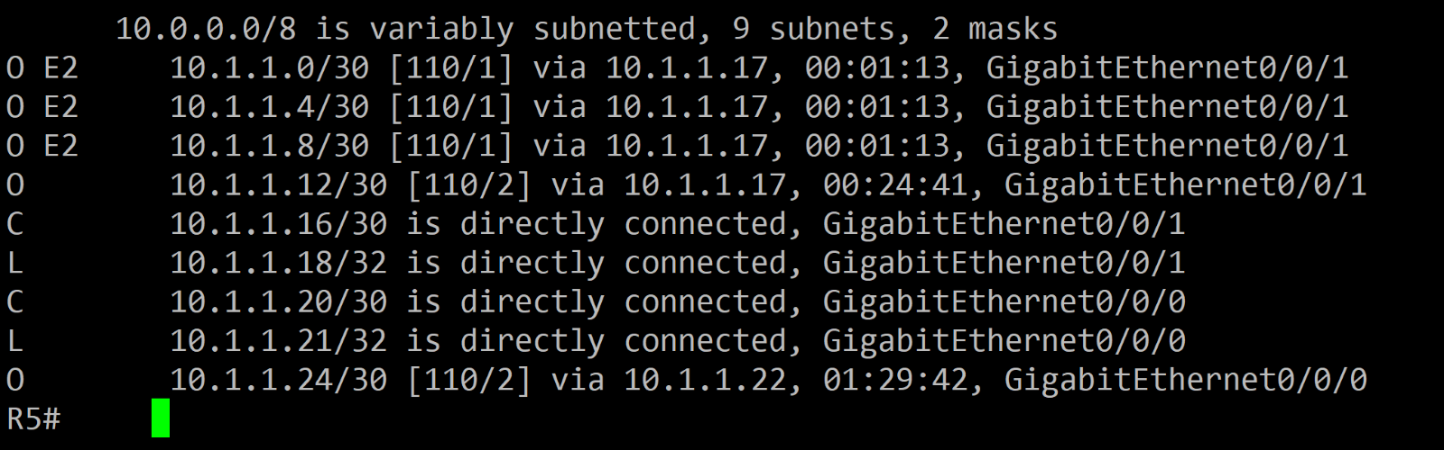

IPV6

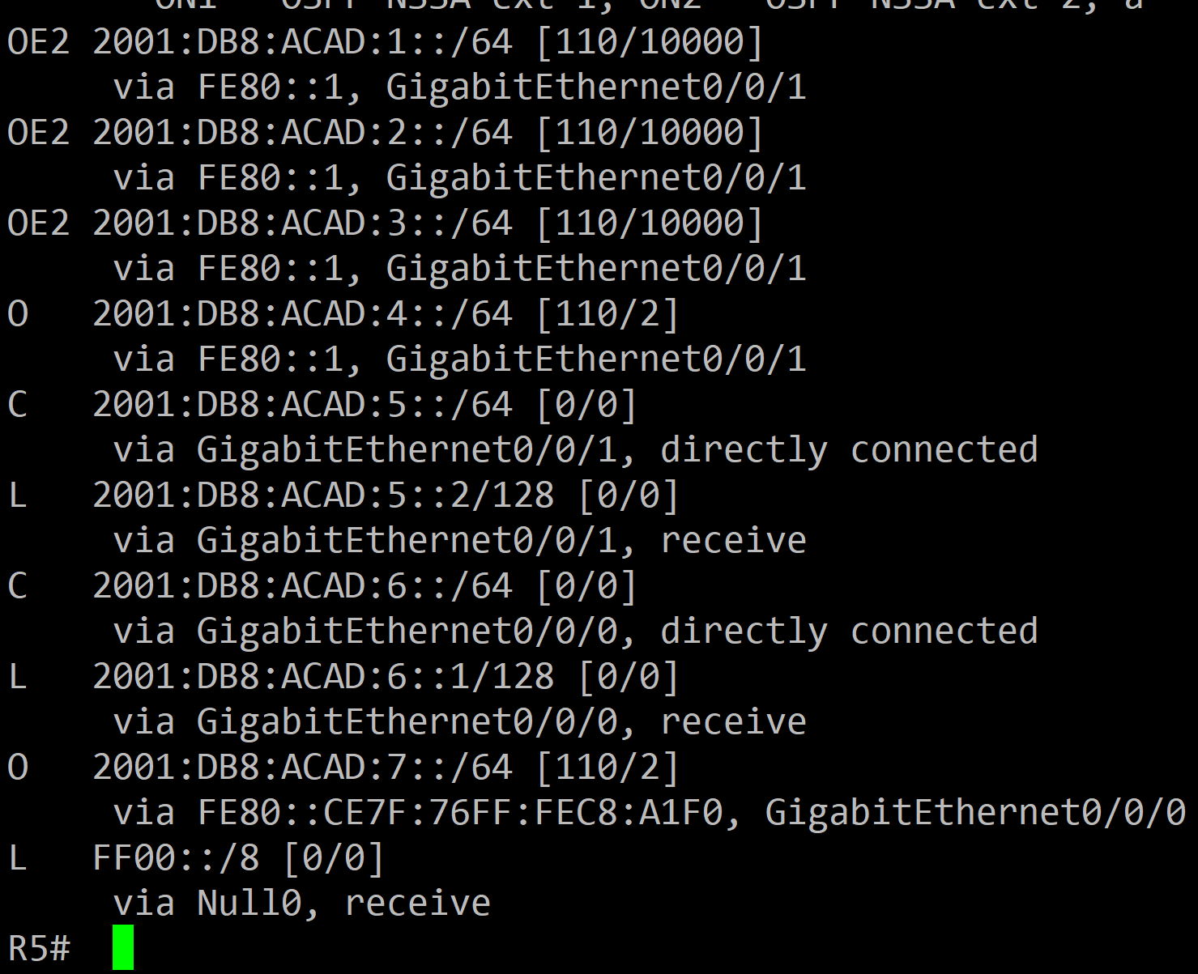

R6

IPV4

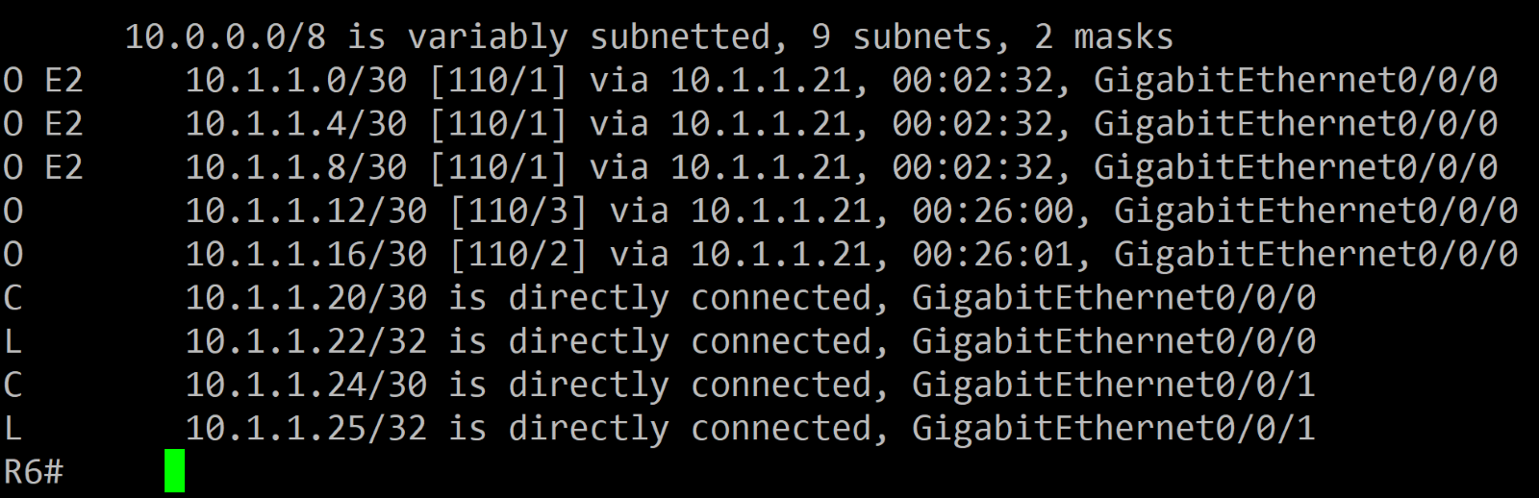

IPV6

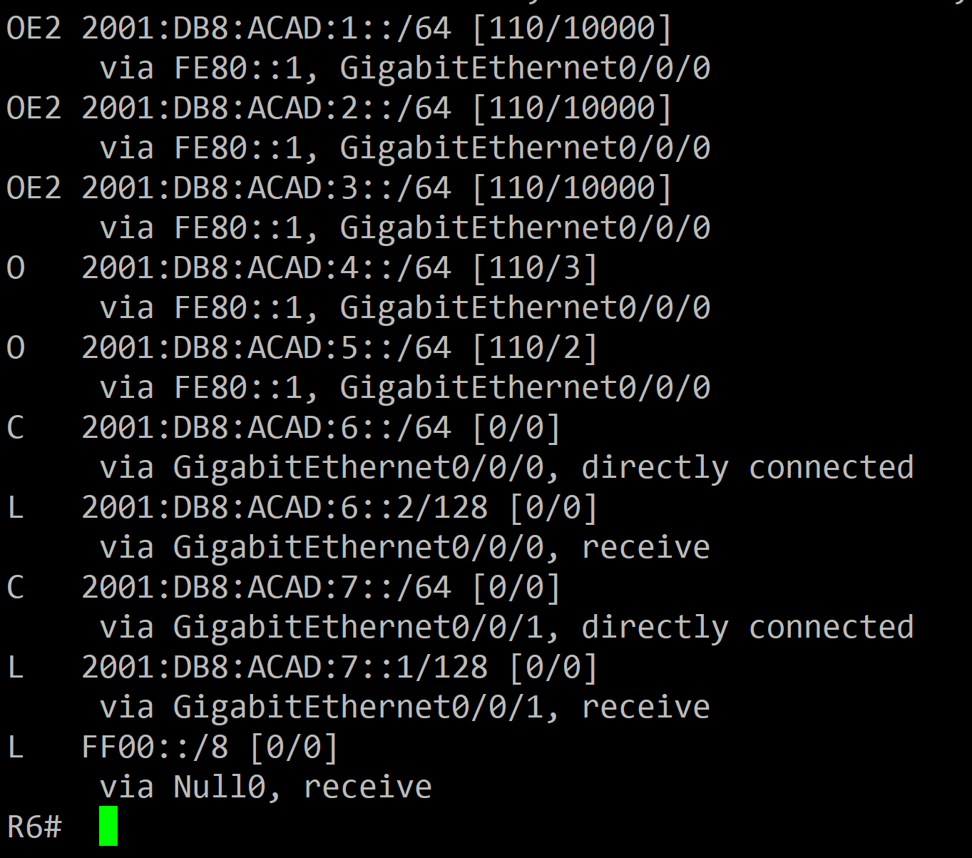

**PROBLEMS I ENCOUNTERED**

I have never set up a lab with three different routing protocols, so I had to research and how to initialize them. Once I had the routing protocols installed and the IPs, I had trouble pinging from R1 to the other end of the network R6. I had found that the connection could not go through the BGP routers, R3 and R4, but they could reach themselves within that network. I had researched my problems and found that I was missing some commands for BGP, and I had fixed most of my connectivity issues. My last problem was that my BGP and OSPF areas would not let IPv6 through. I found out it was because the link local interfaces were bugged, and the solution was to turn off and on the interface.

**CONCLUSION**

In this lab I implemented three different routing protocols, troubleshooted lots of connectivity problems, and learned that many tech problems can be solved with a simple off and on.

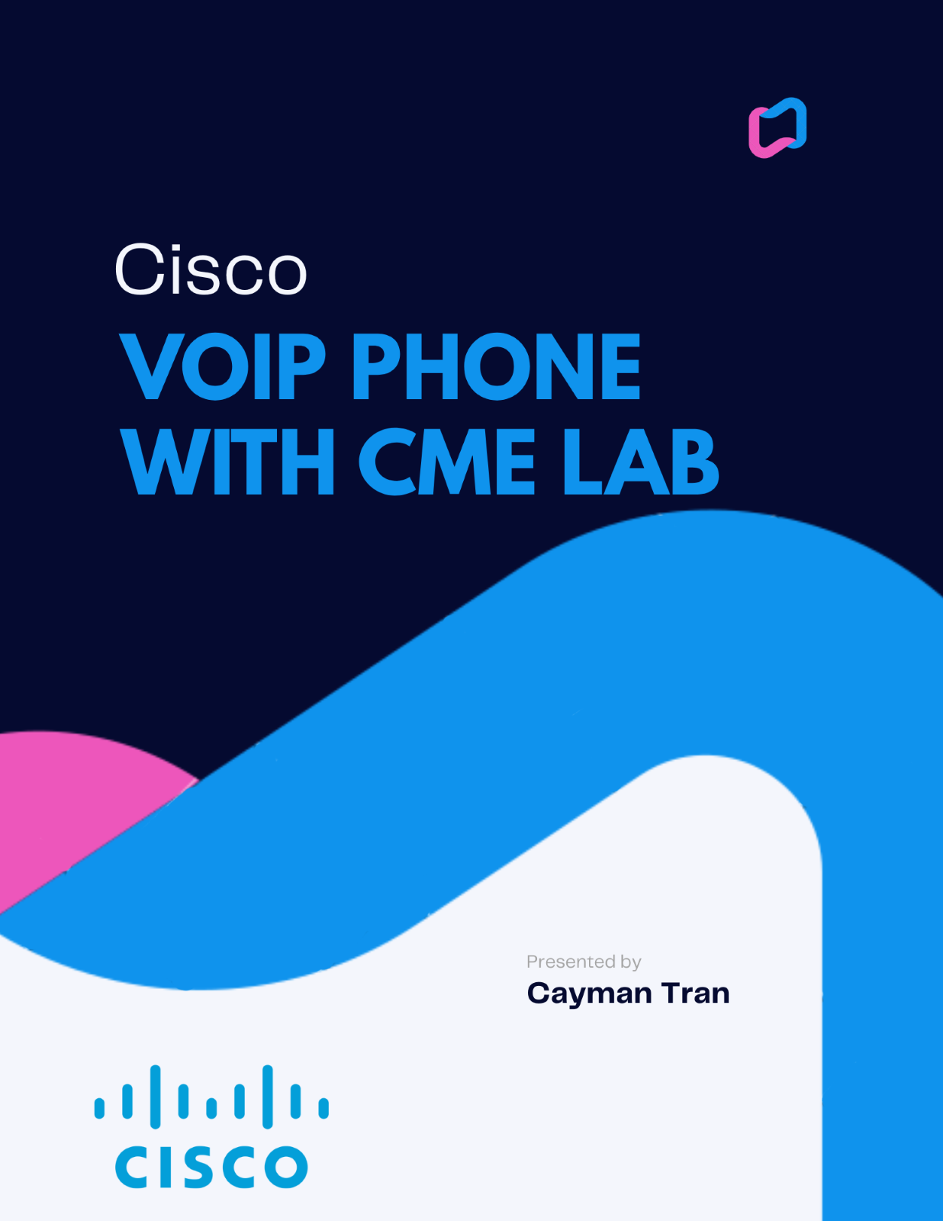

**NETWORK TOPOLOGY**

CME 1 ROUTER (2811) + 1 IP PHONE (7940) + 1 SWITCH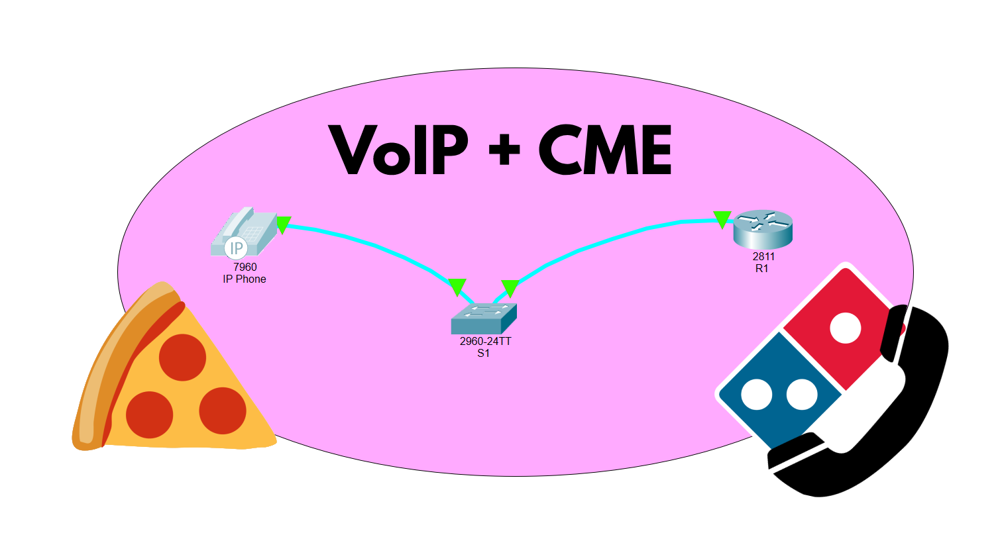

BACKGROUND INFORMATION

Cisco Call Manager Express (CME) is a software solution developed by Cisco Systems that provides IP telephony services on Cisco Integrated Services Routers (ISR) and Cisco 1000 Series Aggregation Services Routers (ASR). It is an integral part of Cisco's IP Communications system, and it can be used to provide unified communications in small and medium-sized businesses and enterprise branch offices.

CME provides a variety of features and functionalities, including call processing, voicemail, interactive voice response, and automatic call distribution. It also supports a variety of endpoint devices, including Cisco IP phones, analog phones, and softphones. In addition, CME can integrate with other Cisco IP Communications solutions, such as Cisco Unity Express for voicemail and Cisco Unified Mobility for single number reach.

CME is based on the Cisco IOS software, which is the operating system used on many Cisco networking devices. This allows administrators to manage CME using the same command-line interface (CLI) and graphical user interface (GUI) as they use to manage other Cisco devices. Additionally, CME can be configured and managed remotely using Cisco Configuration Professional, a web-based tool that simplifies the configuration and management of Cisco IOS devices.

CME is well-suited for small and medium-sized businesses and enterprise branch offices that want to implement a unified communications solution without the need for a dedicated call processing server. It is easy to deploy, configure and manage. Additionally, the integration with other Cisco IP Communications solutions enables it to support more advanced features than other small business IP-PBX solutions.

SUMMARY

In this lab our goal was to implement CME and call a pizza place and order pizza. Our first step was to figure out how to install CME onto our routers and how to configure it. I obtained the cme-full-7.0.0.1 files, then set a TFTP client on my PC. I transferred all the CME files into the routers flash and confirmed it with show flash command. Our next step was to step up VoIP on the router and switch. We did this by configuring IPs on connecting interfaces and creating VLANS for VoIP. We then set up telephony on the router. This allows our IP phone to work on our network and make calls to other IP Phones. We then tested our configuration by setting up another IP Phone on the network and made calls between each other. Our final step to calling outside of our network was to configure commands that would transfer our calls from our router, out of its FXO ports and into and out of our school’s larger network. This allowed us to call the nearest pizza place, Dominos, where we ordered a large pepperoni pizza and a large chicken barbeque pizza.

COMMANDS

Some new commands are:

* tftp-server *(file name)*: Tranfers the files from the tftp server to the router. Our command that we used in our lab to transfer our CME file is below:

copy tftp://*(tftp ip/PC ip)*/ flash:cme-full-7.0.0.1.tar

* ephone *(#)*

device-security-mode *(mode)*

mac-address *(mac-addres): Mac Address of IP Phone*

type (*phone model*): For example 7490

forward-digits (*#*): The number of digits that are forwarded of the intended detonation's Phone #

max-conferences (*#*): The maximum amount of participants in a call. The maximum allowed is 48.

transfer-system full-consult: Allowing transferring calls.

* dial-peer voice (*#*) pots: define the characteristics of a traditional Telephony network connection, POTS = Plain old telephone systems

destination-pattern 91[2-9]..[2-9].....: When inbound call legs are matched, this command uses the calling number (initial or ANI string) to match the incoming call leg to an inbound dial peer.

CONFIGURATIONS

R1 (2811)

hostname R1

boot-start-marker

boot-end-marker

logging message-counter syslog

no aaa new-model

memory-size iomem 10

no network-clock-participate slot 1

dot11 syslog

ip source-route

no ip cef

ip dhcp excluded-address 192.168.10.1 192.168.10.5

ip dhcp excluded-address 192.168.20.1 192.168.20.5

ip dhcp pool VOICE20

network 192.168.20.0 255.255.255.0

default-router 192.168.20.1

option 150 ip 192.168.20.1

no ipv6 cef

multilink bundle-name authenticated

voice-card 0

no dspfarm

voice-card 1

no dspfarm

vtp domain cisco

vtp mode transparent

archive

log config

hidekeys

vlan 2,10,20

vlan 996

name CUSTOMER_NATIVE

interface FastEthernet0/0

ip address dhcp

duplex auto

speed auto

interface FastEthernet0/0.20

encapsulation dot1Q 20

ip address 192.168.20.1 255.255.255.0

interface FastEthernet0/0.50

encapsulation dot1Q 50 native

interface FastEthernet0/1

no ip address

shutdown

duplex auto

speed auto

interface FastEthernet0/0/0

interface FastEthernet0/0/1

interface FastEthernet0/0/2

interface FastEthernet0/0/3

interface Serial0/1/0

no ip address

shutdown

interface Serial0/2/0

no ip address

shutdown

clock rate 2000000

interface Serial0/2/1

no ip address

shutdown

clock rate 2000000

interface Serial0/3/0

no ip address

shutdown

clock rate 2000000

interface Serial0/3/1

no ip address

shutdown

clock rate 2000000

interface Vlan1

no ip address

shutdown

ip forward-protocol nd

ip route 0.0.0.0 0.0.0.0 FastEthernet0/1

no ip http server

no ip http secure-server

ip flow-export version 9

tftp-server P00308000500.sbn

tftp-server P00308000500.loads

tftp-server flash:P00308000500.bin alias P00308000500

tftp-server flash:P00308000500.sb2

control-plane

voice-port 1/0/0

ring number 3

connection plar opx 1010

caller-id enable

voice-port 1/0/1

voice-port 1/0/2

voice-port 1/0/3

voice-port 1/1/0

voice-port 1/1/1

dial-peer voice 82 pots

destination-pattern 9[2-9]..[2-9]......

port 1/0/0

forward-digits 10

dial-peer voice 83 pots

destination-pattern 91[2-9]..[2-9]......

port 1/0/0

forward-digits all

dial-peer voice 81 pots

destination-pattern 9[469]11

port 1/0/0

forward-digits 3

telephony-service

max-ephones 3

max-dn 2

ip source-address 192.167.20.1 port 2000

auto assign 1 to 2

max-conferences 8 gain –6

transfer-system full-consult

create cnf-files version-stamp Jan 01 2002 00:00:00

ephone-dn 1

number 1010

ephone-dn 2

number 1020

ephone 1

device-security-mode none

mac-address 001D.A219.FA62

type 7940

button 1:2

ephone 2

device-security-mode none

mac-address 0015.2B47.6685

type 7960

button 1:1

ephone 3

device-security-mode none

mac-address 001D.A219.F562

type 7940

line con 0

line aux 0

line vty 0 4

login

scheduler allocate 20000 1000

End

S1

hostname S1

boot-start-marker

boot-end-marker

no aaa new-model

system mtu routing 1500

vtp domain CCNP

vtp mode transparent

authentication mac-move permit

ip subnet-zero

spanning-tree mode pvst

spanning-tree etherchannel guard misconfig

spanning-tree extend system-id

vlan internal allocation policy ascending

vlan 10

name DATA

vlan 20

name VOICE

vlan 30

name MGT

vlan 40

name MISC

vlan 50

name NATIVE

vlan 99

name MANAGEMENT

interface FastEthernet0/1

switchport trunk encapsulation dot1q

switchport trunk native vlan 50

switchport mode trunk

interface FastEthernet0/2

switchport mode access

switchport voice vlan 20

spanning-tree portfast

interface FastEthernet0/3

switchport mode access

switchport voice vlan 20

spanning-tree portfast

interface FastEthernet0/4

interface FastEthernet0/5

interface FastEthernet0/6

interface FastEthernet0/7

interface FastEthernet0/8

interface FastEthernet0/9

interface FastEthernet0/10

interface FastEthernet0/11

interface FastEthernet0/12

interface FastEthernet0/13

interface FastEthernet0/14

interface FastEthernet0/15

interface FastEthernet0/16

interface FastEthernet0/17

interface FastEthernet0/18

interface FastEthernet0/19

interface FastEthernet0/20

interface FastEthernet0/21

interface FastEthernet0/22

interface FastEthernet0/23

interface FastEthernet0/24

interface GigabitEthernet0/1

interface GigabitEthernet0/2

interface Vlan1

no ip address

shutdown

ip classless

ip http server

ip sla enable reaction-alerts

line con 0

line vty 0 4

login

line vty 5 15

login

end

**SHOW PIZZA**

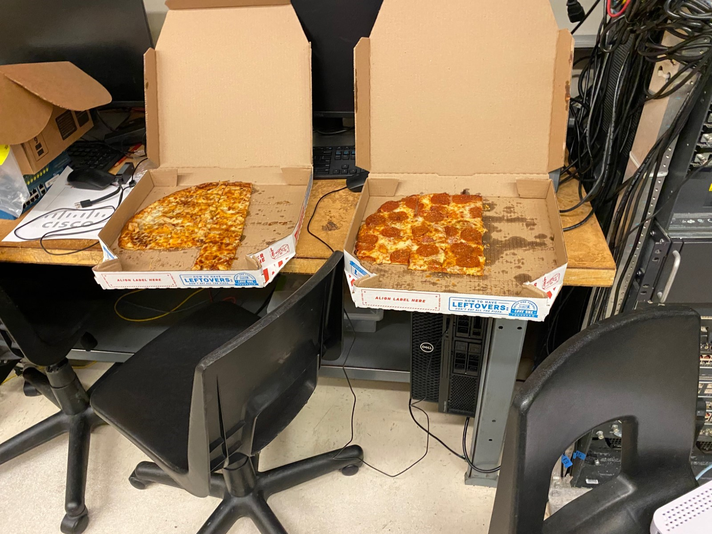

**PROBLEMS I ENCOUNTERED**

During this lab when encountered many problems. Our first problem was figuring out how to use than IP Phone. We researched videos and documents on Cisco Call Manger Express. Once we had plugged our Phone into our network, we configured our switch and router and set up telephony. We could call from phone to phone on our network, but it could not call out. We had obtained information on how to forward calls out of our FXO ports on a router and we finally could make calls outside of our network.

**CONCLUSION**

IP phones are still being used today, and knowing how to set them up is very useful, but tricky. But if you find yourself with a craving for pizza, I suggest using your mobile phone to call for pizza.

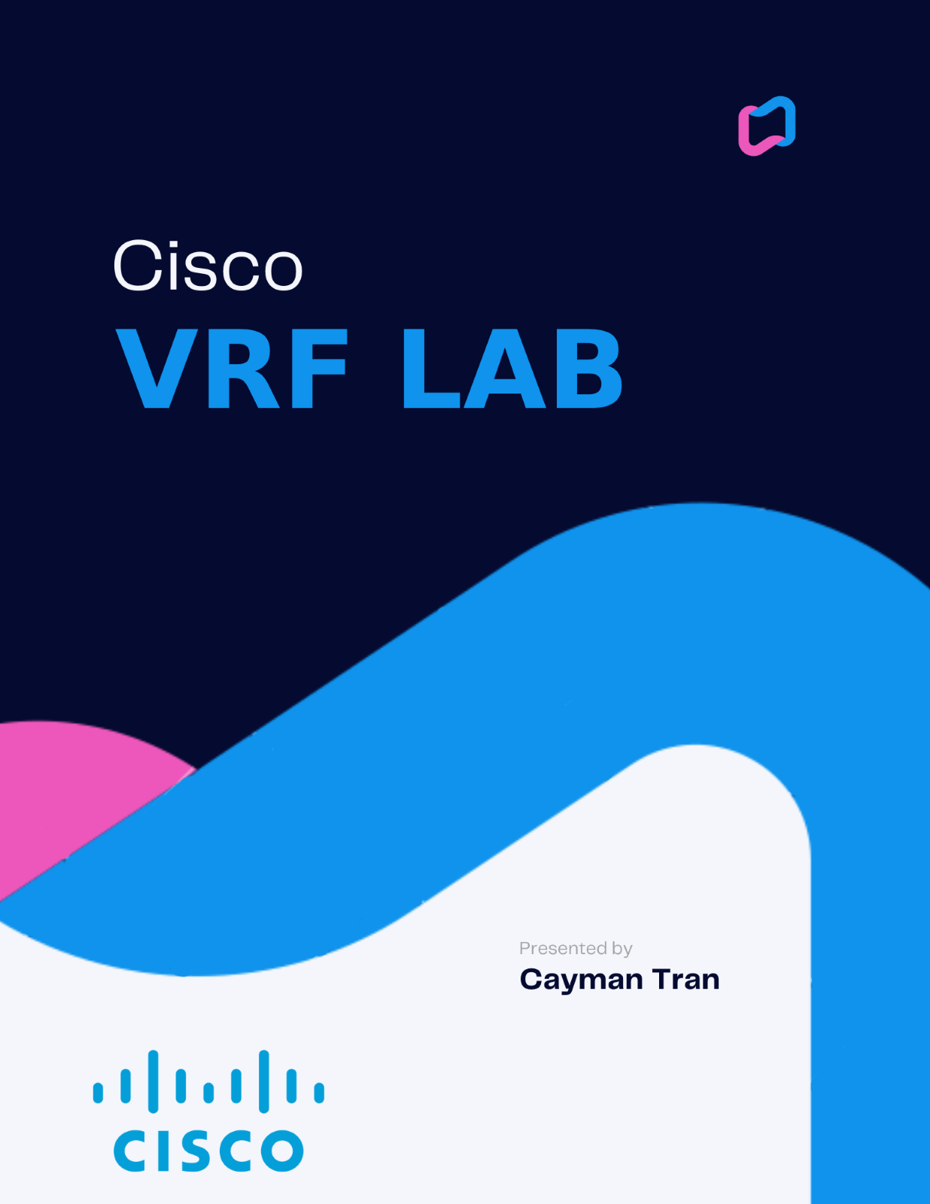

**NETWORK TOPOLOGY**

VRF 4 ROUTERS + 4 PCS

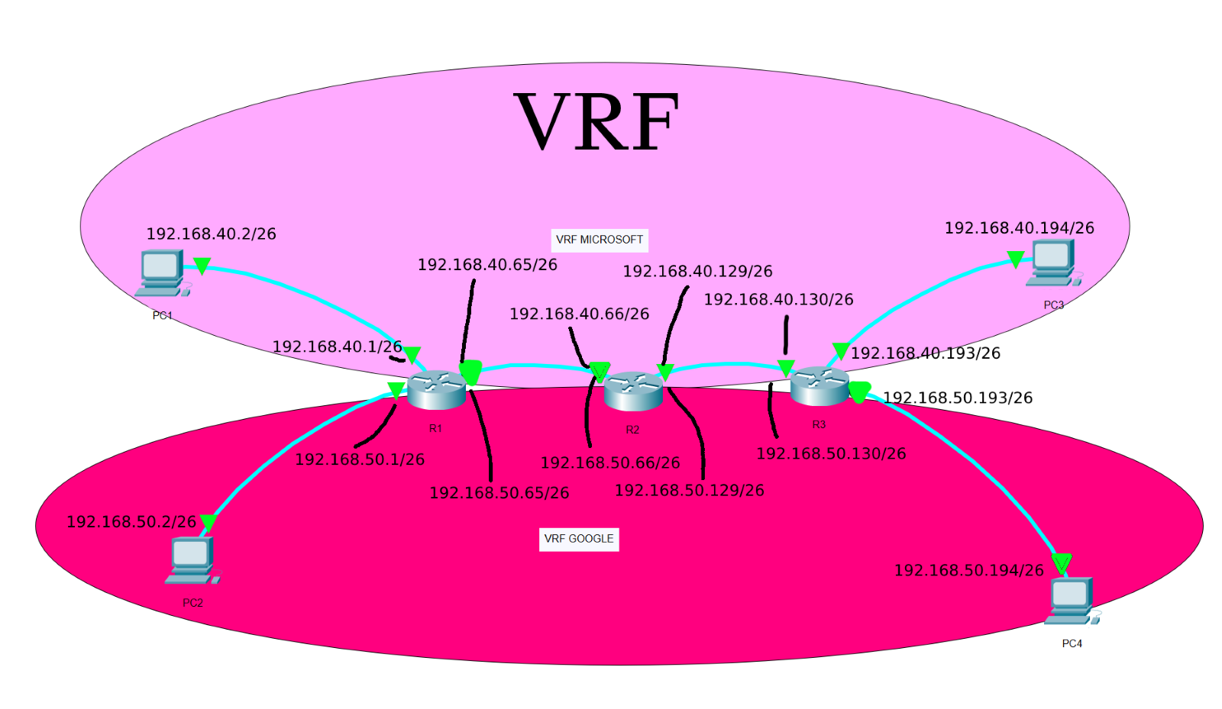

BACKGROUND INFORMATION

VRF (Virtual Routing and Forwarding) is a routing protocol used in networks to provide multiple instances of a routing table within a single physical router. This allows each instance to maintain its own separate routing table and forward packets accordingly, providing network isolation and separation of routes between different VPNs, tenants or customers within a Service Provider network. This leads to improved security, scalability, and reduces the risk of route leaks. VRF operates at the data link layer of the OSI model and is used primarily in large service provider networks, enterprise networks and cloud service providers. VRF technology enables network administrators to create multiple isolated network domains within a single physical network infrastructure, thereby improving network security, management, and scalability.

SUMMARY

In this lab, I implemented two VRFs, MICROSOFT and GOOGLE. This allowed us to only send traffic from PC1 to PC3 without the ability to send to the other VRF. This is similar to how VLANs work. I split router IPs for each different VRF, MICROSOFT being .40 and GOOGLE being .50 in the /26 subnet. I then added the necessary IPs to each host, PC3 and PC4 being loopback on the router, and added the two VRFs on each router. I then added VRF OSPF. I encountered some problems, which after I troubleshooted, the network was fully functional.

COMMANDS

Some new commands are:

*ip vrf (vrf name)*: Enabling a new VRF

*ip vrf fowarding (vrf name)*: Setting a VRF on an interface

*Router ospf (ospf #) vrf (vrf name)*: Setting VRF to run through OSPF

CONFIGURATIONS

R1

version 16.9

service timestamps debug datetime msec

service timestamps log datetime msec

platform qfp utilization monitor load 80

platform punt-keepalive disable-kernel-core

hostname R1

boot-start-marker

boot-end-marker

vrf definition Mgmt-intf

address-family ipv4

exit-address-family

address-family ipv6

exit-address-family

no aaa new-model

ip vrf GOOGLE

ip vrf MICROSOFT

no ip domain lookup

login on-success log

subscriber templating

multilink bundle-name authenticated

crypto pki trustpoint TP-self-signed-2667303412

enrollment selfsigned

subject-name cn=IOS-Self-Signed-Certificate-2667303412

revocation-check none

rsakeypair TP-self-signed-2667303412

license udi pid ISR4321/K9 sn FLM2407011F

no license smart enable

diagnostic bootup level minimal

spanning-tree extend system-id

redundancy

mode none

interface GigabitEthernet0/0/0

no ip address

negotiation auto

no shutdown

interface GigabitEthernet0/0/1.40

encapsulation dot1Q 40

ip vrf forwarding MICROSOFT

ip address 192.168.40.65 255.255.255.192

interface GigabitEthernet0/0/1.50

encapsulation dot1Q 50

ip vrf forwarding GOOGLE

ip address 192.168.50.65 255.255.255.192

interface GigabitEthernet0/0/1

no ip address

negotiation auto

no shutdown

interface GigabitEthernet0/0/0.40

encapsulation dot1Q 40

ip vrf forwarding MICROSOFT

ip address 192.168.40.1 255.255.255.192

negotiation auto

interface GigabitEthernet0/0/0.50

encapsulation dot1Q 50

ip vrf forwarding GOOGLE

ip address 192.168.50.1 255.255.255.192

negotiation auto

router ospf 1 vrf MICROSOFT

network 192.168.40.0 0.0.0.63 area 0

network 192.168.40.65 0.0.0.63 area 0

router ospf 2 vrf GOOGLE

network 192.168.50.0 0.0.0.63 area 0

network 192.168.50.65 0.0.0.63 area 0

ip forward-protocol nd

ip http server

ip http authentication local

ip http secure-server

ip tftp source-interface GigabitEthernet0

control-plane

line con 0

transport input none

stopbits 1

line aux 0

stopbits 1

line vty 0 4

login

end

R2

version 16.9

service timestamps debug datetime msec

service timestamps log datetime msec

platform qfp utilization monitor load 80

platform punt-keepalive disable-kernel-core

hostname R2

boot-start-marker

boot-end-marker

vrf definition Mgmt-intf

address-family ipv4

exit-address-family

address-family ipv6

exit-address-family

no aaa new-model

ip vrf GOOGLE

ip vrf MICROSOFT

no ip domain lookup

login on-success log

subscriber templating

vtp domain cisco

vtp mode transparent

multilink bundle-name authenticated

crypto pki trustpoint TP-self-signed-4288135047

enrollment selfsigned

subject-name cn=IOS-Self-Signed-Certificate-4288135047

revocation-check none

rsakeypair TP-self-signed-4288135047

license udi pid ISR4321/K9 sn FLM2406090M

no license smart enable

diagnostic bootup level minimal

spanning-tree extend system-id

redundancy

mode none

interface GigabitEthernet0/0/0

no ip address

negotiation auto

no shutdown

interface GigabitEthernet0/0/1.40

encapsulation dot1Q 40

ip vrf forwarding MICROSOFT

ip address 192.168.40.129 255.255.255.192

interface GigabitEthernet0/0/1.50

encapsulation dot1Q 50

ip vrf forwarding GOOGLE

ip address 192.168.50.129 255.255.255.192

interface GigabitEthernet0/0/1

no ip address

negotiation auto

no shutdown

interface GigabitEthernet0/0/0.40

encapsulation dot1Q 40

ip vrf forwarding MICROSOFT

ip address 192.168.40.66 255.255.255.192

interface GigabitEthernet0/0/0.50

encapsulation dot1Q 50

ip vrf forwarding GOOGLE

ip address 192.168.50.66 255.255.255.192

interface GigabitEthernet0/1/0

no ip address

shutdown

negotiation auto

interface GigabitEthernet0/1/1

no ip address

shutdown

negotiation auto

interface GigabitEthernet0

vrf forwarding Mgmt-intf

no ip address

shutdown

negotiation auto

router ospf 1 vrf MICROSOFT

network 192.168.40.64 0.0.0.63 area 0

network 192.168.40.128 0.0.0.63 area 0

router ospf 2 vrf GOOGLE

network 192.168.50.64 0.0.0.63 area 0

network 192.168.50.128 0.0.0.63 area 0

ip forward-protocol nd

ip http server

ip http authentication local

ip http secure-server

ip tftp source-interface GigabitEthernet0

control-plane

line con 0

transport input none

stopbits 1

line aux 0

stopbits 1

line vty 0 4

login

end

R3

version 16.9

service timestamps debug datetime msec

service timestamps log datetime msec

platform qfp utilization monitor load 80

no platform punt-keepalive disable-kernel-core

hostname R3

boot-start-marker

boot-end-marker

vrf definition Mgmt-intf

address-family ipv4

exit-address-family

address-family ipv6

exit-address-family

no aaa new-model

ip vrf GOOGLE

ip vrf MICROSOFT

no ip domain lookup

login on-success log

subscriber templating

vtp domain cisco

vtp mode transparent

multilink bundle-name authenticated

crypto pki trustpoint TP-self-signed-859896477

enrollment selfsigned

subject-name cn=IOS-Self-Signed-Certificate-859896477

revocation-check none

rsakeypair TP-self-signed-859896477

license udi pid ISR4321/K9 sn FLM240608PJ

no license smart enable

diagnostic bootup level minimal

spanning-tree extend system-id

redundancy

mode none

interface Loopback0

no ip address

interface Loopback40

ip vrf forwarding MICROSOFT

ip address 192.168.40.194 255.255.255.192

no shutdown

interface Loopback50

ip vrf forwarding GOOGLE

ip address 192.168.50.194 255.255.255.192

no shutdown

interface GigabitEthernet0/0/0

no ip address

negotiation auto

no shutdown

interface GigabitEthernet0/0/1

no ip address

negotiation auto

interface GigabitEthernet0/0/0.40

encapsulation dot1Q 40

ip vrf forwarding MICROSOFT

ip address 192.168.40.130 255.255.255.192

interface GigabitEthernet0/0/0.50

encapsulation dot1Q 50

ip vrf forwarding GOOGLE

ip address 192.168.50.130 255.255.255.192

interface GigabitEthernet0/1/0

no ip address

shutdown

negotiation auto

interface GigabitEthernet0/1/1

no ip address

shutdown

negotiation auto

interface GigabitEthernet0

vrf forwarding Mgmt-intf

no ip address

shutdown

negotiation auto

router ospf 1 vrf MICROSOFT

network 192.168.40.128 0.0.0.63 area 0

network 192.168.40.193 0.0.0.63 area 0

router ospf 2 vrf GOOGLE

network 192.168.50.128 0.0.0.63 area 0

network 192.168.50.193 0.0.0.63 area 0

ip forward-protocol nd

ip http server

ip http authentication local0

ip http secure-server

ip tftp source-interface GigabitEthernet0

control-plane

line con 0

transport input none

stopbits 1

line aux 0

stopbits 1

line vty 0 4

login

end

S1

version 12.2

no service pad

service timestamps debug datetime msec

service timestamps log datetime msec

no service password-encryption

hostname S1

boot-start-marker

boot-end-marker

no aaa new-model

system mtu routing 1500

vtp domain CCNP

vtp mode transparent

crypto pki trustpoint TP-self-signed-1670285312

enrollment selfsigned

subject-name cn=IOS-Self-Signed-Certificate-1670285312

revocation-check none

rsakeypair TP-self-signed-1670285312

spanning-tree mode pvst

spanning-tree extend system-id

vlan internal allocation policy ascending

vlan 2

name data

vlan 3

name voice

vlan 4

name management

vlan 5

name Phoneline

vlan 6

name native

vlan 10

name Trivago

vlan 20

name Data

vlan 30

name Expedia

vlan 40

name GOOGLE

vlan 50

name MICROSOFT

vlan 100

name Voice

vlan 400,707

vlan 996

name CUSTOMER_NATIVE

vlan 999

interface FastEthernet1/0/1

switchport trunk encapsulation dot1q

switchport trunk allowed vlan 40,50

switchport mode trunk

interface FastEthernet1/0/2

interface FastEthernet1/0/3

switchport access vlan 40

switchport mode access

interface FastEthernet1/0/4

switchport access vlan 50

switchport mode access

interface FastEthernet1/0/5

interface FastEthernet1/0/6

interface FastEthernet1/0/7

interface FastEthernet1/0/8

interface FastEthernet1/0/9

interface FastEthernet1/0/10

interface FastEthernet1/0/11

interface FastEthernet1/0/12

interface FastEthernet1/0/13

interface FastEthernet1/0/14

interface FastEthernet1/0/15

interface FastEthernet1/0/16

interface FastEthernet1/0/17

interface FastEthernet1/0/18

interface FastEthernet1/0/19

interface FastEthernet1/0/20

interface FastEthernet1/0/21

interface FastEthernet1/0/22

interface FastEthernet1/0/23

interface FastEthernet1/0/24

interface GigabitEthernet1/0/1

interface GigabitEthernet1/0/2

interface GigabitEthernet1/1/1

interface GigabitEthernet1/1/2

interface Vlan1

no ip address

shutdown

interface Vlan40

ip address 192.168.40.4 255.255.255.192

interface Vlan50

ip address 192.168.50.4 255.255.255.192

ip http server

ip http secure-server

logging esm config

line con 0

line vty 5 15

end

**PINGS**

PC1 To PC4 (Loopback)

C:\Users\user>ping 192.168.40.194

Pinging 192.168.40.194 with 32 bytes of data:

Reply from 192.168.40.194: bytes=32 time=1ms TTL=253

Reply from 192.168.40.194: bytes=32 time=1ms TTL=253

Reply from 192.168.40.194: bytes=32 time=1ms TTL=253

Reply from 192.168.40.194: bytes=32 time=1ms TTL=253

Ping statistics for 192.168.40.194:

Packets: Sent = 4, Received = 4, Lost = 0 (0% loss),

Approximate round trip times in milli-seconds:

Minimum = 1ms, Maximum = 1ms, Average = 1ms

**TRACEROUTES**

PC1 to PC3 (Loopback)

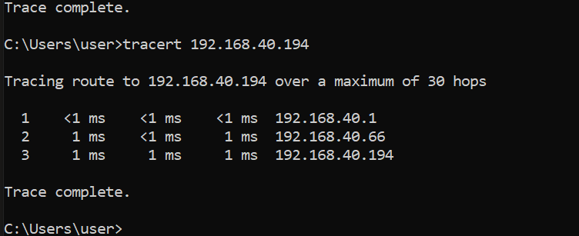

PC2 to PC4 (Loopback)

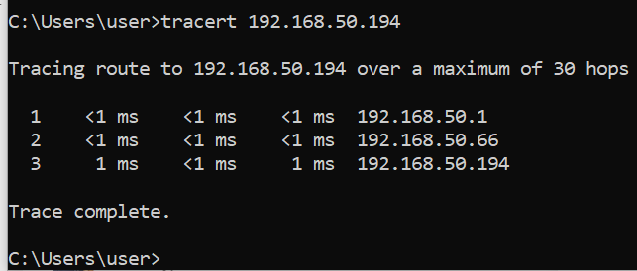

**SHOW IP ROUTE VRF GOOGLE**

R1 – MICROSOFT VRF

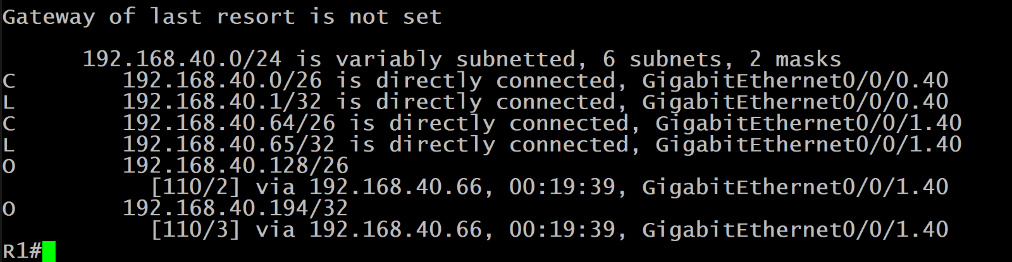

R1 – GOOGLE VRF

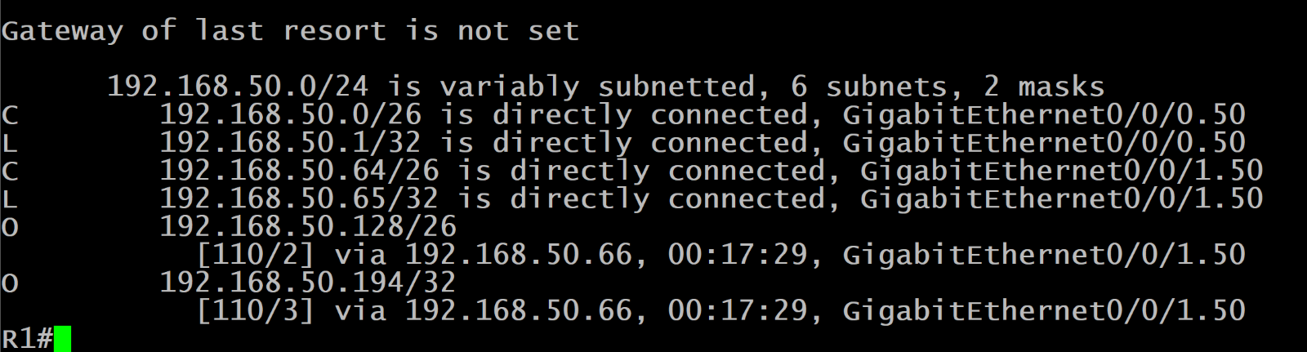

**PROBLEMS I ENCOUNTERED**

The only problem I encountered while setting up this lab was accidentally setting the wrong IP address on the wrong interfaces on Router 1. I swapped set G0/0/0 and G0/0/1 IPs, which meant the PC and the R1 could not communicate due to being in differing subnets. Once I fixed this the network was running,

**CONCLUSION**

In conclusion, VRF is a powerful routing protocol that provides network isolation and separation of routes, improving network security, scalability, and reducing the risk of route leaks. Setting up VRF in a network involves defining VRF instances, creating a unique routing table for each VRF, and configuring routing protocols and interfaces to use the VRF.

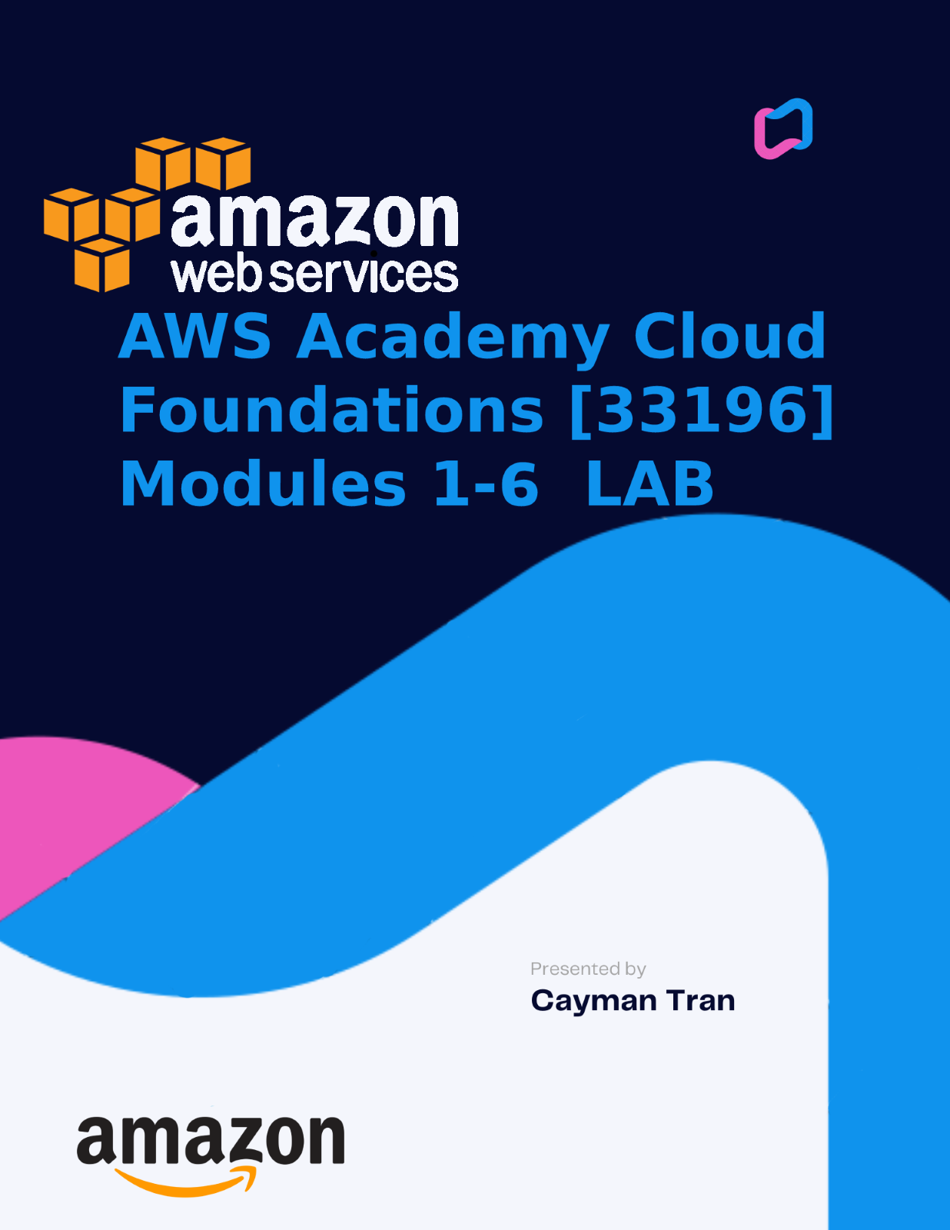

BACKGROUND INFORMATION

AWS Academy Cloud Foundations is a course designed to provide an overview of cloud computing and its various concepts, services, and deployment models. The Cloud Foundations course covers a range of topics, including cloud computing basics, cloud service models, security and compliance in the cloud, and cloud deployment models. I learned about AWS services, such as Amazon Elastic Compute Cloud (EC2), Amazon Simple Storage Service (S3), and Amazon Relational Database Service (RDS). I learned this course through a combination of videos, hands-on exercises, and labs. I have gained a solid understanding of cloud computing and its benefits, as well as the skills needed to deploy and manage cloud-based solutions using AWS services.

Module 1: Cloud Computing Basics

* Introduction to cloud computing
* History and evolution of cloud computing
* Cloud service models (IaaS, PaaS, SaaS)
* Cloud deployment models (public, private, hybrid)

Module 2: AWS Cost Management

* AWS pricing models
* Cost optimization strategies
* AWS Total Cost of Ownership (TCO) Calculator
* AWS Cost Explorer

Module 3: AWS Global Infrastructure

* Overview of AWS regions and availability zones
* AWS global infrastructure and network
* AWS services and their availability across regions
* Choosing the right region for your workload

Module 4: AWS Cloud Security

* Security in the cloud
* AWS Shared Responsibility Model
* Identity and Access Management (IAM)
* Compliance frameworks and AWS compliance

Module 5: Networking and Content Delivery

* Introduction to Amazon Virtual Private Cloud (VPC)
* VPC components and subnets
* Network Access Control Lists (ACLs) and Security Groups
* Amazon Route 53 and DNS management
* Amazon CloudFront and content delivery networks (CDNs)

Module 6: Computing in the Cloud

* Overview of Amazon Elastic Compute Cloud (EC2)
* EC2 instance types, AMIs, and security groups
* Elastic Load Balancing (ELB)
* Auto Scaling and Amazon CloudWatch

# **Lab 1: Introduction to AWS IAM**

Summary:

This lab will demonstrate:

* Exploring pre-created **IAM Users and Groups**
* Inspecting **IAM policies** as applied to the pre-created groups
* Following a **real-world scenario**, adding users to groups with specific capabilities enabled
* Locating and using the **IAM sign-in URL**
* **Experimenting** with the effects of policies on service access

**AWS Identity and Access Management**

AWS Identity and Access Management (IAM) can be used to:

* **Manage IAM Users and their access:** You can create Users and assign them individual security credentials (access keys, passwords, and multi-factor authentication devices). You can manage permissions to control which operations a User can perform.
* **Manage IAM Roles and their permissions:** An IAM Role is similar to a User, in that it is an AWS identity with permission policies that determine what the identity can and cannot do in AWS. However, instead of being uniquely associated with one person, a Role is intended to be *assumable* by anyone who needs it.
* **Manage federated users and their permissions:** You can enable *identity federation* to allow existing users in your enterprise to access the AWS Management Console, to call AWS APIs and to access resources, without the need to create an IAM User for each identity.

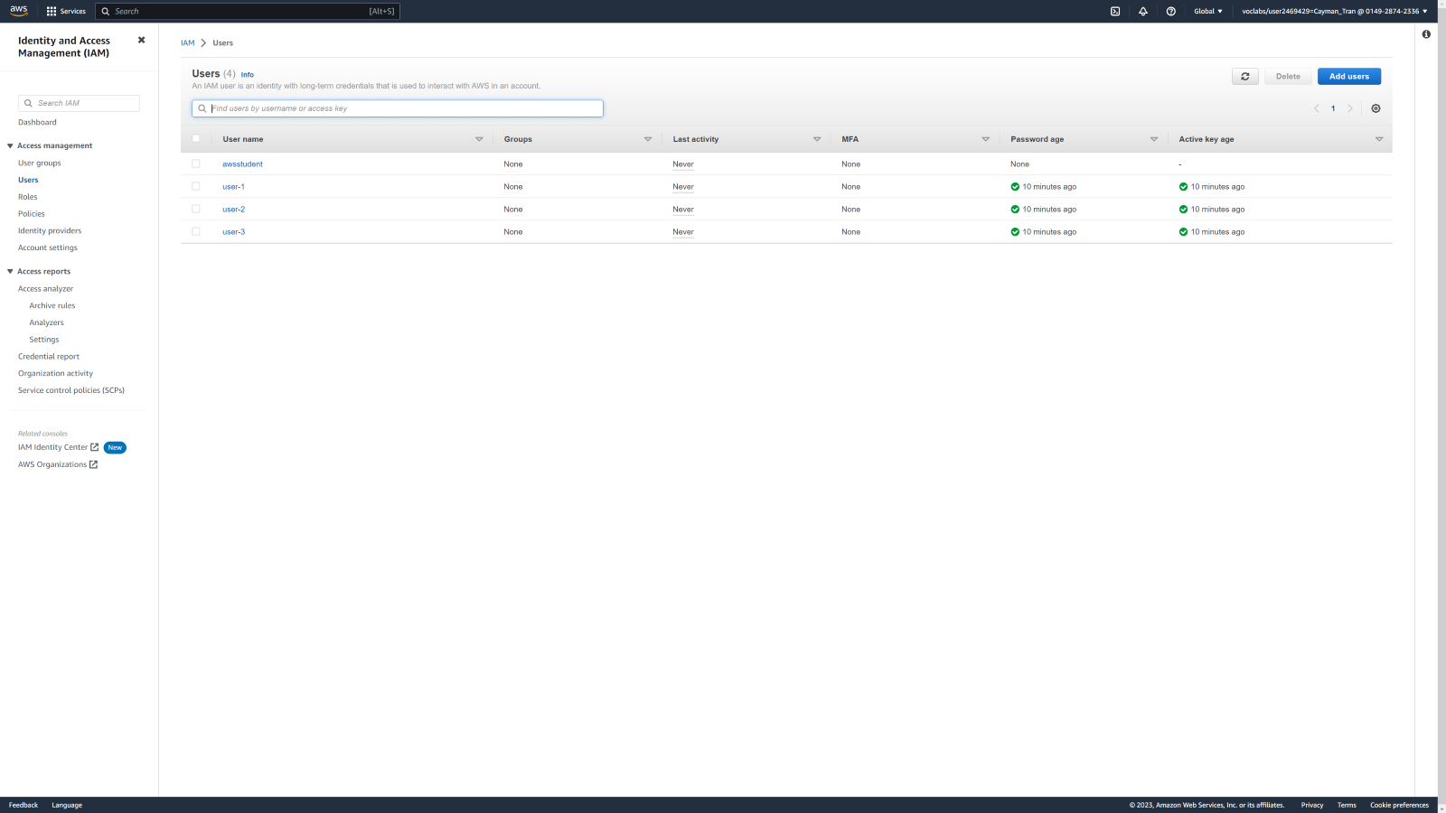

Opening AWS and looking through users in IAM.

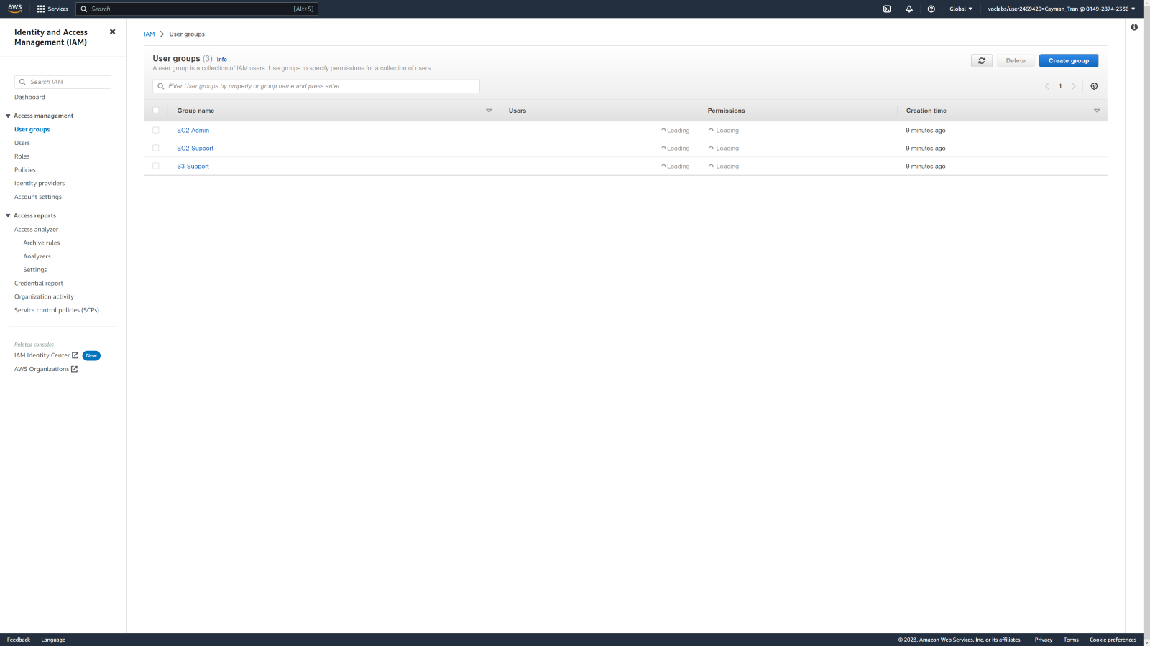

Here I investigated user groups.

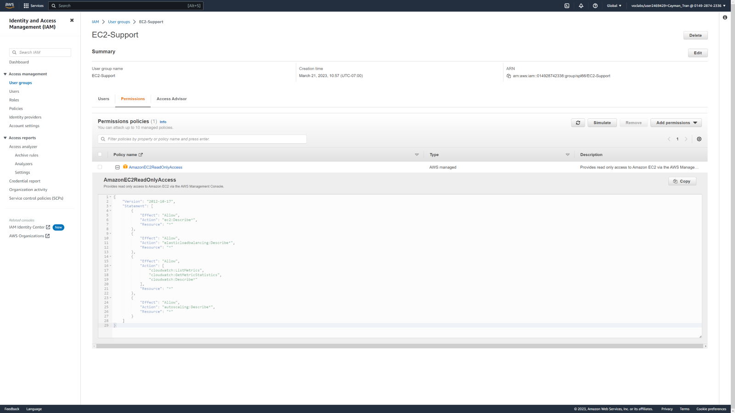

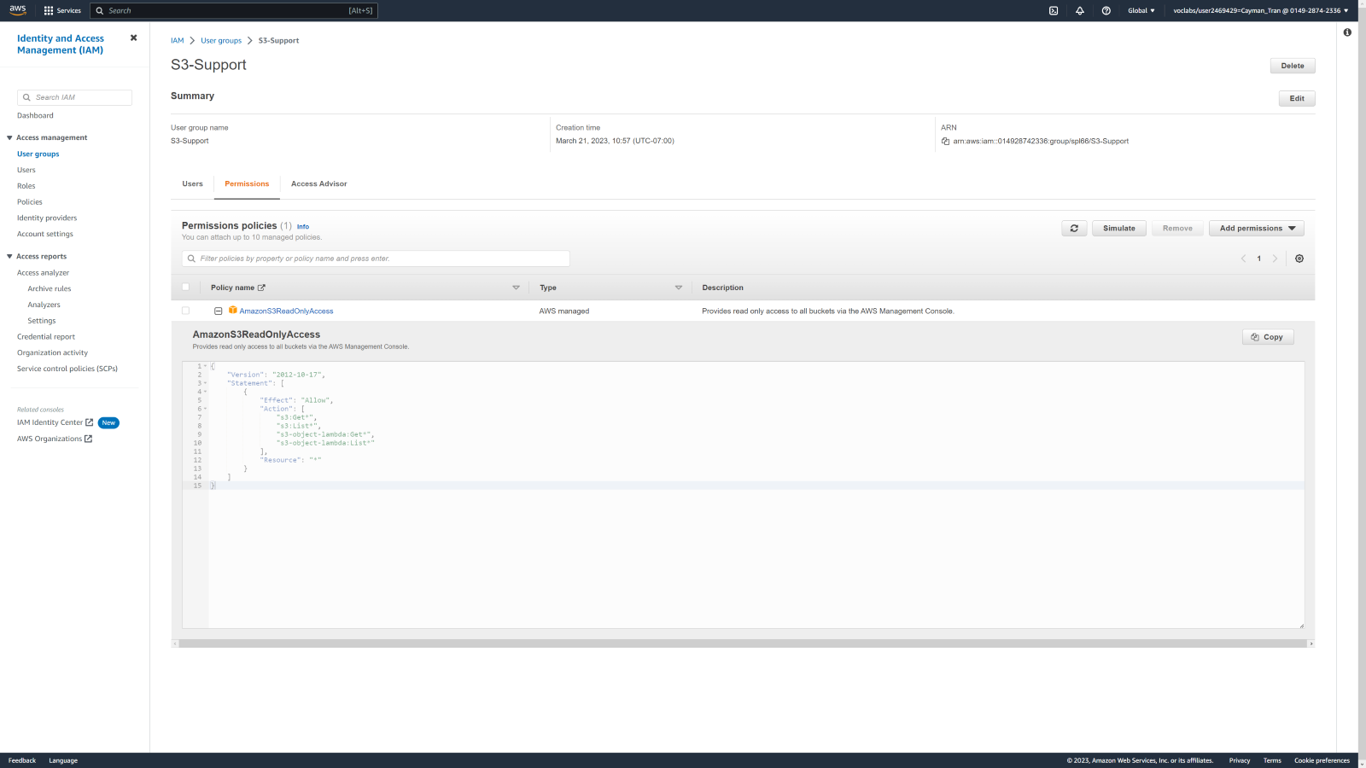

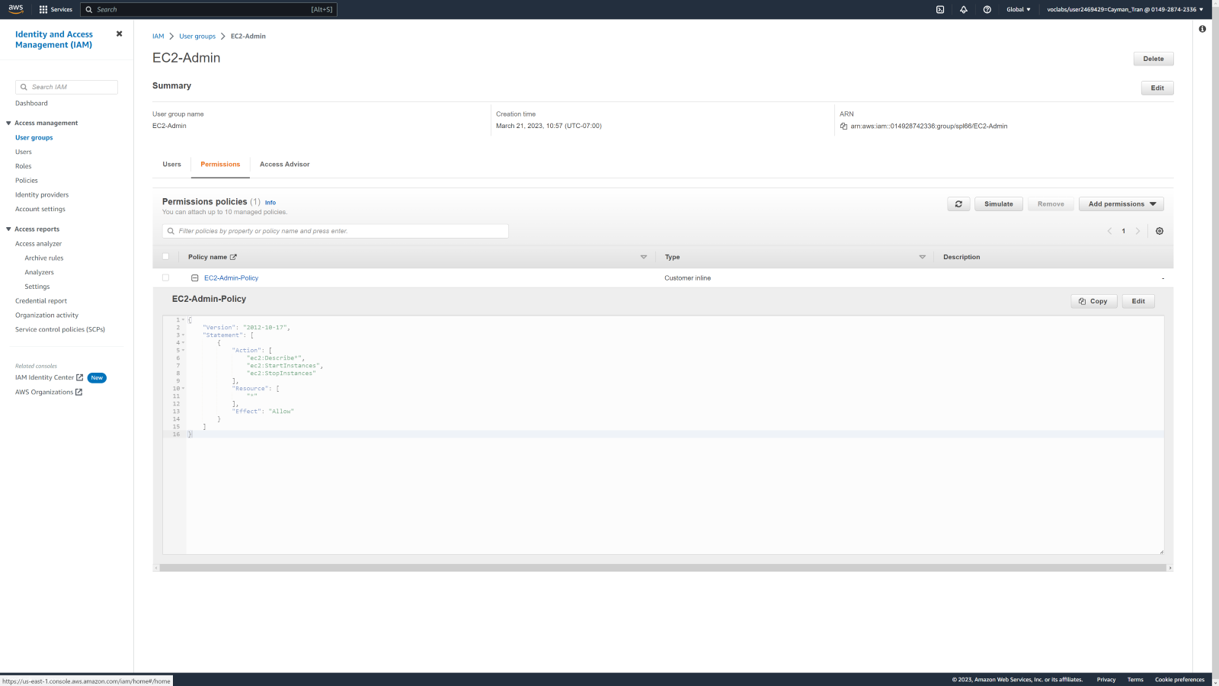

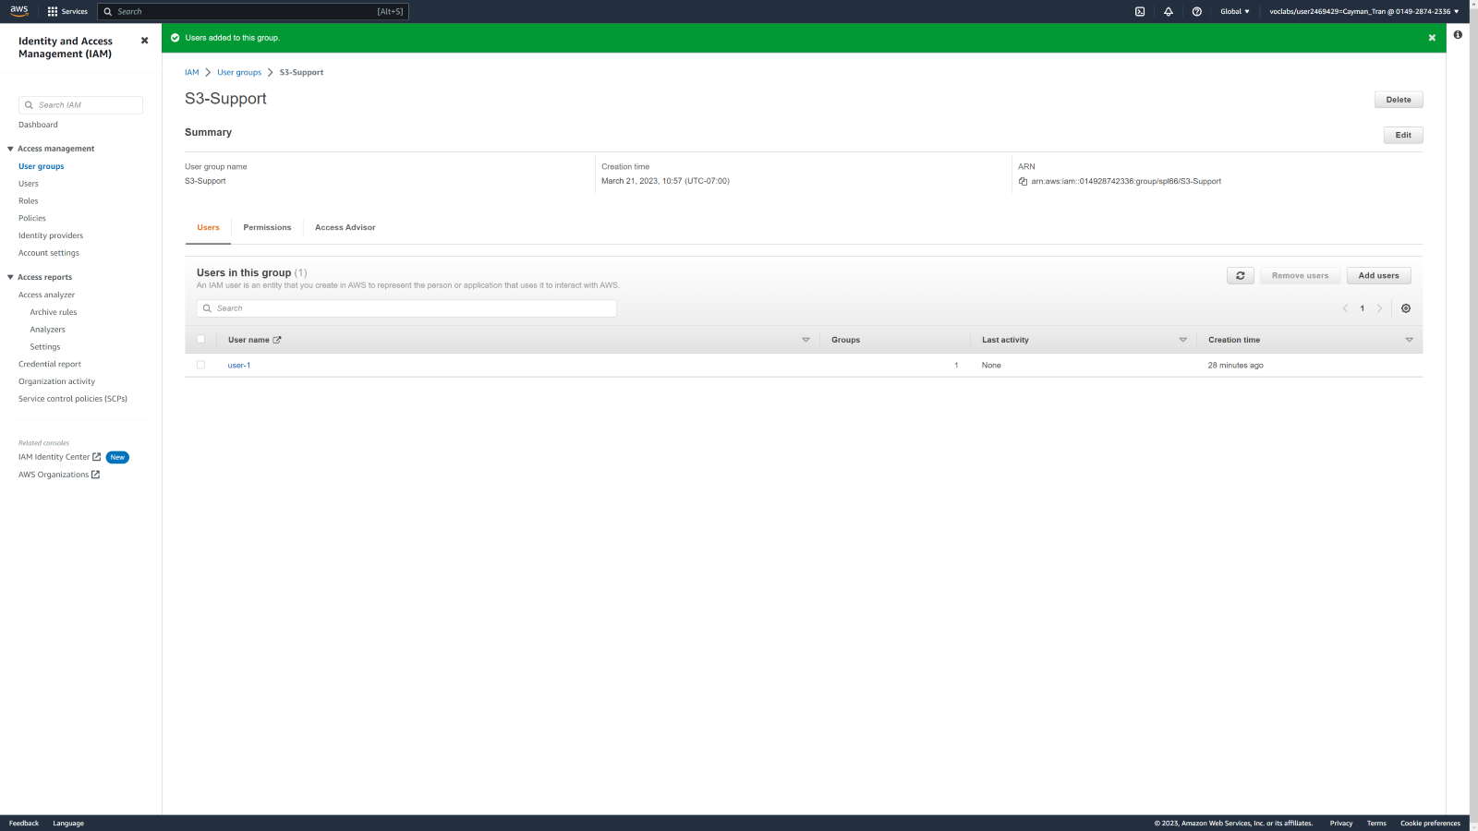

Viewing policy details for groups.

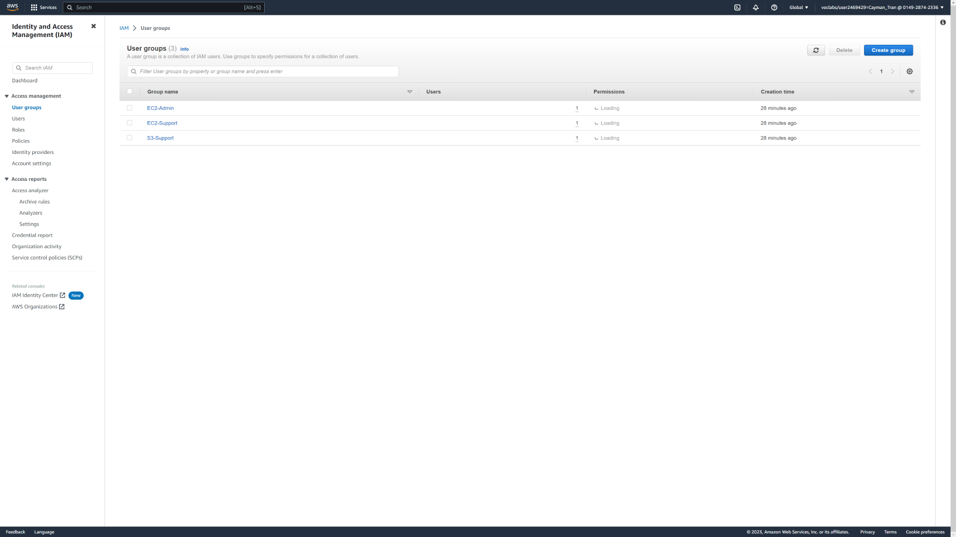

I added user-1 to the S3-Support group. 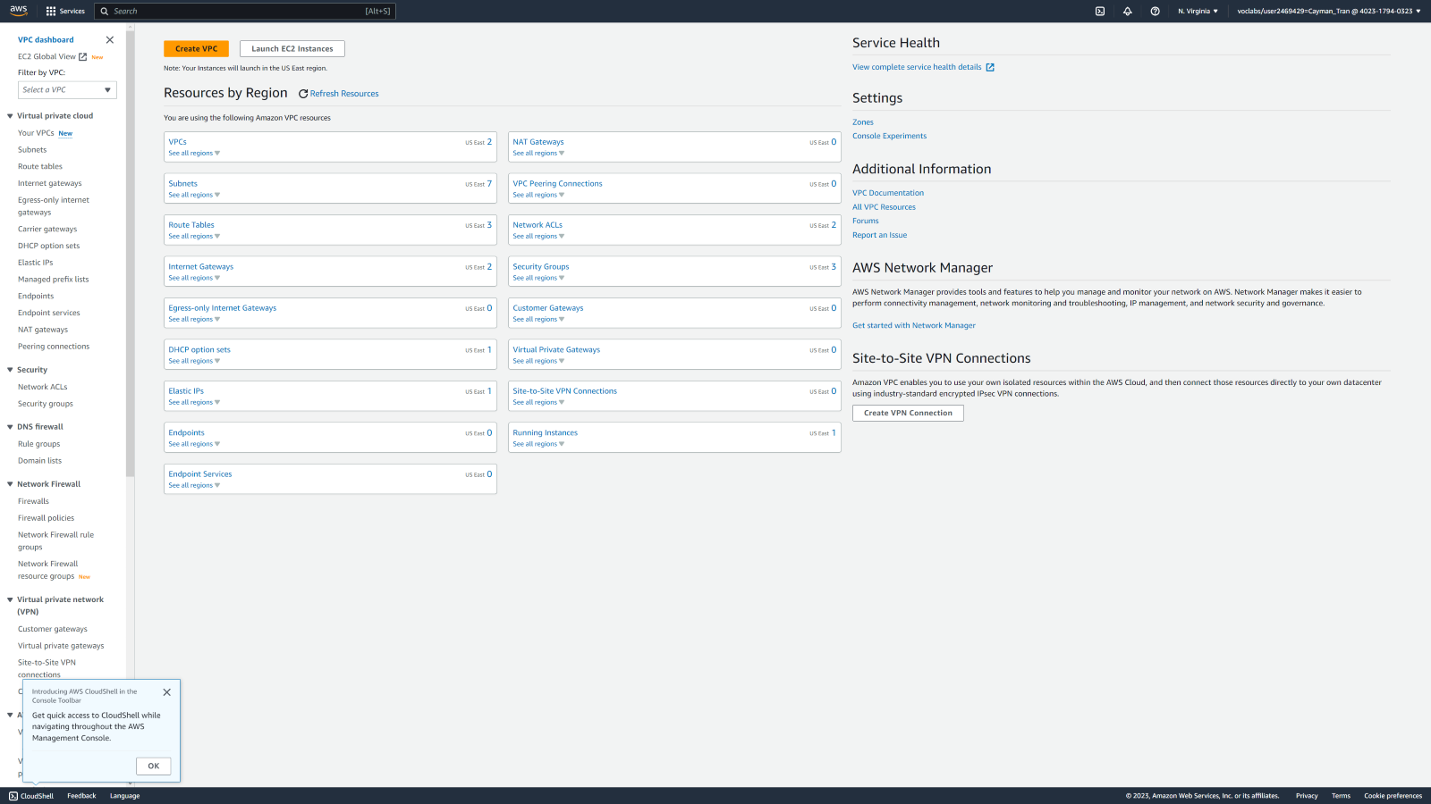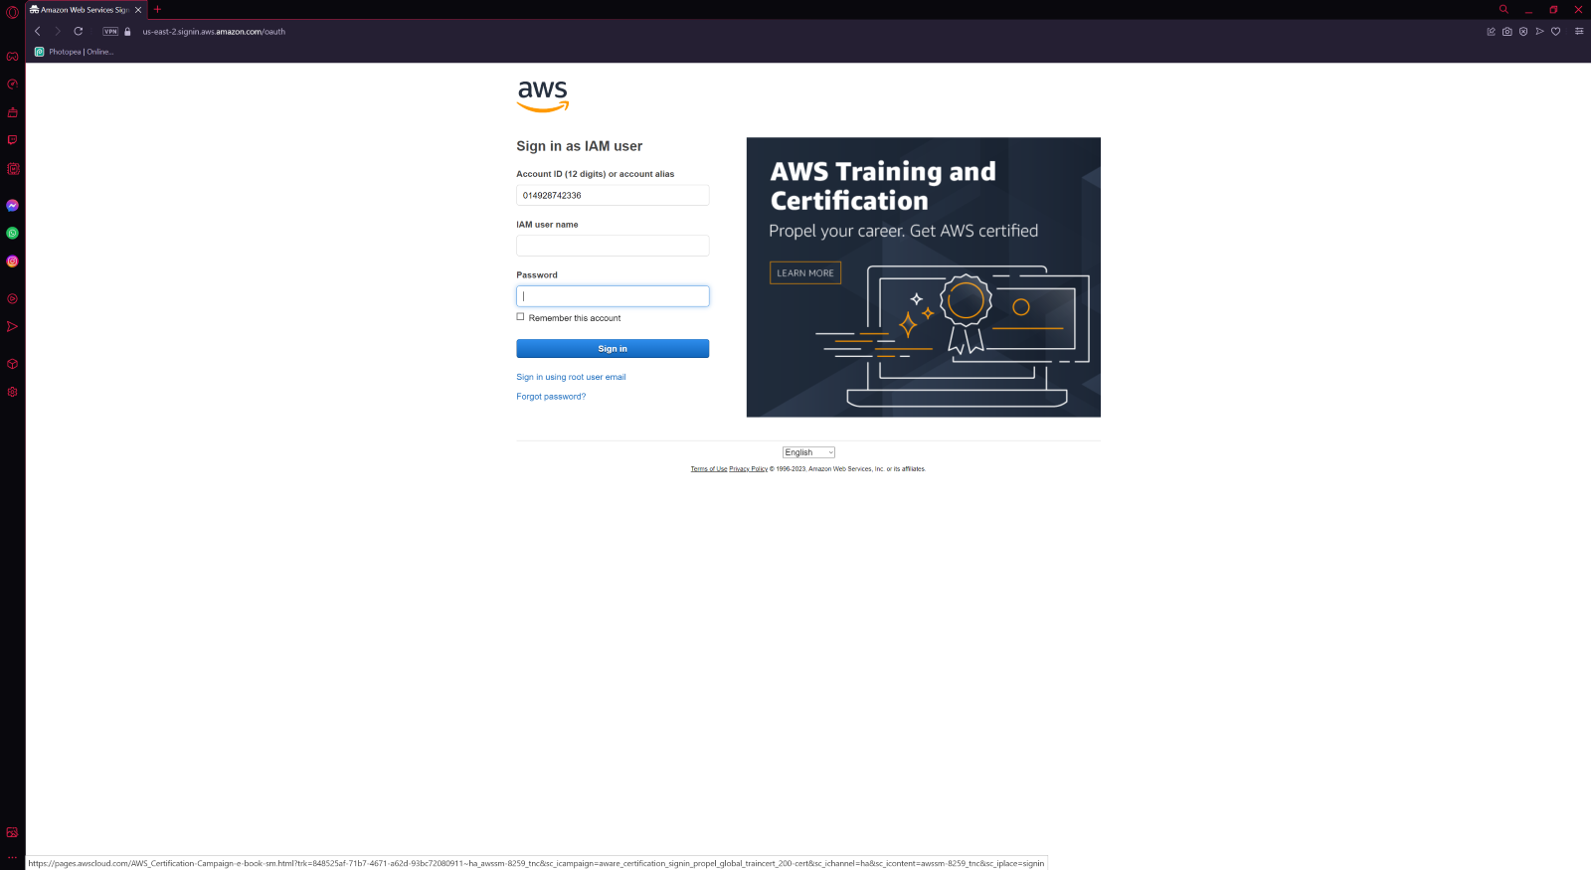

For Task 3, I signed into the users to test them out.

# **Lab 2: Build your VPC and Launch a Web Server**

Summary:

In this lab, you will use Amazon Virtual Private Cloud (VPC) to create your own VPC and add additional components to produce a customized network. You will also create a security group. You will then configure and customize an EC2 instance to run a web server and you will launch the EC2 instance to run in a subnet in the VPC.

**Amazon Virtual Private Cloud (Amazon VPC)** enables you to launch Amazon Web Services (AWS) resources into a virtual network that you defined. This virtual network closely resembles a traditional network that you would operate in your own data center, with the benefits of using the scalable infrastructure of AWS. You can create a VPC that spans multiple Availability Zones.

  
I opened the AWS Management Console and searched for "VPC" in the search box. Then I clicked on the VPC option to open the VPC console.

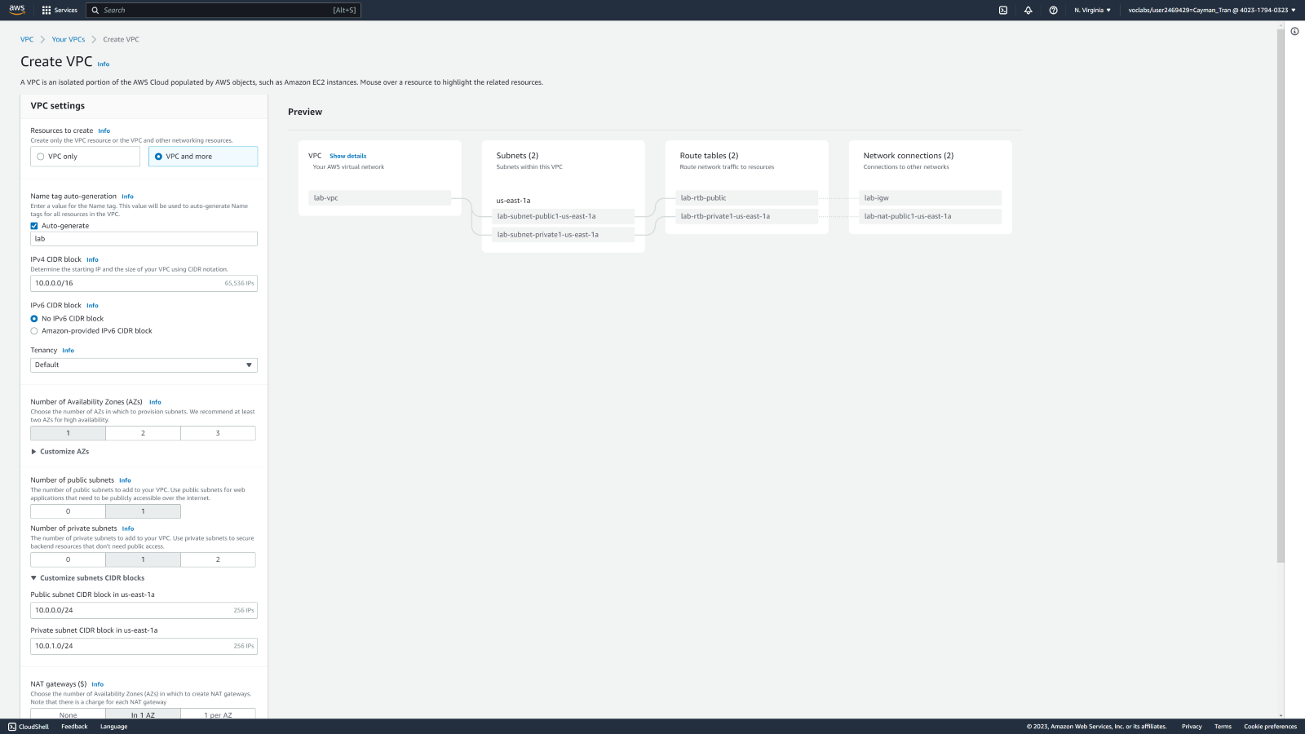

I configured the VPC settings following instructions.

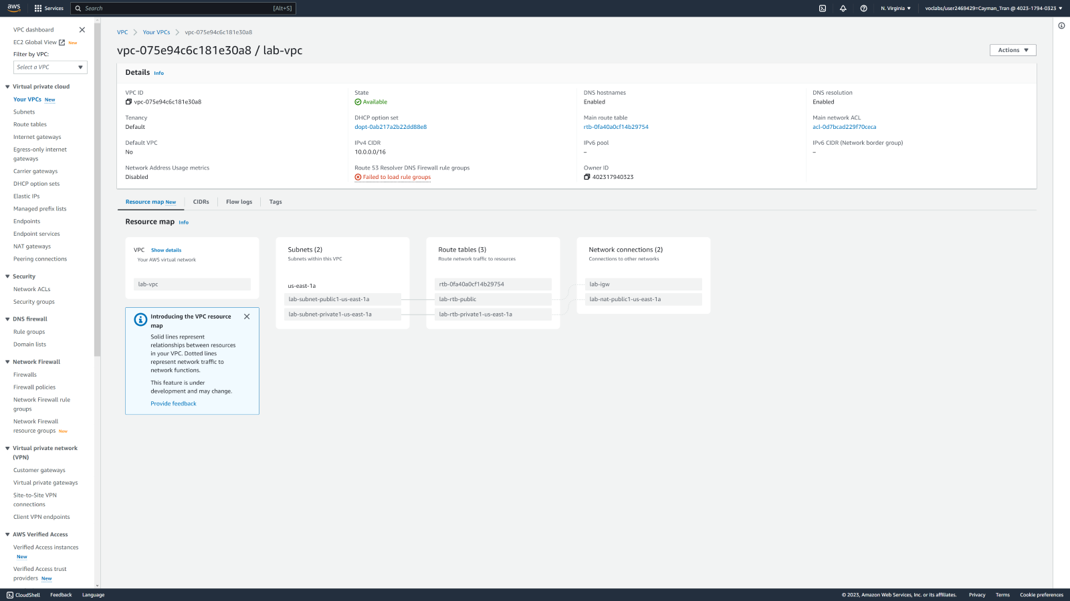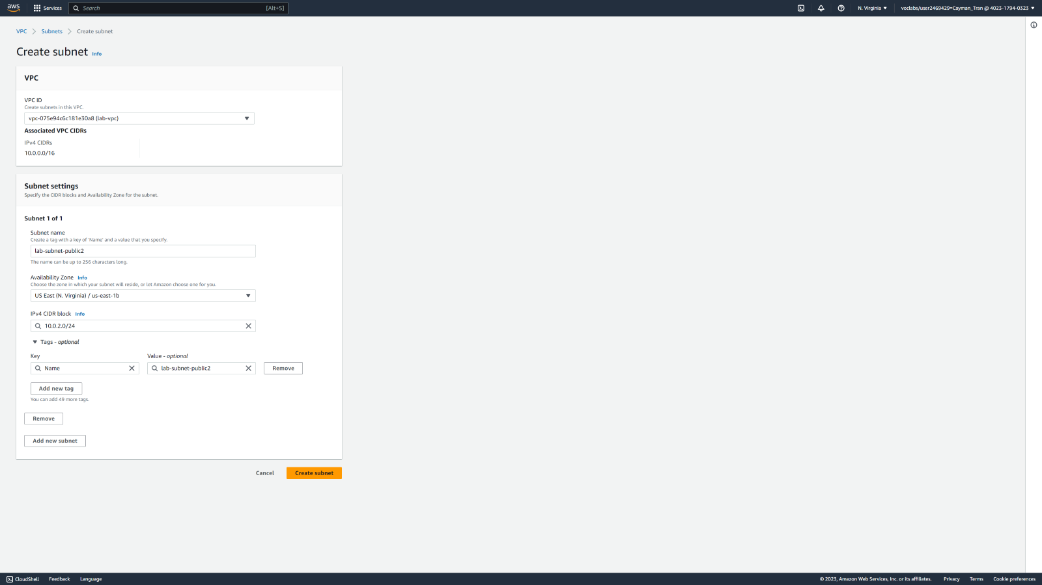Subnet Settings for the VPC.

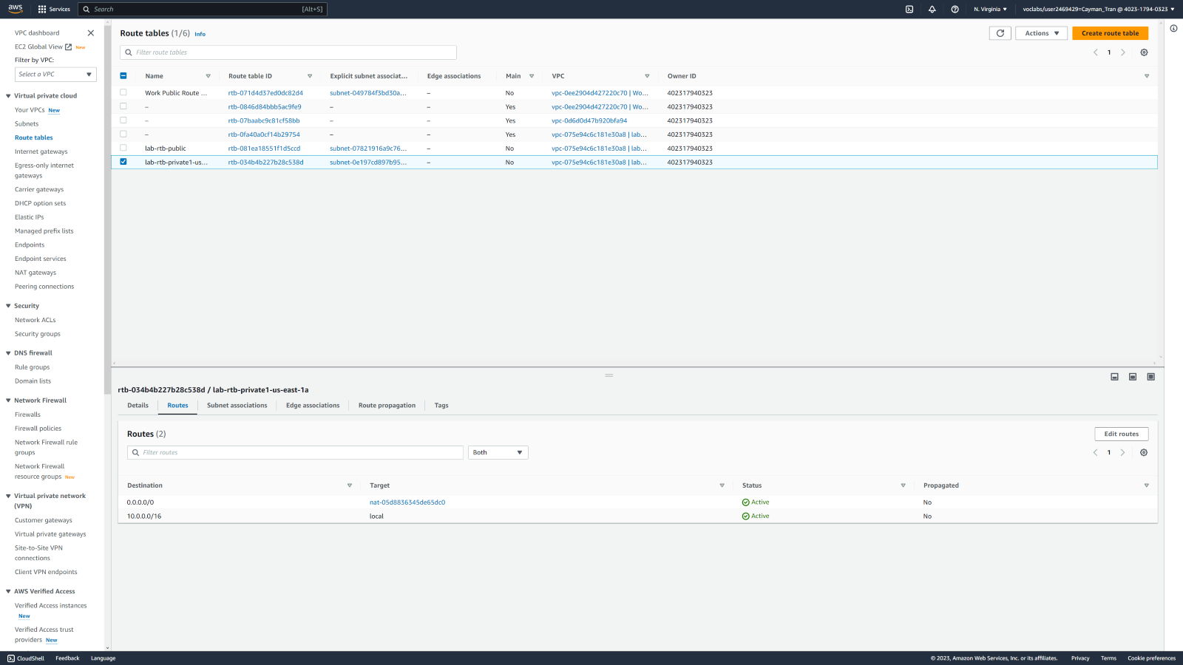

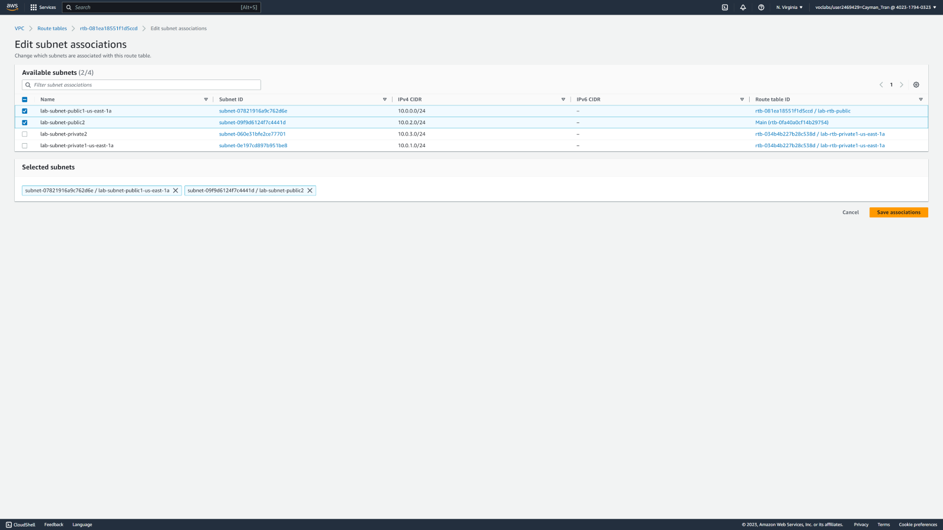Here I edit subnet associations to lab-subnet-private2.

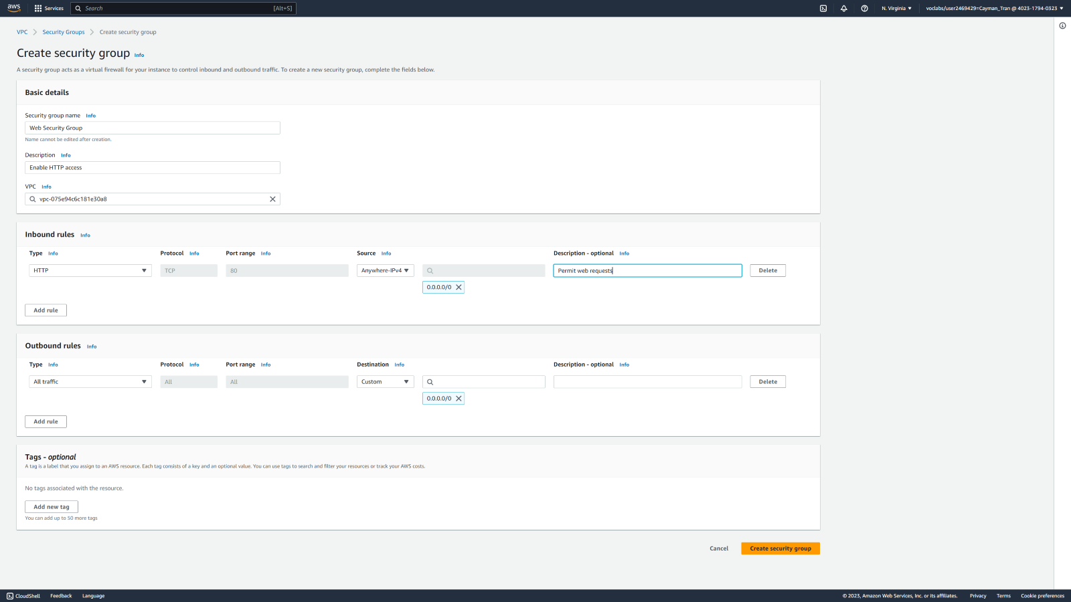

Creating a security group which acts as a virtual firewall. 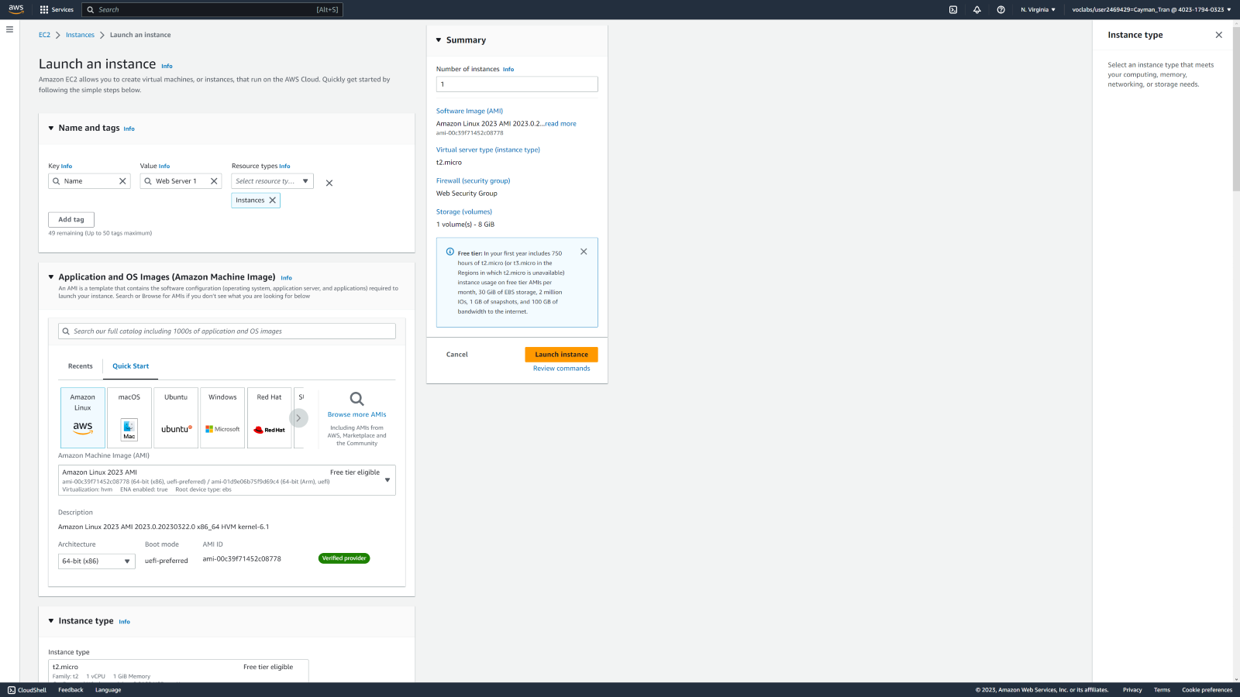

Launching EC2 Web Server Instance into the newly created VPC.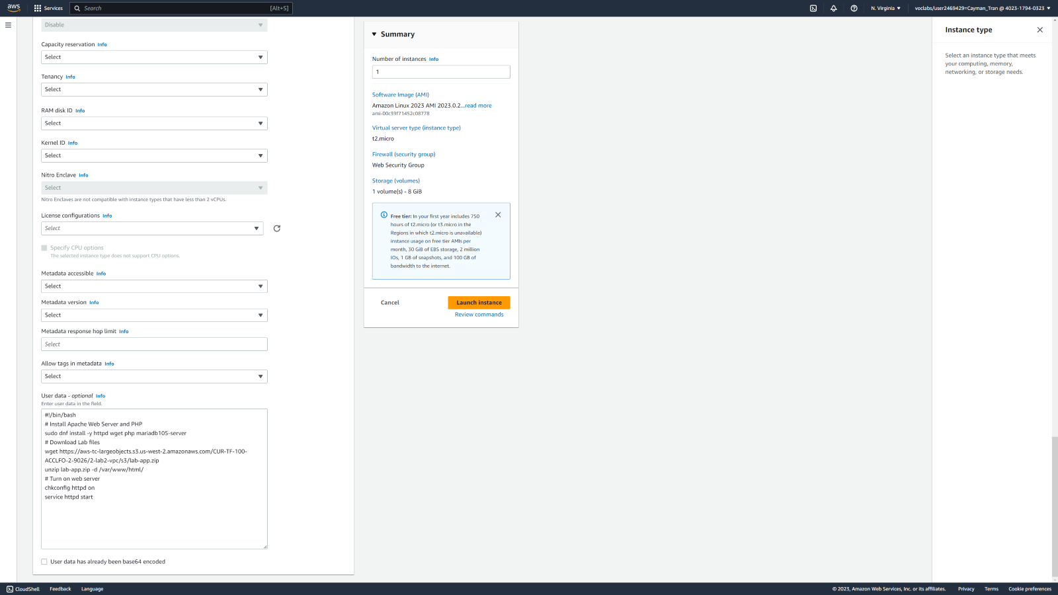 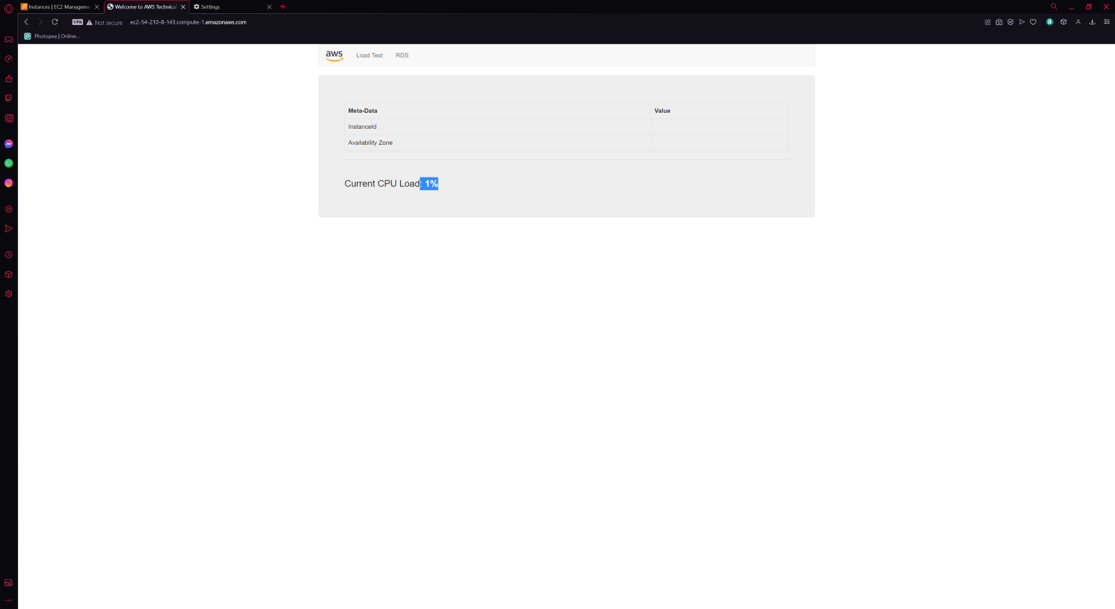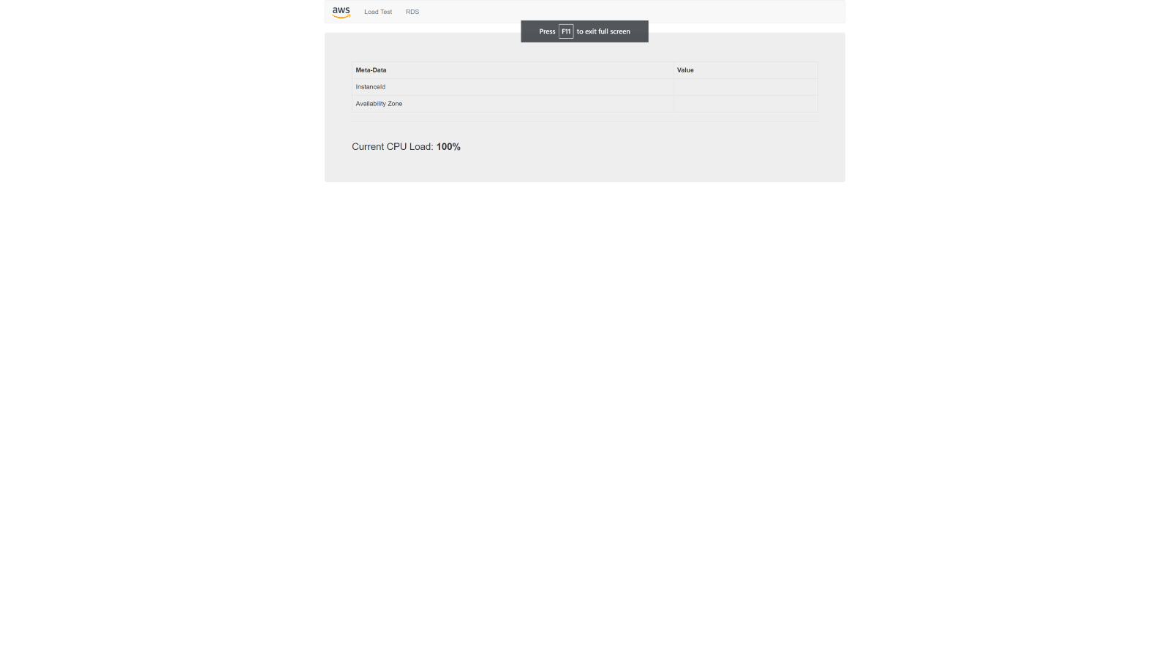

# **Lab 3: Introduction to Amazon EC2**

Summary:

This lab provides you with a basic overview of launching, resizing, managing, and monitoring an Amazon EC2 instance.

**Amazon Elastic Compute Cloud (Amazon EC2)** is a web service that provides resizable compute capacity in the cloud. It is designed to make web-scale cloud computing easier for developers.

Amazon EC2's simple web service interface allows you to obtain and configure capacity with minimal friction. It provides you with complete control of your computing resources and lets you run on Amazon's proven computing environment. Amazon EC2 reduces the time required to obtain and boot new server instances to minutes, allowing you to quickly scale capacity, both up and down, as your computing requirements change.

Amazon EC2 changes the economics of computing by allowing you to pay only for capacity that you actually use. Amazon EC2 provides developers the tools to build failure resilient applications and isolate themselves from common failure scenarios.

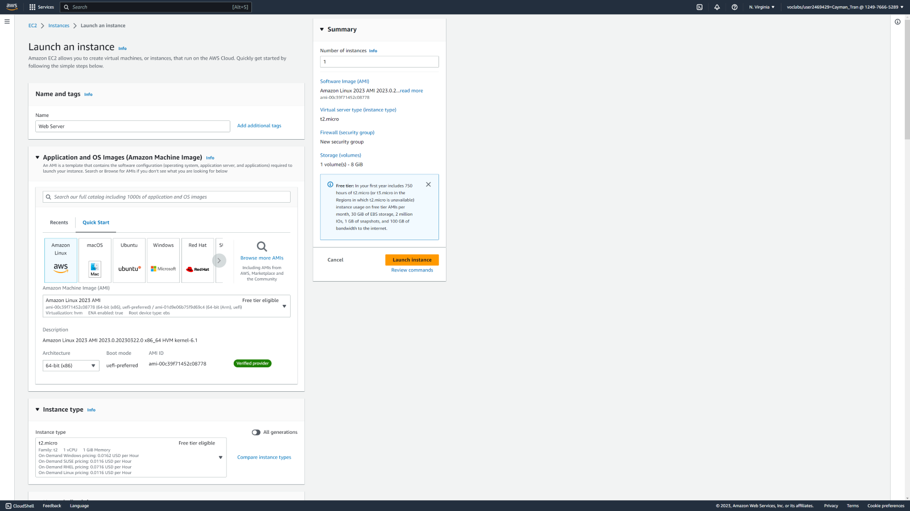

Launching and configuring instance named Web Server.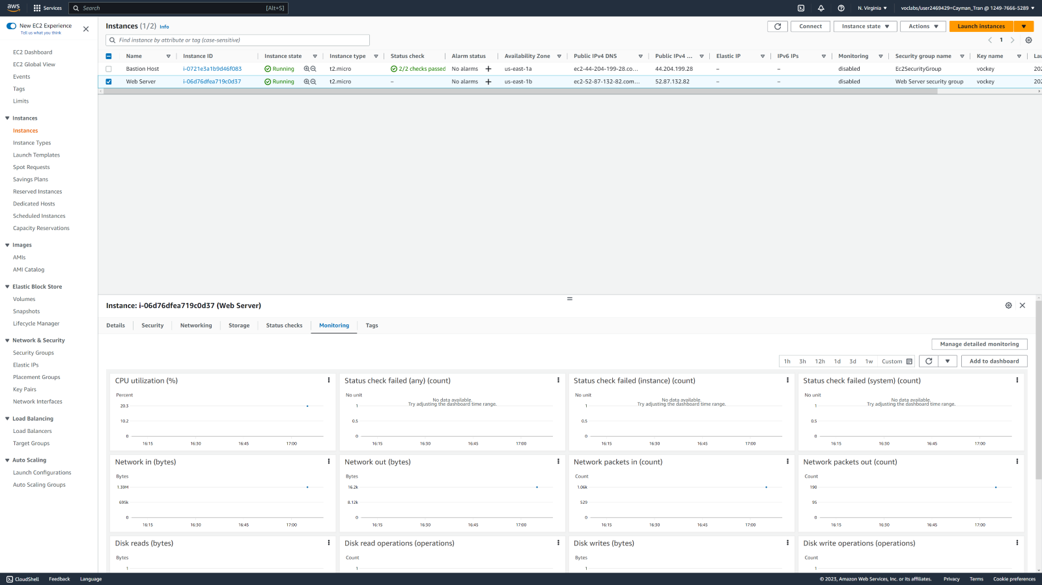

Instance below

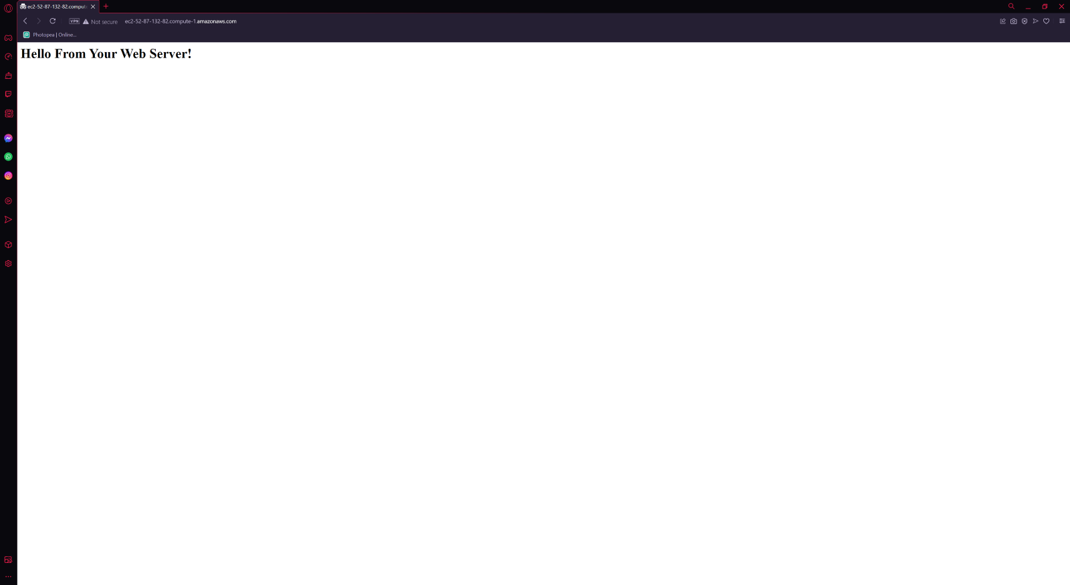The System Log displays the console output of the instance, which is a valuable tool for problem diagnosis. It is especially useful for troubleshooting kernel problems and service configuration issues that could cause an instance to terminate or become unreachable before its SSH daemon can be started. If you do not see a system log, wait a few minutes and then try again. 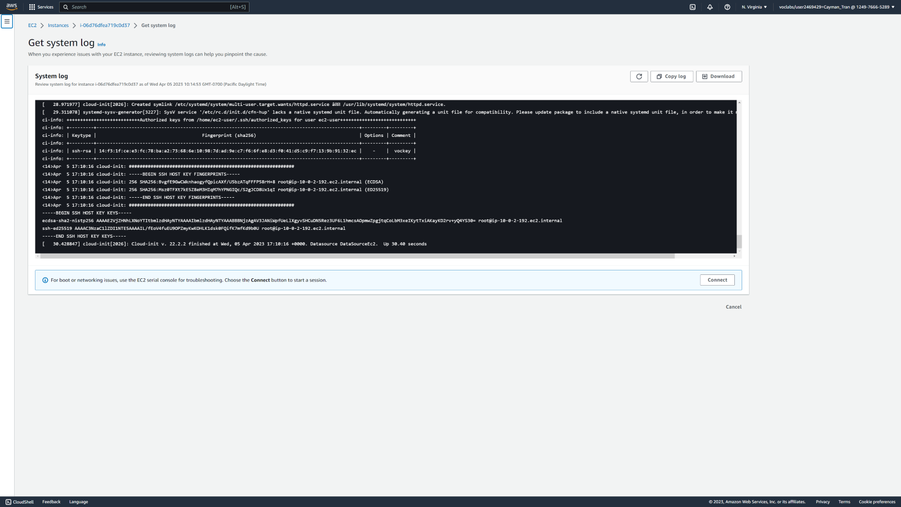

Seeing EC2 instance console. 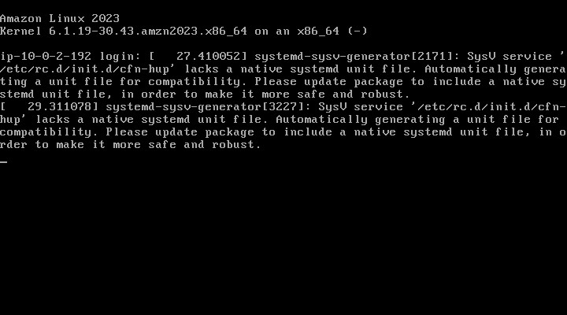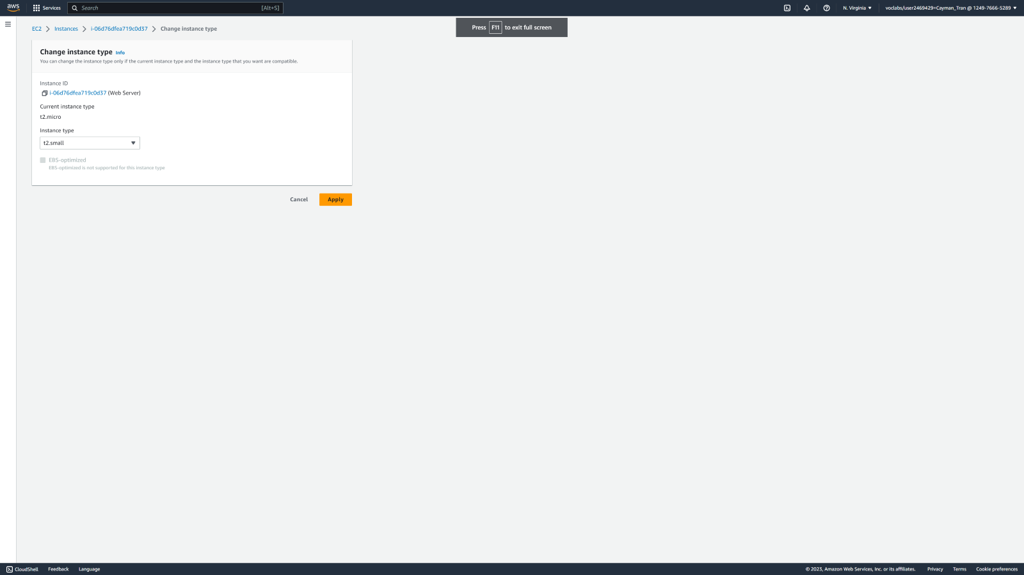

Changing instance types and resizing.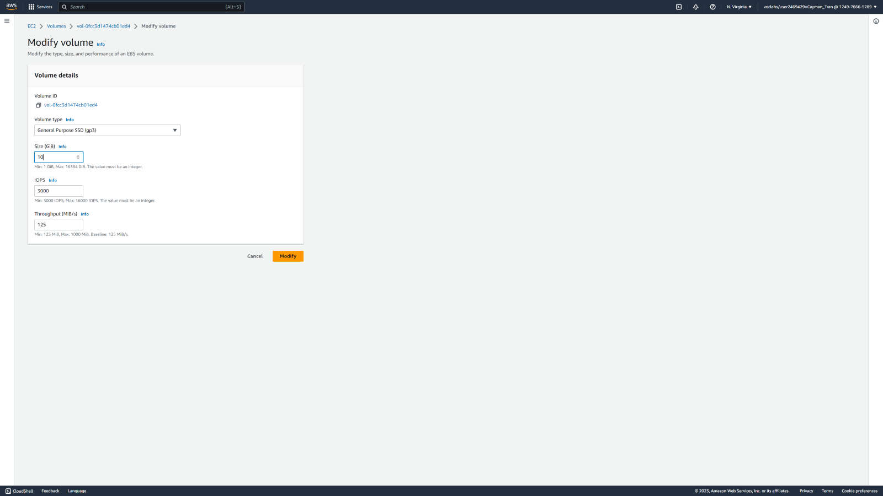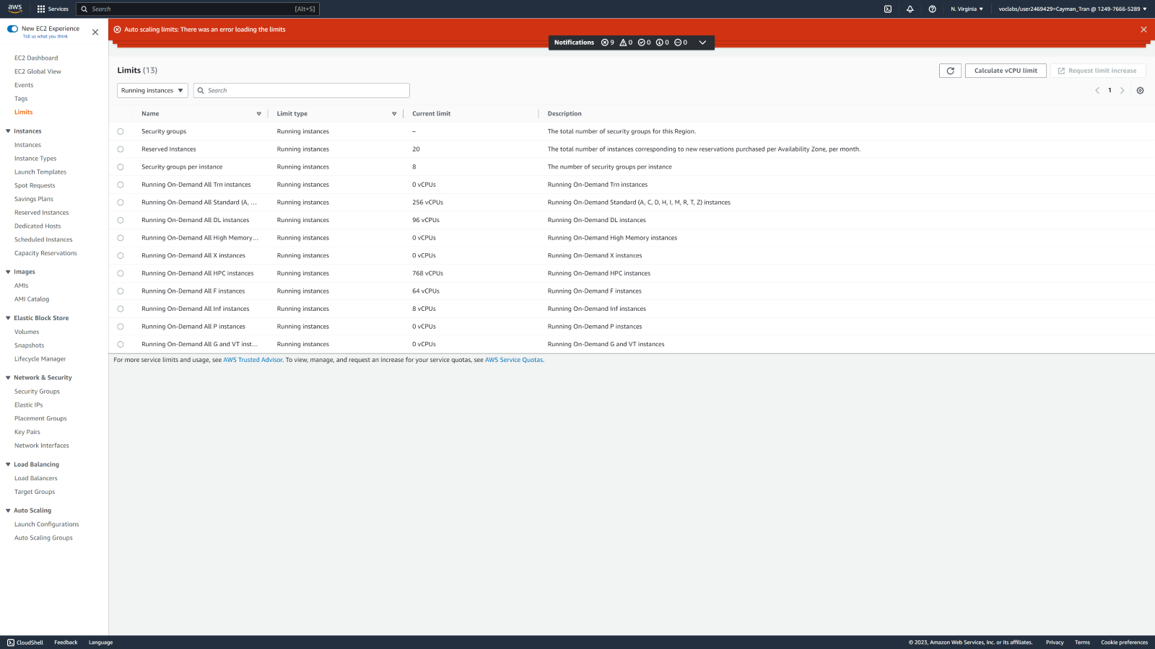

Exploring Limits for instances. Then terminating them.

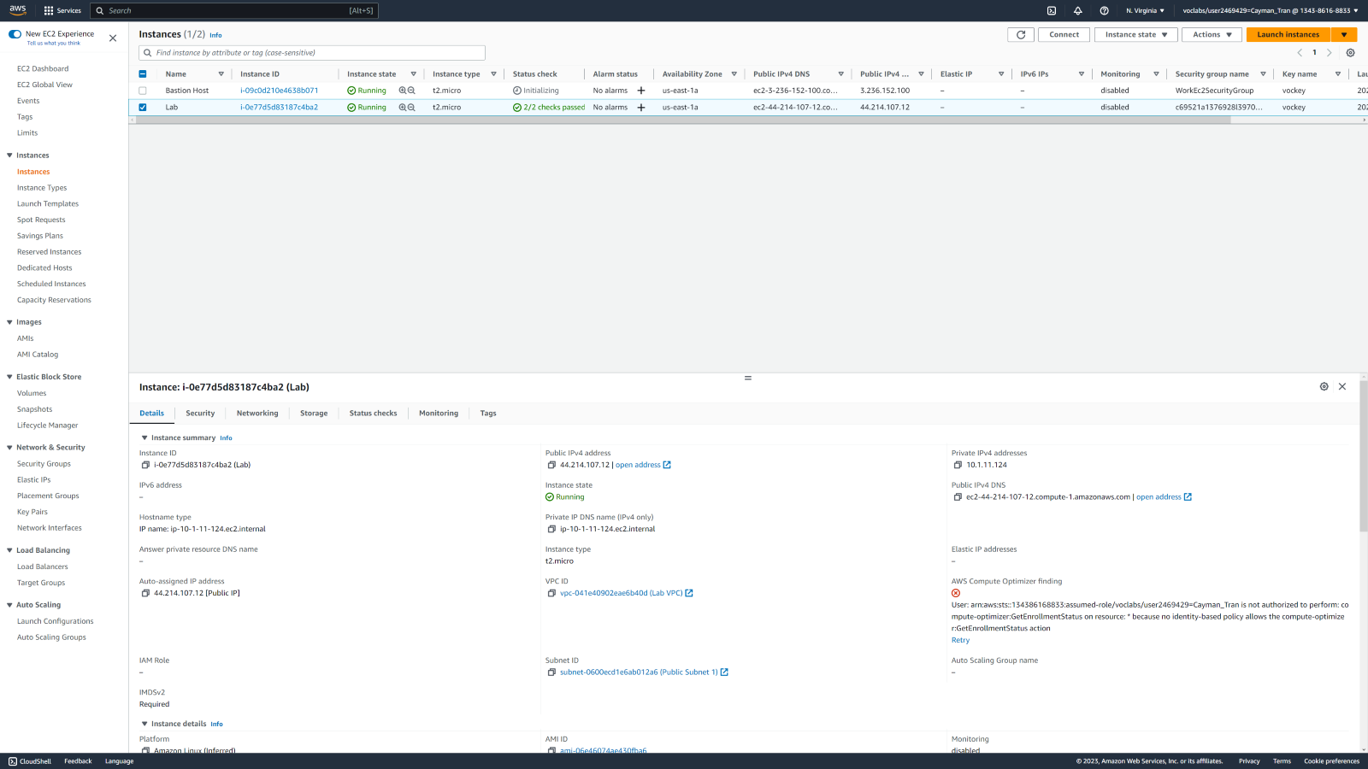

**CONCLUSION**

In conclusion, the AWS Academy Cloud Foundations course provides a comprehensive overview of cloud computing and AWS services. Through Modules 1-6, I learned about the essential concepts and components of cloud computing, including virtualization, storage, networking, and security. I also gained experience with AWS tools and services, such as EC2, S3, and VPC.

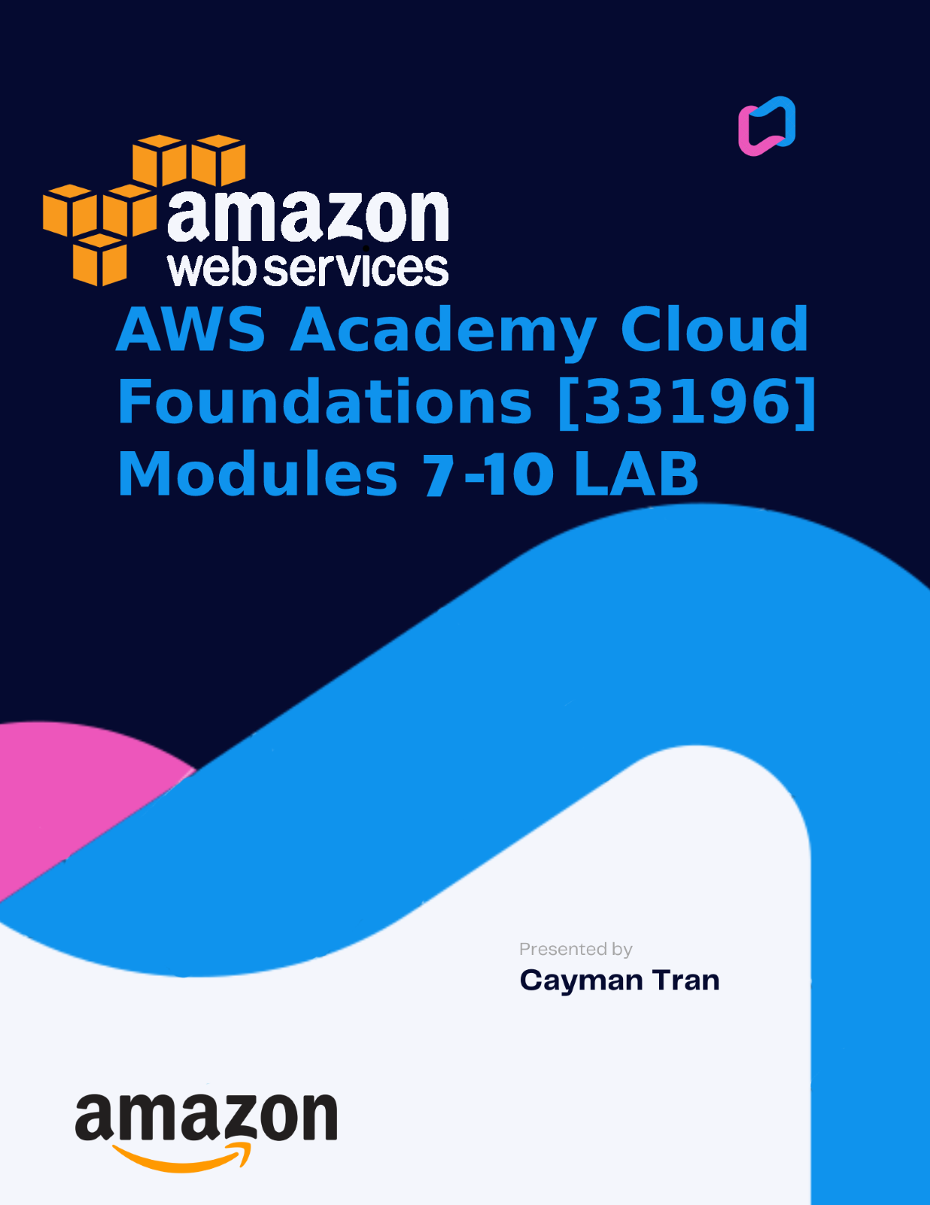

BACKGROUND INFORMATION

AWS Academy Cloud Foundations is a course designed to provide an overview of cloud computing and its various concepts, services, and deployment models. The Cloud Foundations course covers a range of topics, including cloud computing basics, cloud service models, security and compliance in the cloud, and cloud deployment models. I learned about AWS services, such as Amazon Elastic Compute Cloud (EC2), Amazon Simple Storage Service (S3), and Amazon Relational Database Service (RDS). I learned this course through a combination of videos, hands-on exercises, and labs. I have gained a solid understanding of cloud computing and its benefits, as well as the skills needed to deploy and manage cloud-based solutions using AWS services.

Module 7: Storage

* Covers the various storage options available in AWS, including Amazon S3, Amazon EBS, and Amazon Glacier. Contains the different use cases for each storage service, as well as best practices for configuring, managing, and securing data stored in AWS.

Module 8: Databases

* Provides an overview of AWS database services, including Amazon RDS, Amazon DynamoDB, and Amazon Redshift. Teaches about the different types of databases, how to choose the right database service for their applications, and how to provision, configure, and manage databases in the cloud.

Module 9: Cloud Architecture

* Focuses on cloud architecture, including designing and deploying applications on AWS. Trains about architectural best practices for high availability, scalability, and fault tolerance, as well as how to use AWS services like Elastic Load Balancing, Auto Scaling and Amazon Route 53 to build a robust and scalable infrastructure. Additionally, students learn how to use AWS CloudFormation and AWS Elastic Beanstalk to automate infrastructure deployment and application management.

Module 10: Auto Scaling and Monitoring

* Covers AWS Auto Scaling, which is a service that automatically adjusts the capacity of AWS resources to meet changing demands. Teaches how to use Auto Scaling to ensure optimal performance and cost efficiency, as well as how to monitor AWS resources using AWS CloudWatch. Additionally, students learn about best practices for monitoring and troubleshooting applications running in the cloud.

# **Lab 4: Working with EBS**

Amazon Elastic Block Store provides persistent storage for Amazon EC2 instances. This storage is network-attached and remains intact independently of an instance's lifespan. Amazon EBS volumes are known for their high reliability and availability and can function as a standard block device attached to a running Amazon EC2 instance, or as a boot partition for Amazon EC2 instances.

This lab guide provides a step-by-step overview of Amazon EBS basics, but it only scratches the surface of Amazon EBS concepts. For more in-depth information, please refer to the Amazon EBS documentation.

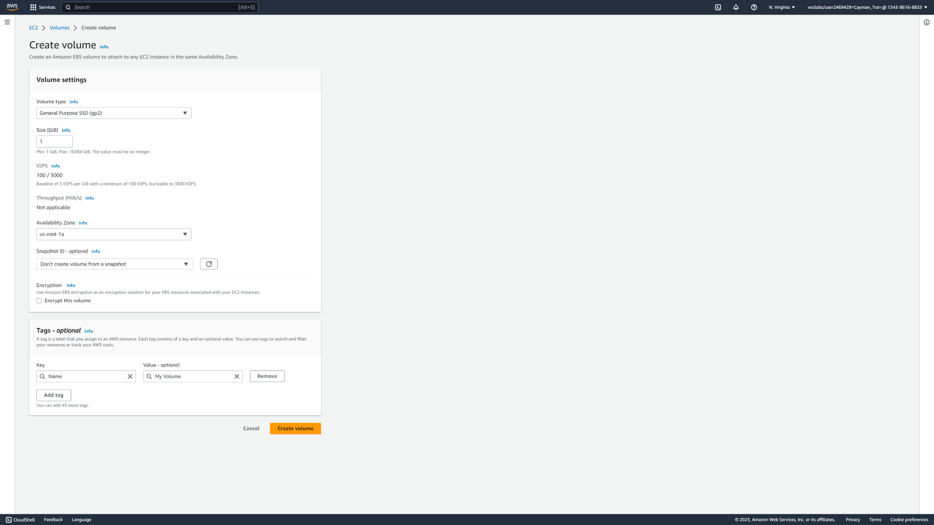

Creating a new EBS volume for a EC2 Instance.

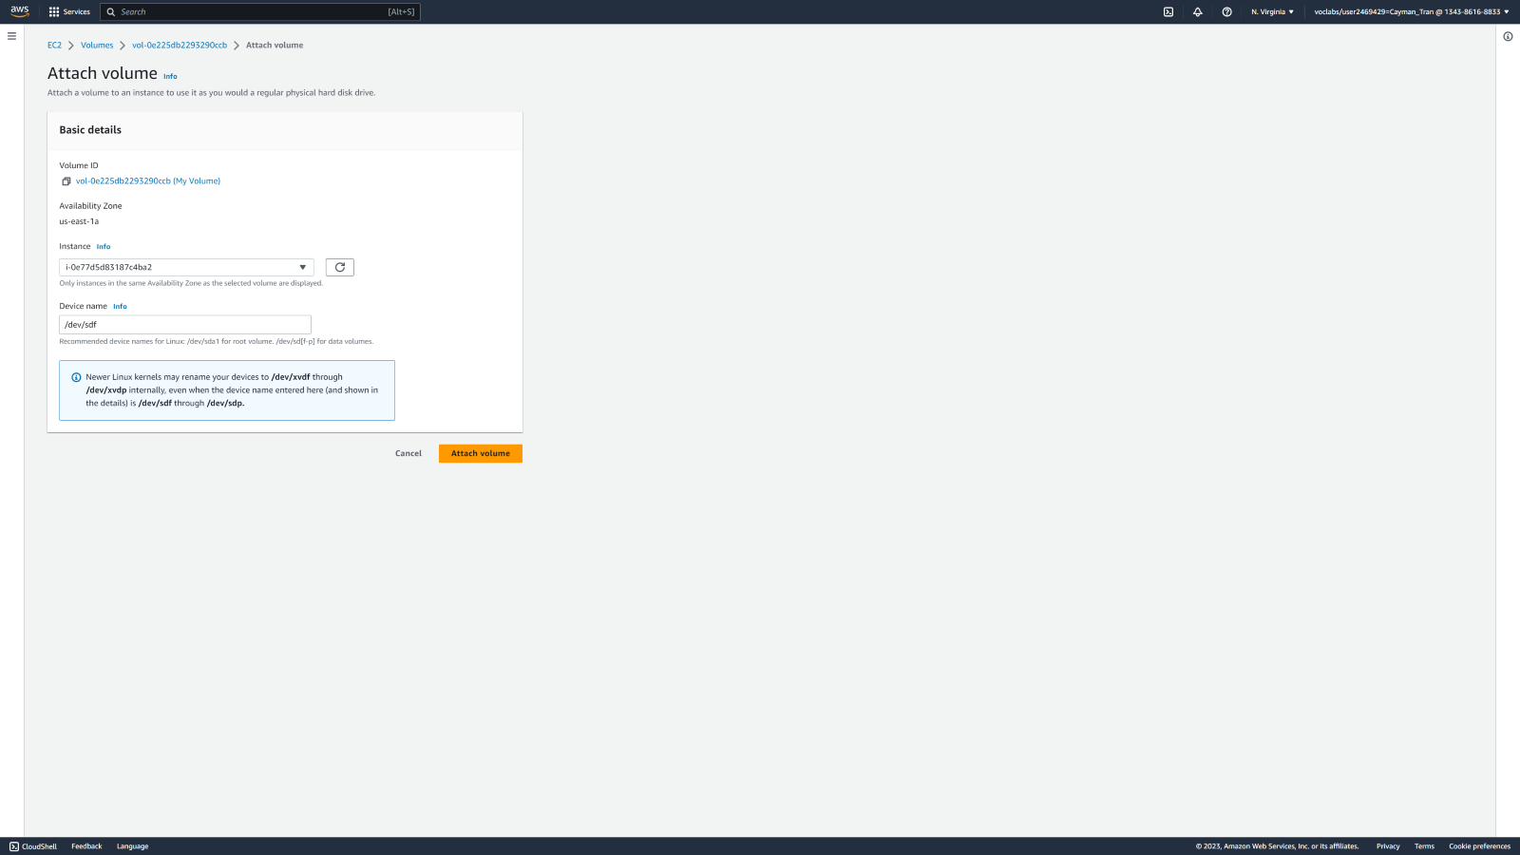

Attaching volume to Lab Instance.

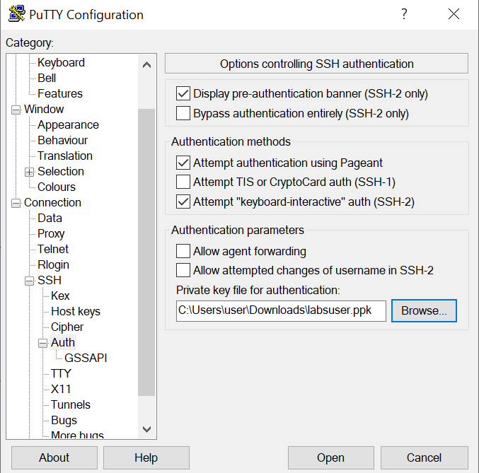

Connecting to new EC2 Instance through SSH with key in putty.

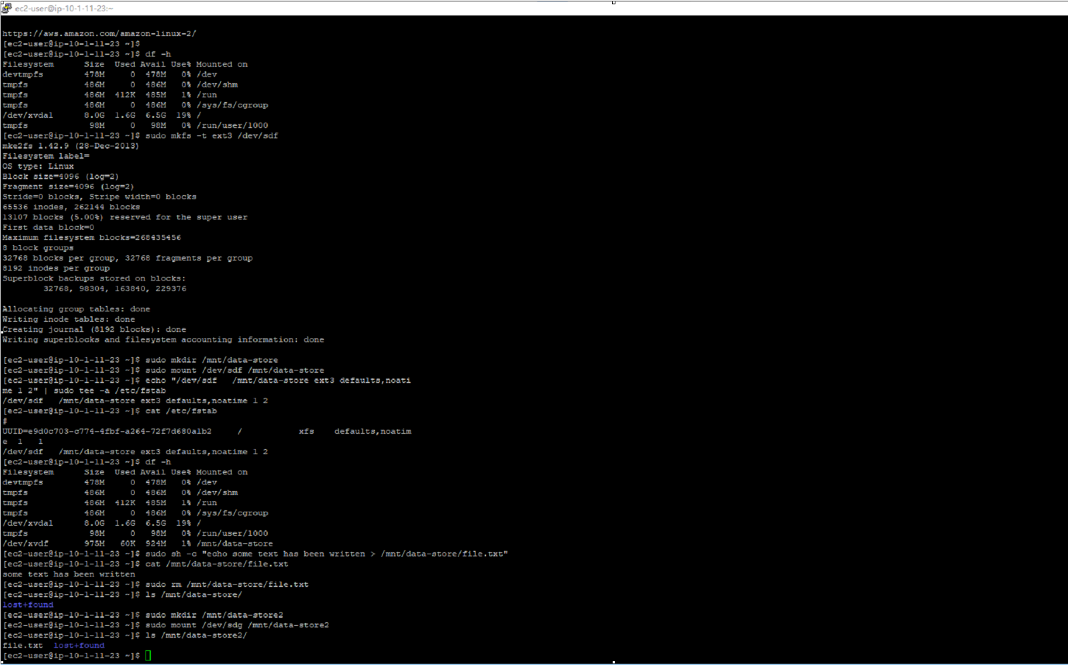

Consoled in and configuring file system.

# **Lab 5: Build Your DB Server and Interact With Your DB Using an App**

Amazon Relational Database Service simplifies the process of establishing, managing, and expanding a relational database in the cloud. It offers cost-effective and adjustable capacity while taking care of time-consuming database administration tasks, freeing you up to concentrate on your applications and business. Amazon RDS gives you the option of selecting from six well-known database engines, namely Amazon Aurora, Oracle, Microsoft SQL Server, PostgreSQL, MySQL, and MariaDB.

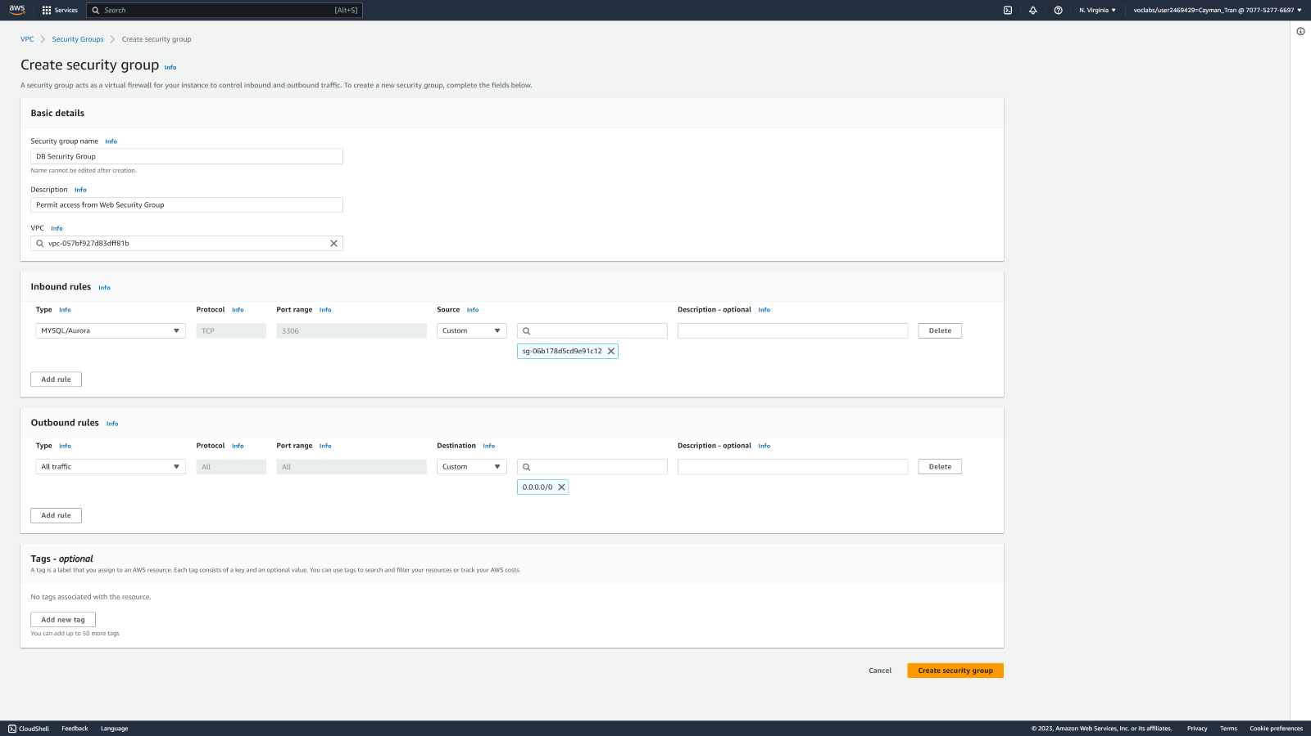

Creating a Security Group for RDS DB Instance named DB Security Group.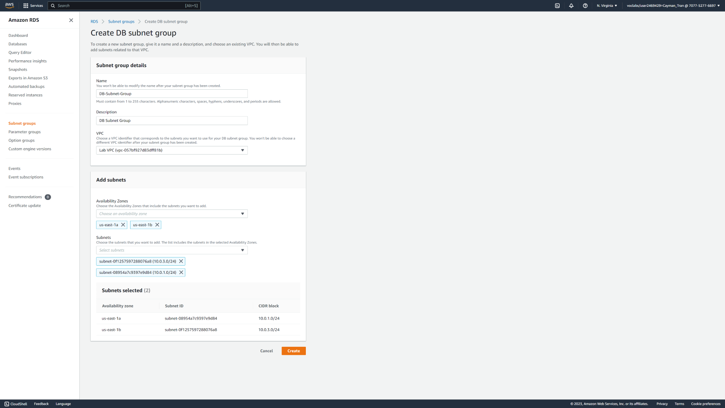

Creating two availability zones for the Subnet Group. 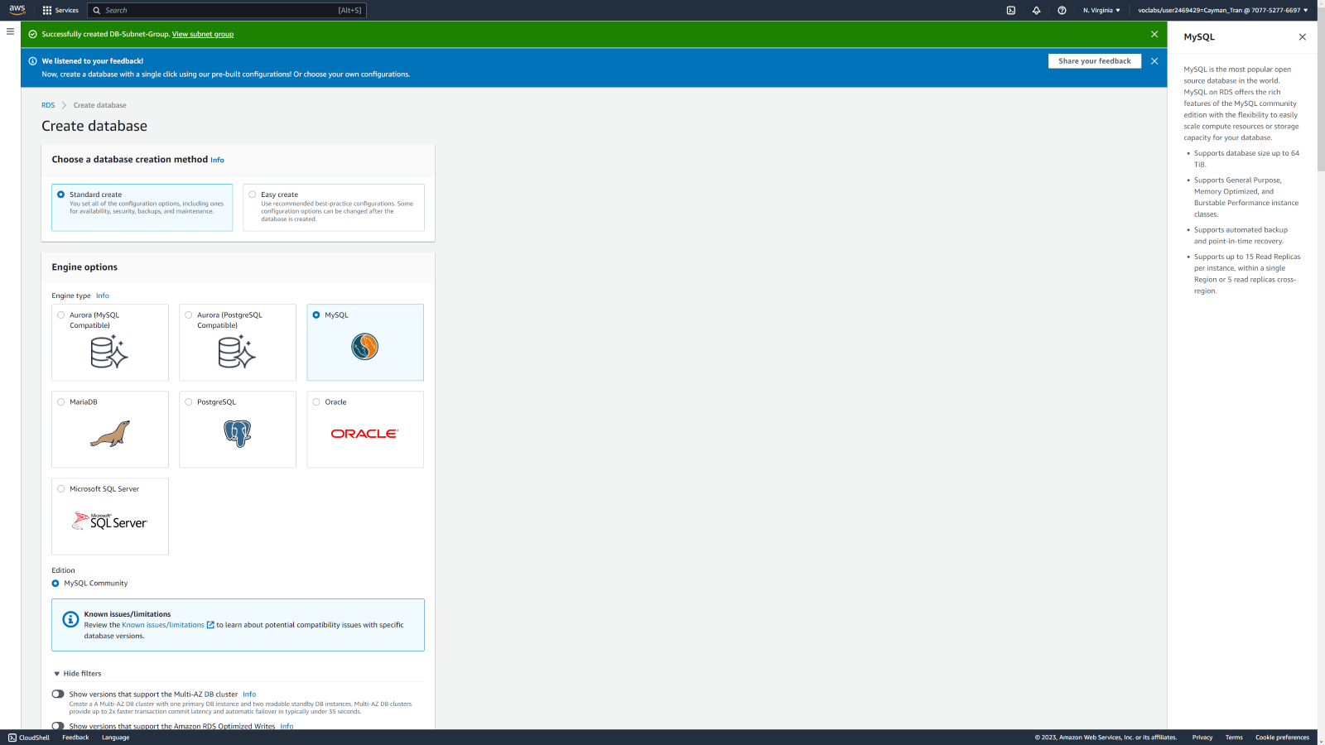

Creating and configuring the RDS DB Instance. 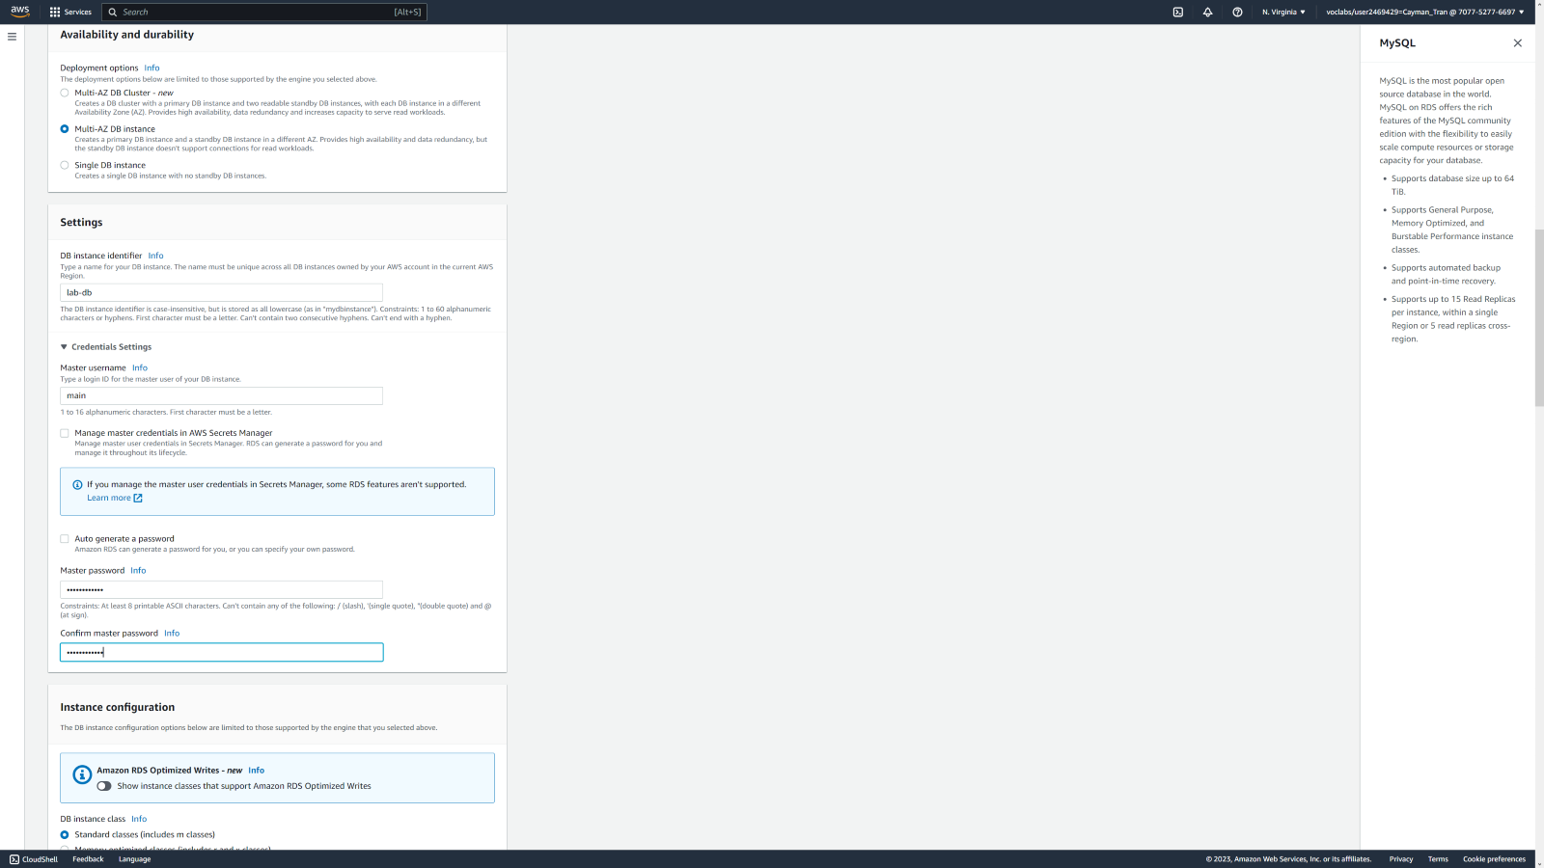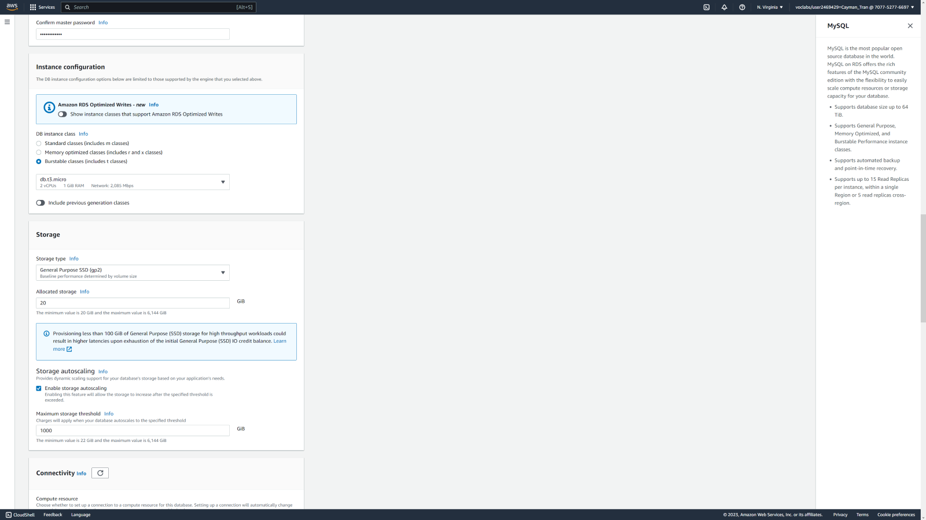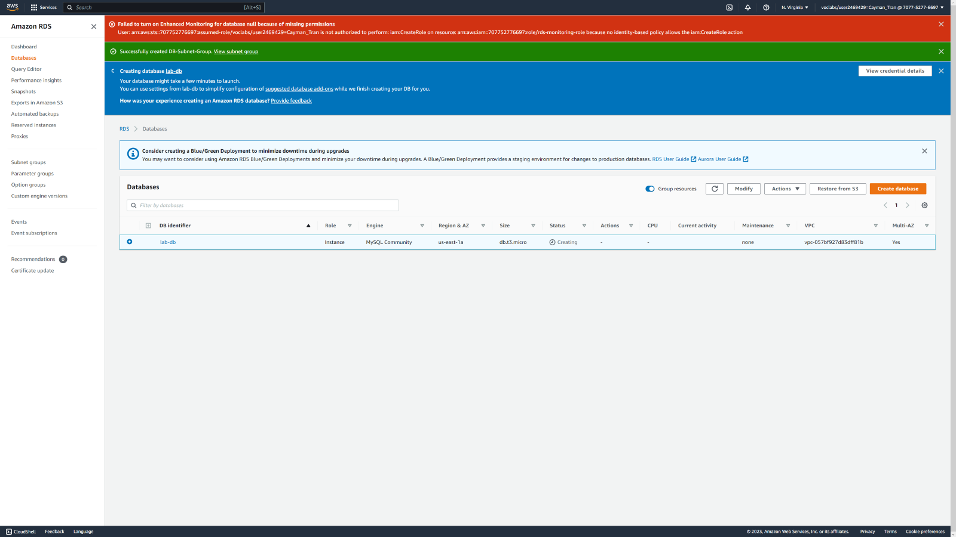

Instance Created.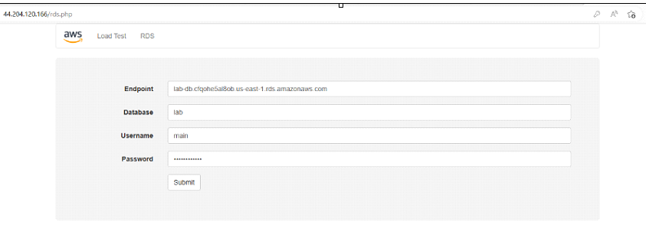Opening the Database in a browswer with the WebServer IP address.

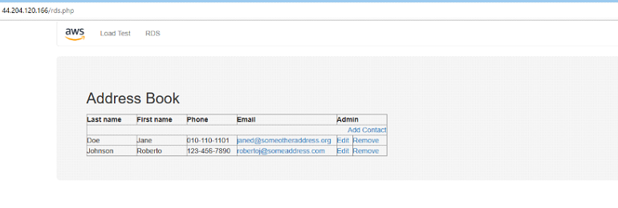

The Database contains an address book of people.

# **Lab 6: Scale and Load Balance Your Architecture**

By automatically distributing incoming application traffic across multiple Amazon EC2 instances, Elastic Load Balancing allows you to achieve fault tolerance in your applications, seamlessly providing the required amount of load balancing capacity needed to route application traffic.

Auto Scaling helps you preserve application availability and facilitates automatic scaling of your Amazon EC2 capacity, based on conditions you define. With Auto Scaling, you can ensure that you have the desired number of Amazon EC2 instances running, while automatically increasing the number of instances during demand spikes to maintain performance and decreasing capacity during lulls to reduce costs.

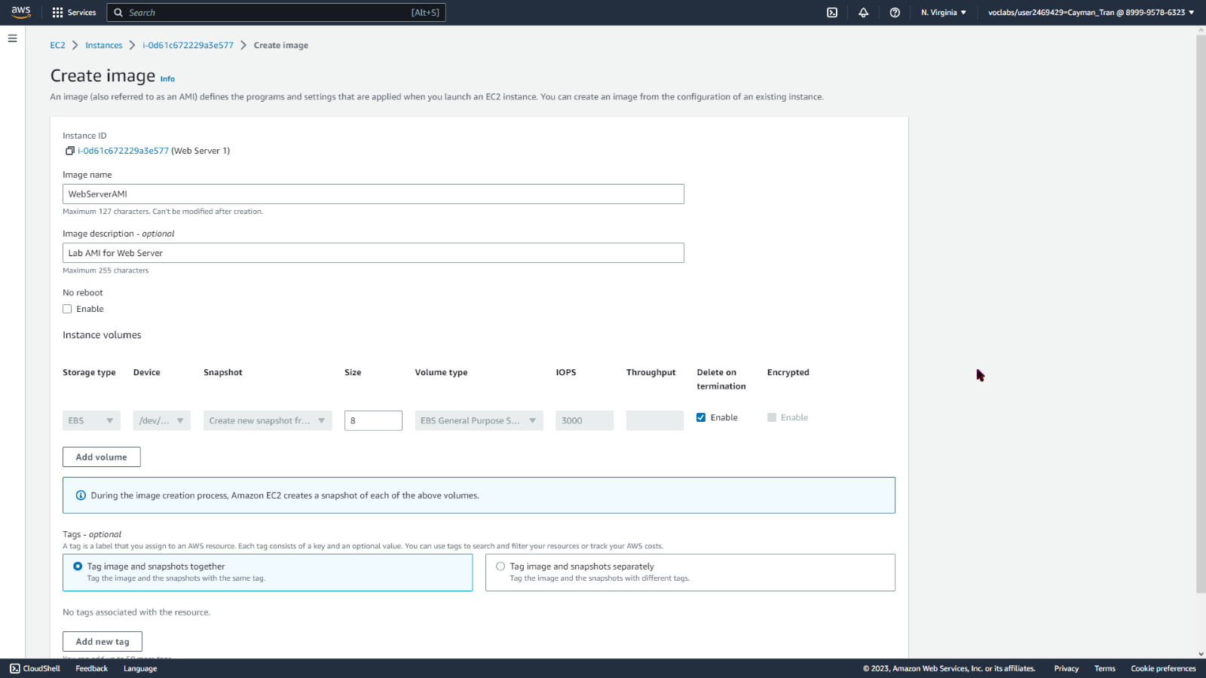

Creating AMI for Auto Scaling. Image name is WebServerAMI.

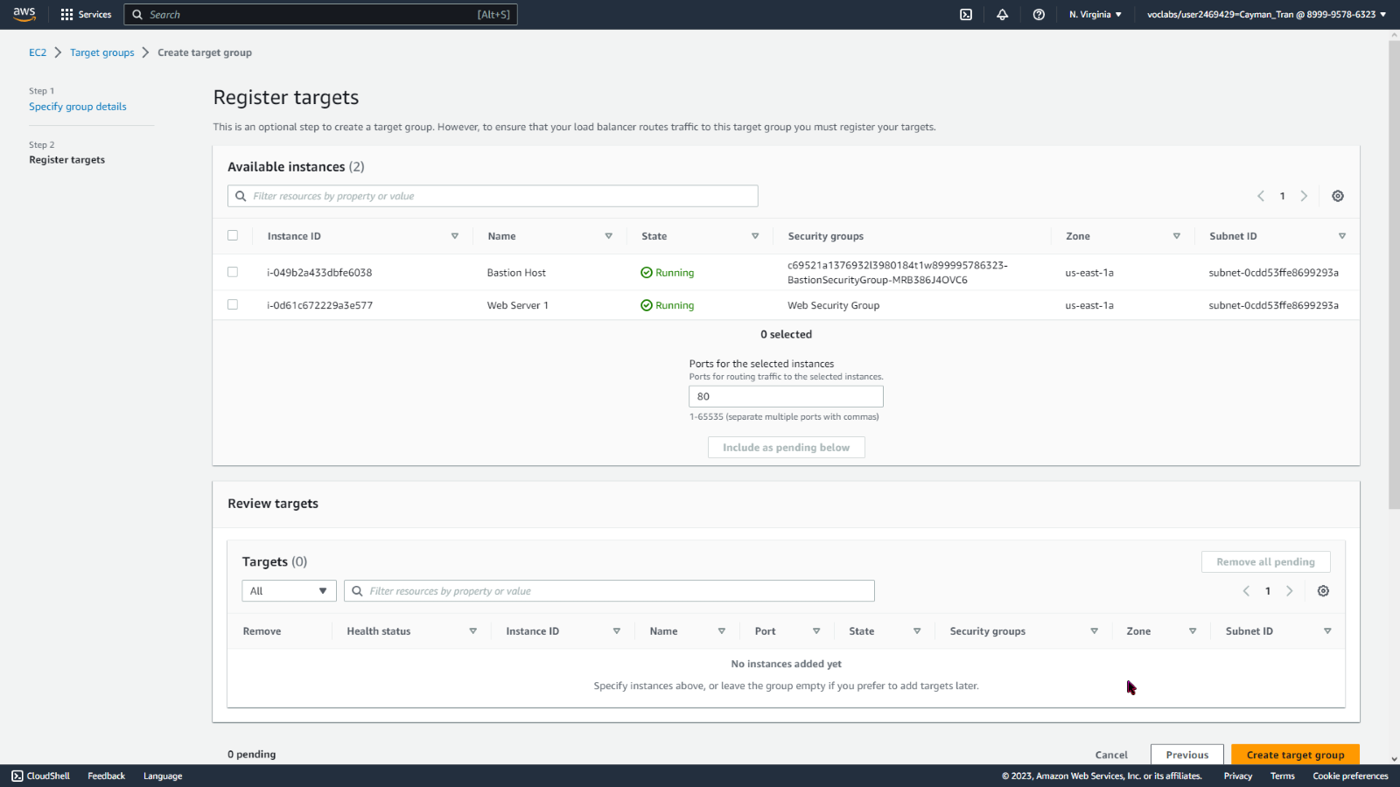

Creating a target group for the load balancers.

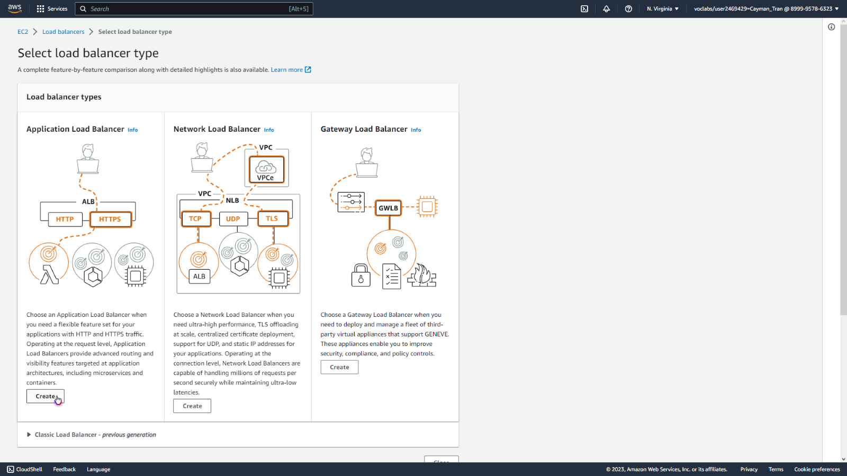

Creating a Load Balancer.

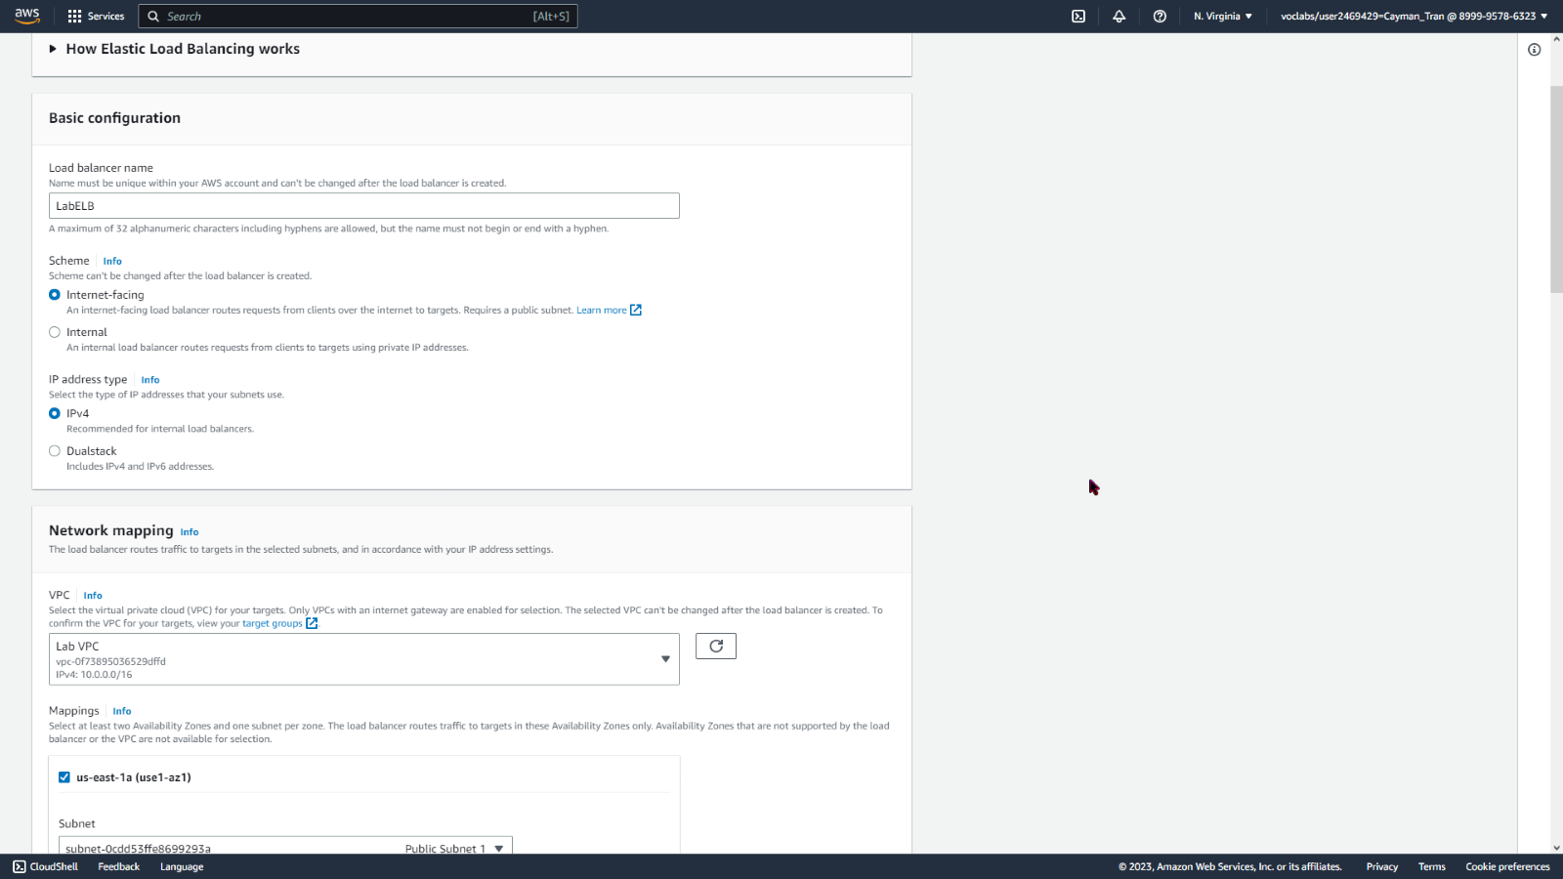

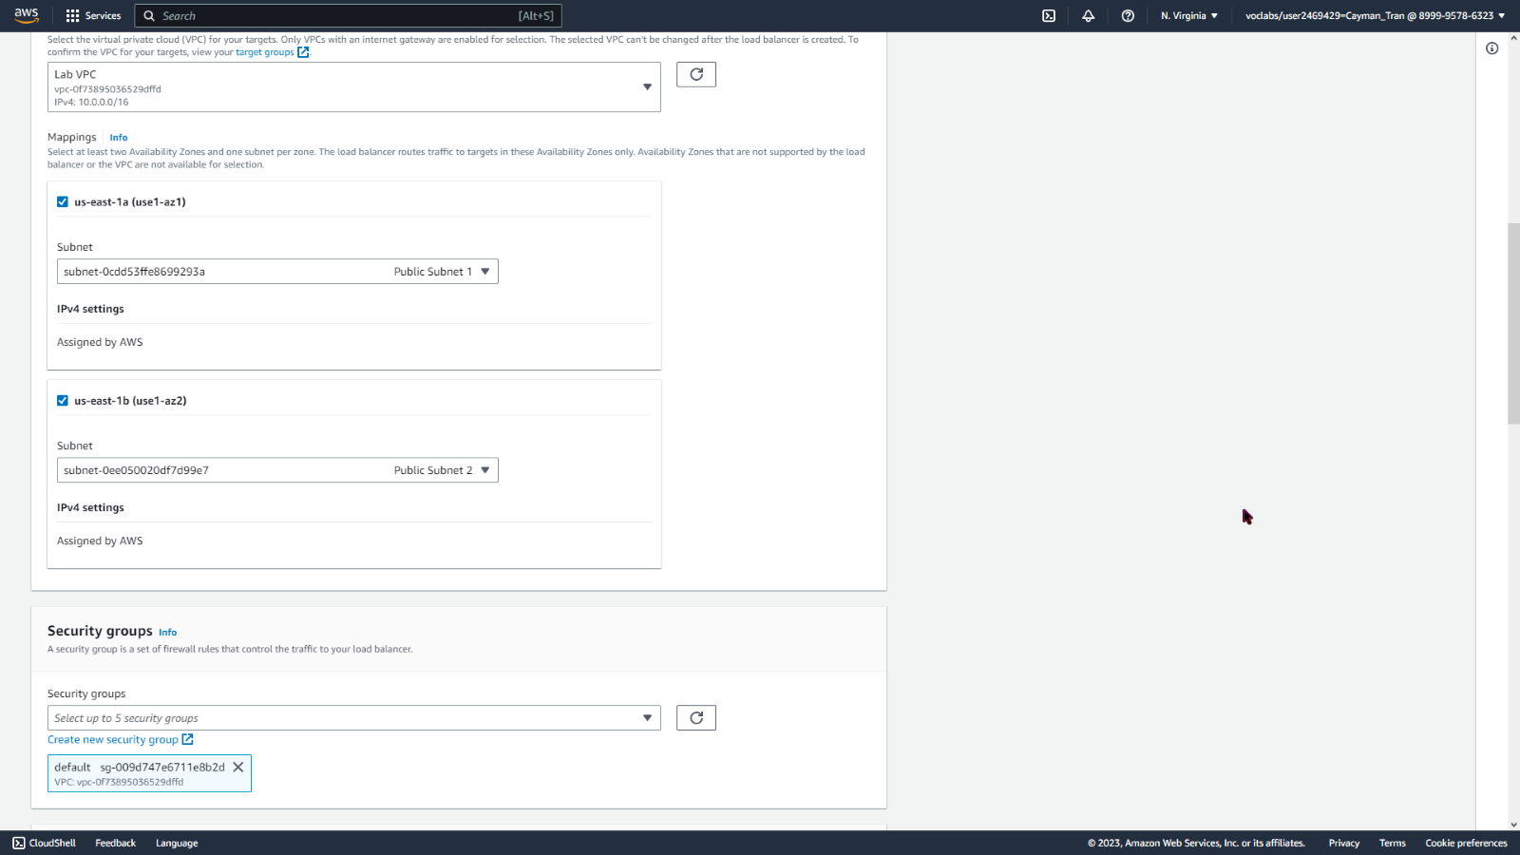

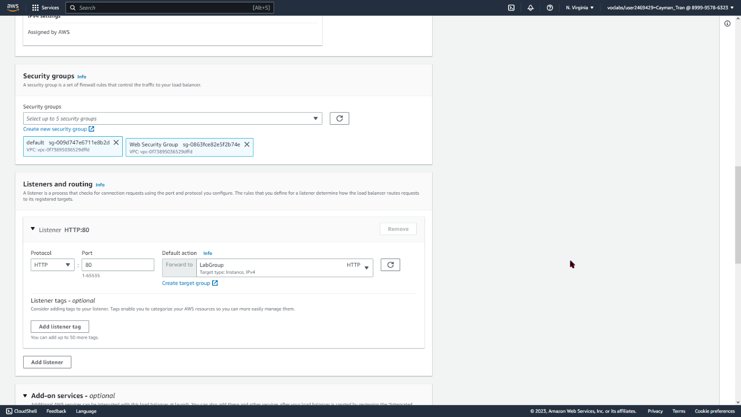

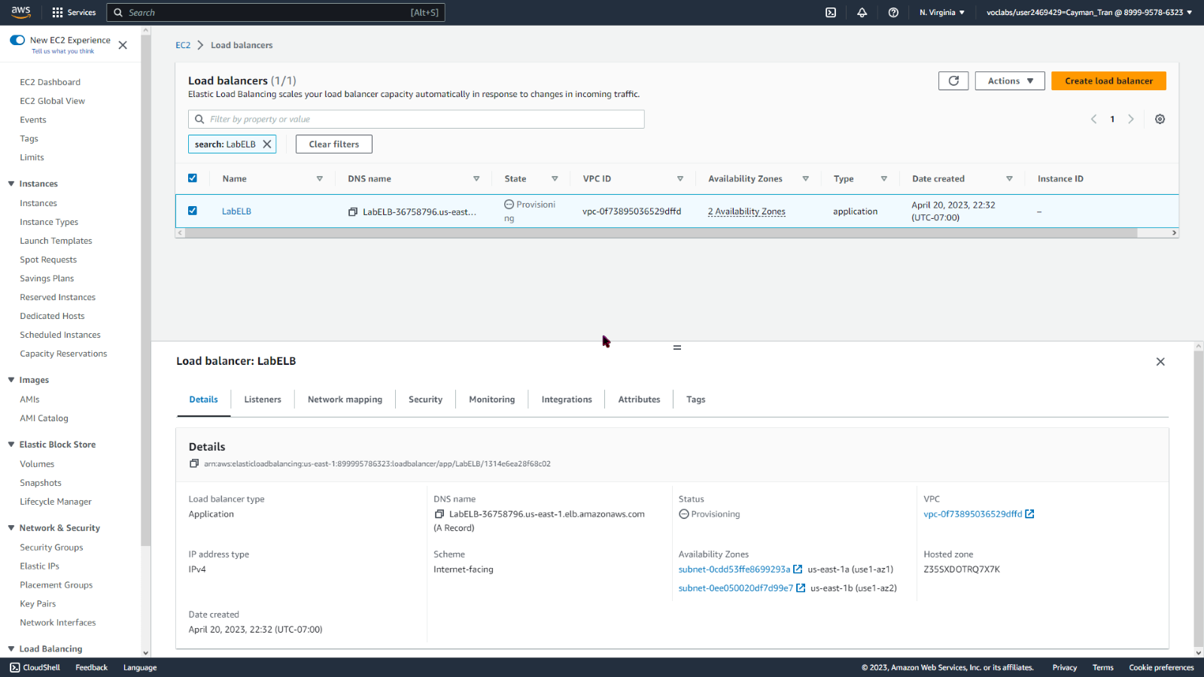

Load Balancer created.

Creating a Launch Configuration for Auto Scaling Groups.

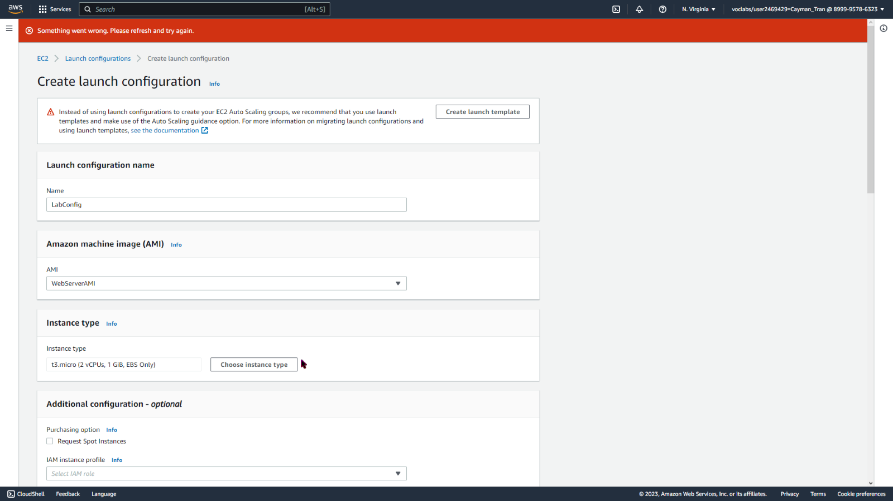

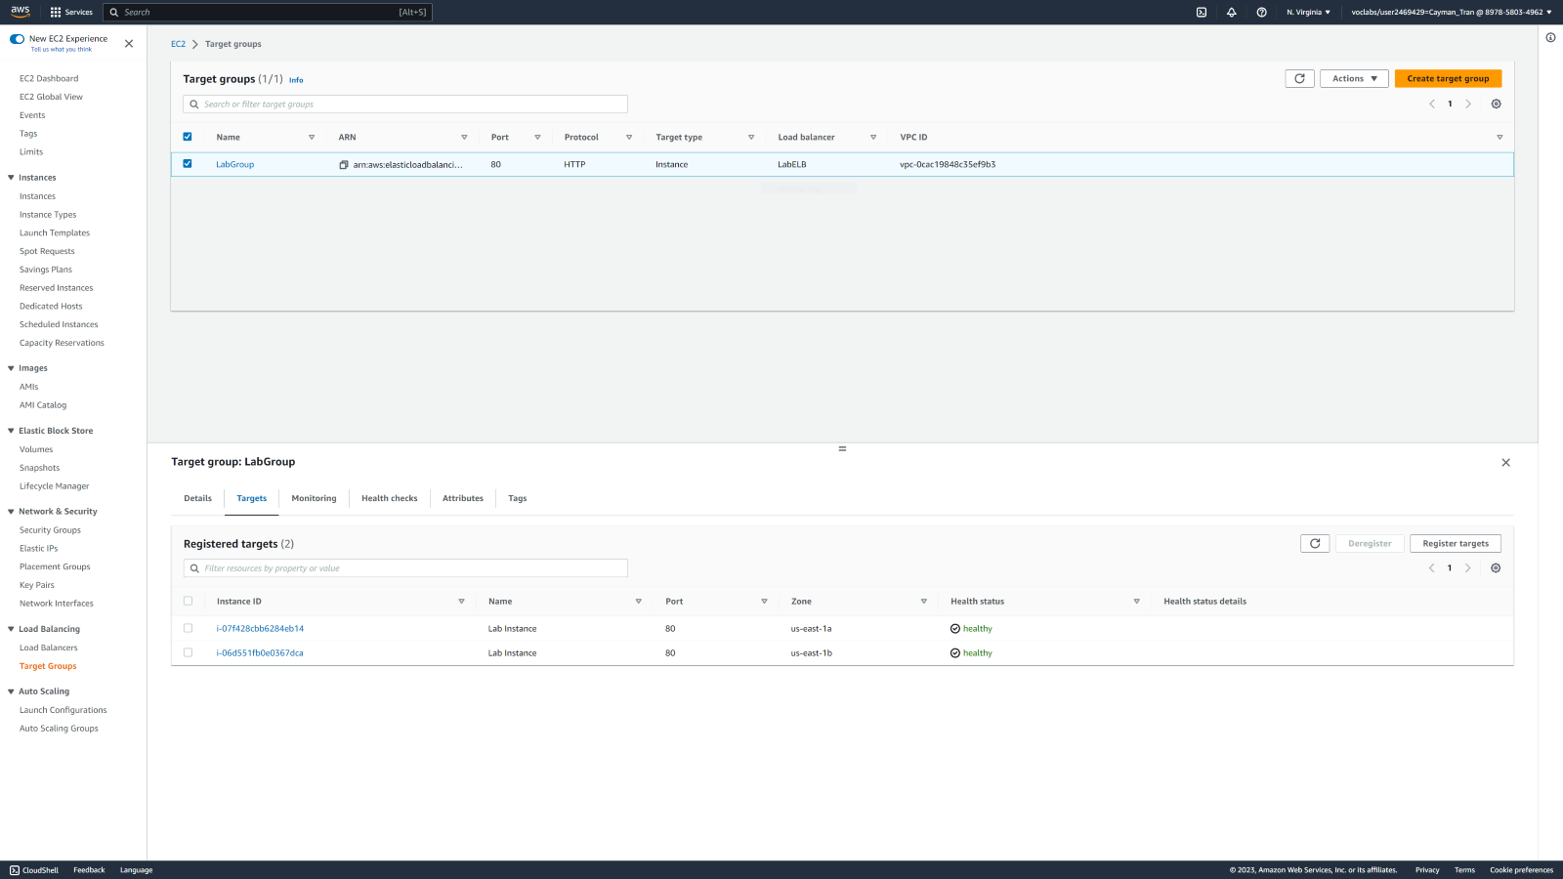

Creating the Auto Scaling Group.

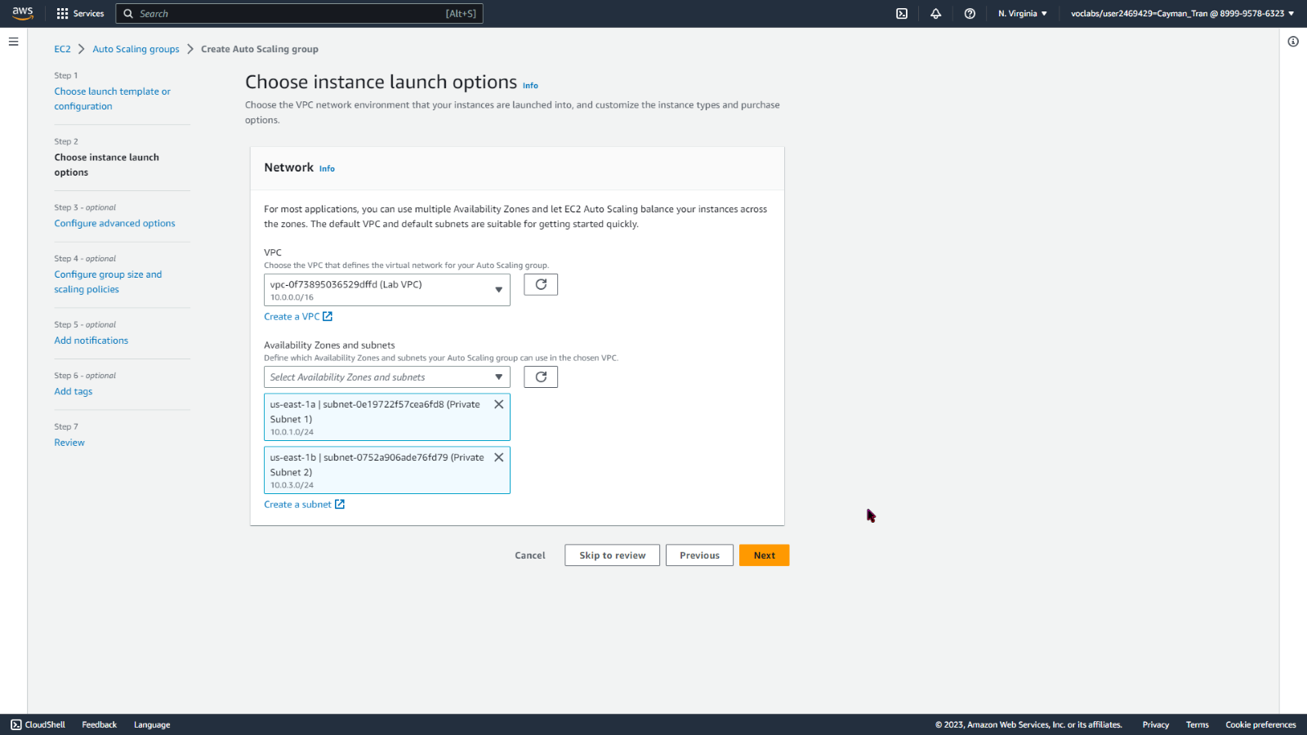

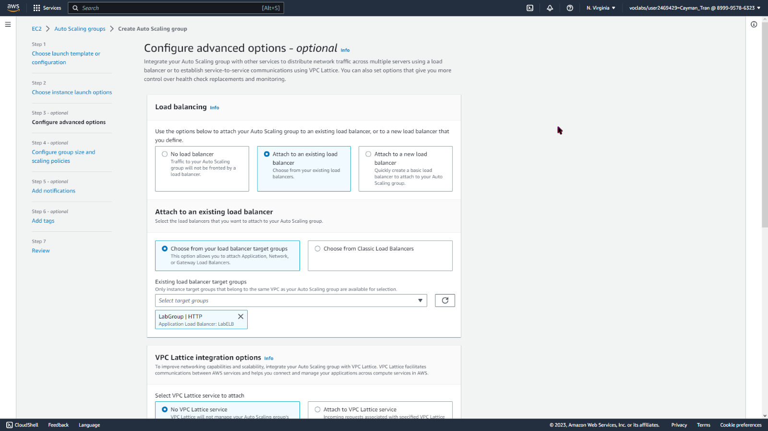

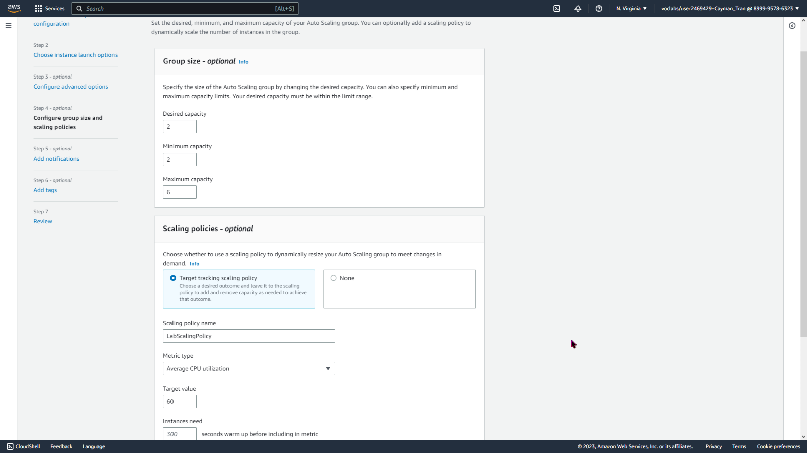

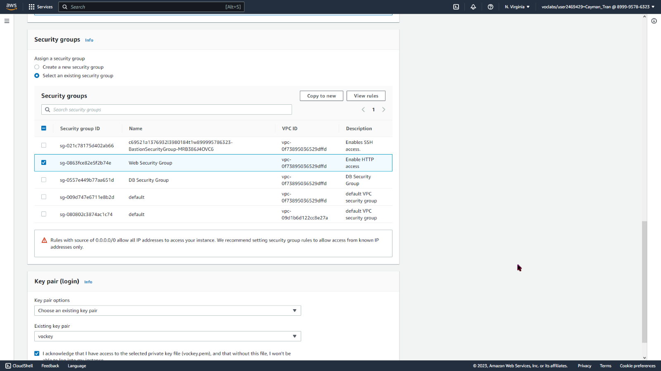

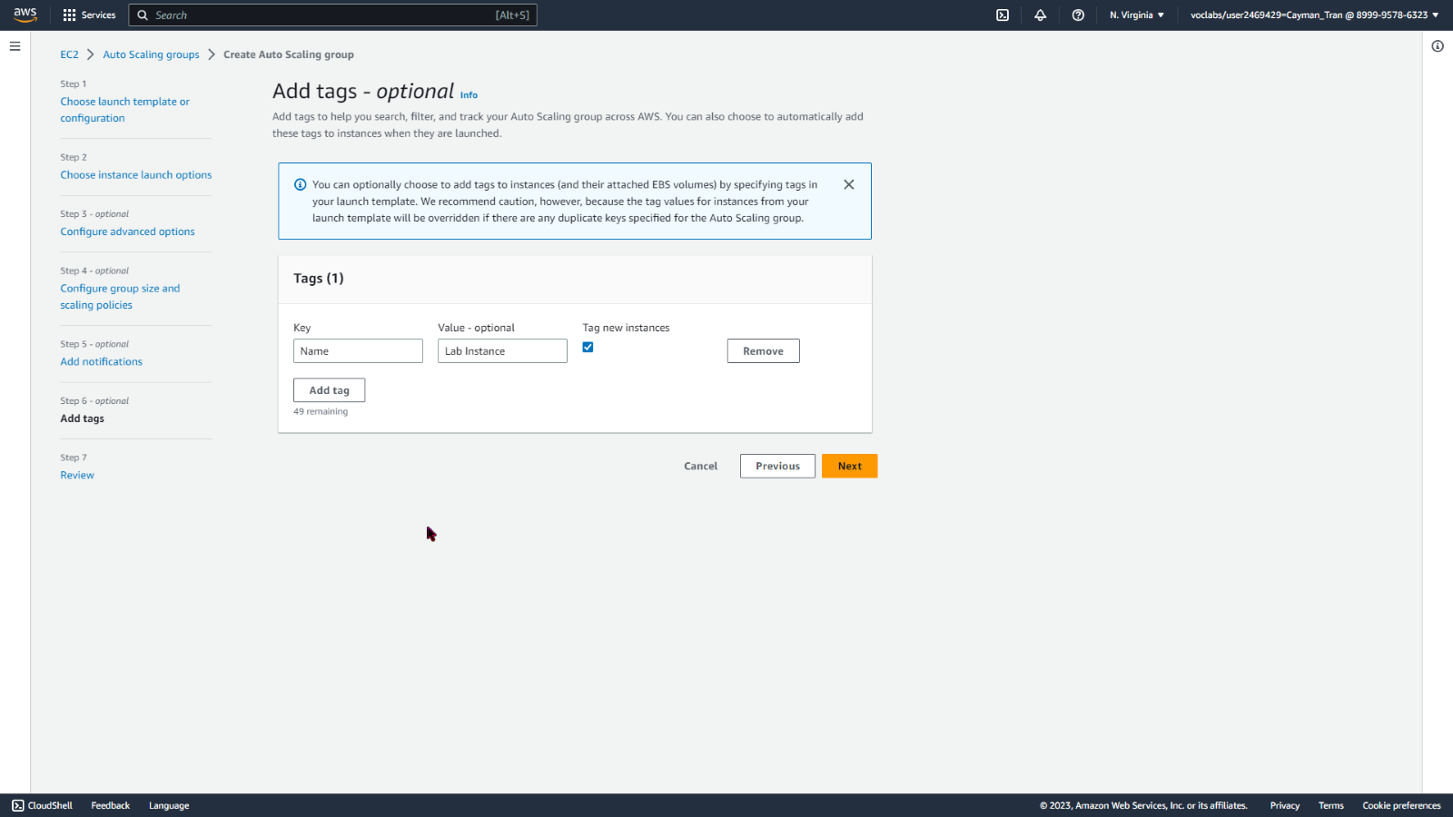

Adding a tag.

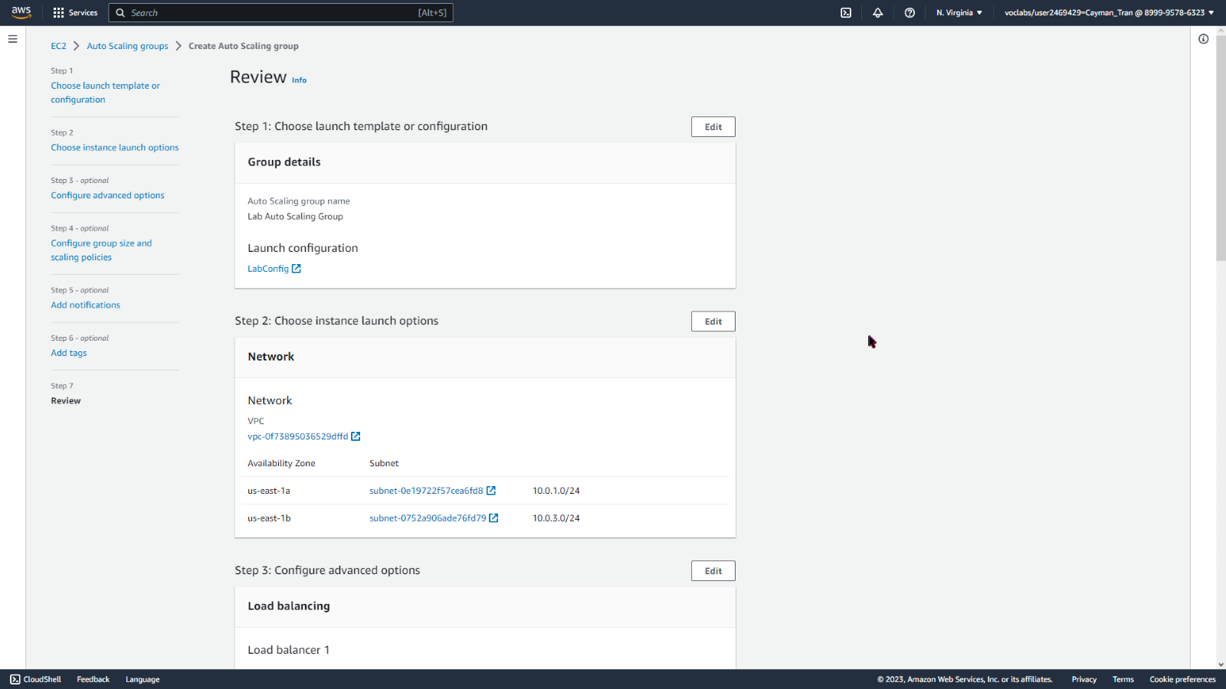

Review the config.

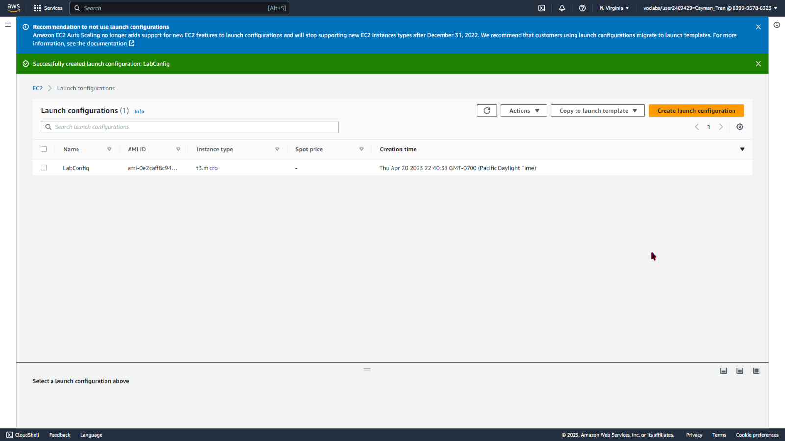

Verifying that the Target Groups are healthy.



Amazon CloudWatch is a monitoring and observability service and it provides real-time monitoring and visibility of AWS resources and applications running on AWS. CloudWatch collects and tracks metrics, logs, and events, and can send alerts or trigger automated actions based on predefined rules and thresholds.

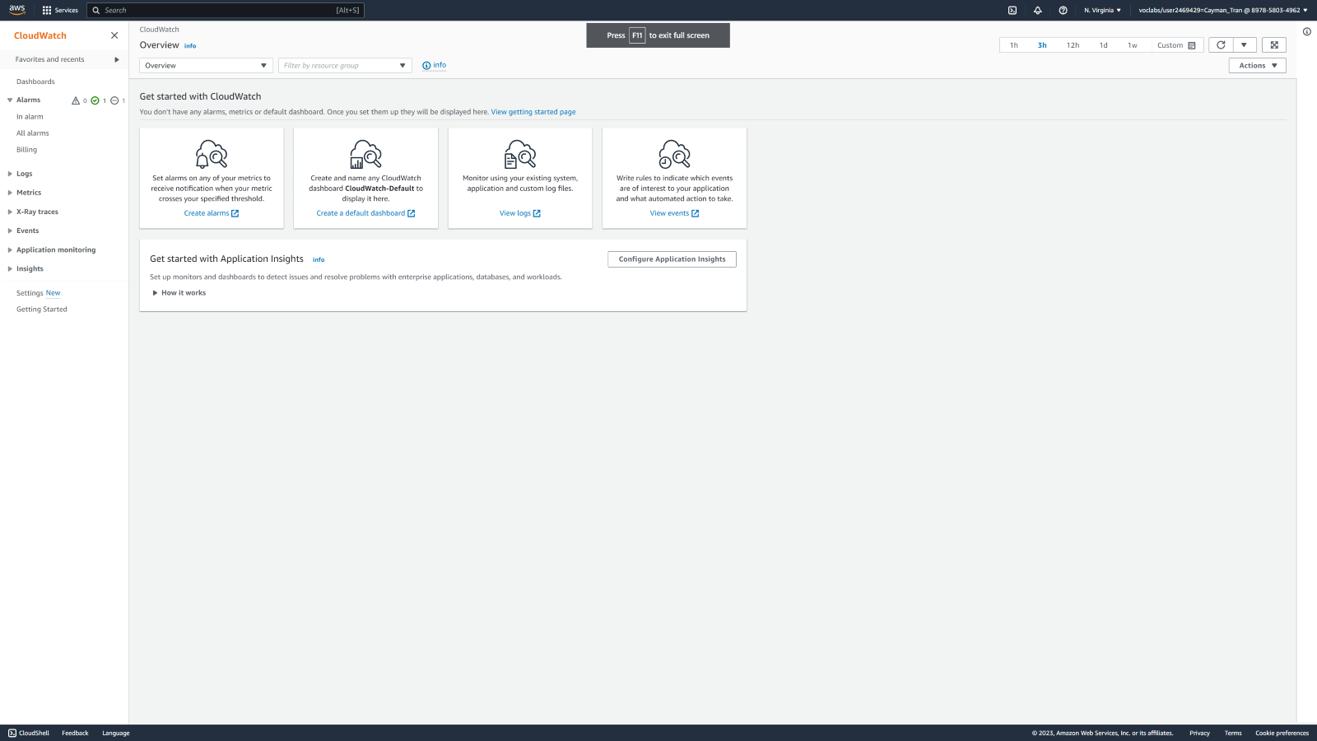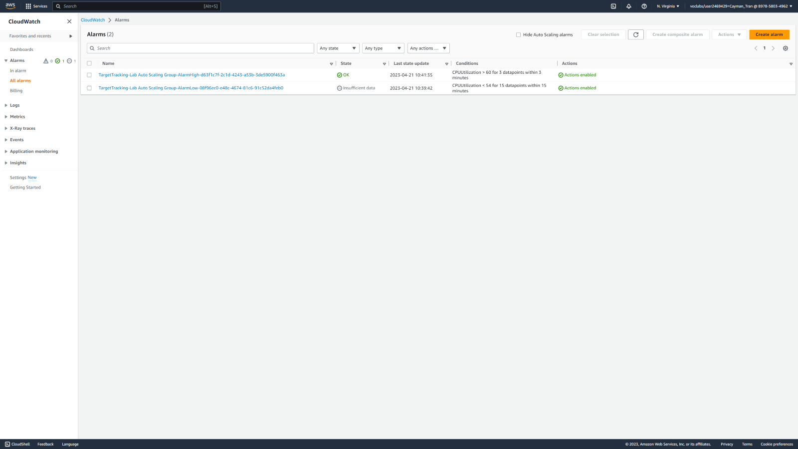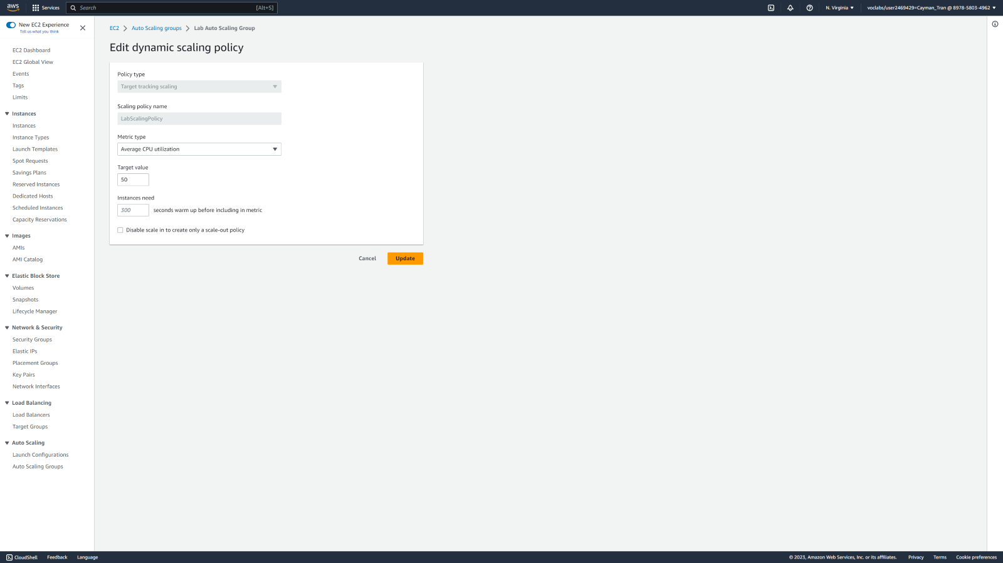

Editing Alarm time.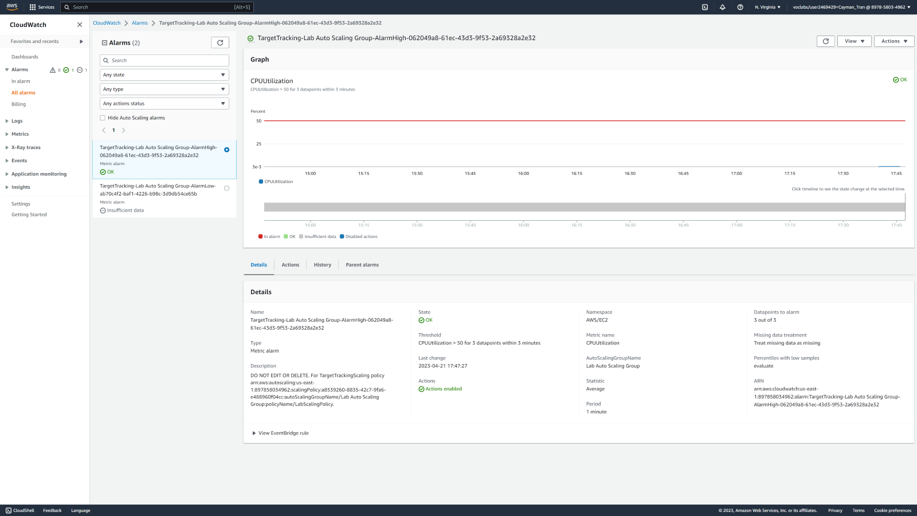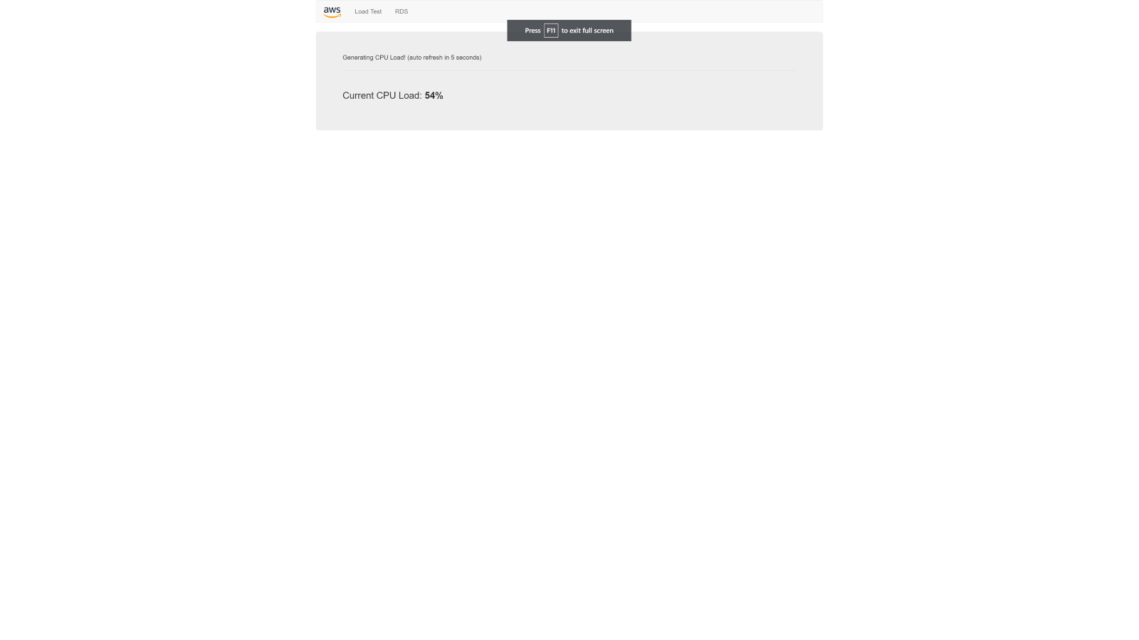

Testing the Load Balancing and Seeing the CPU Utilization rise to hit the alarm.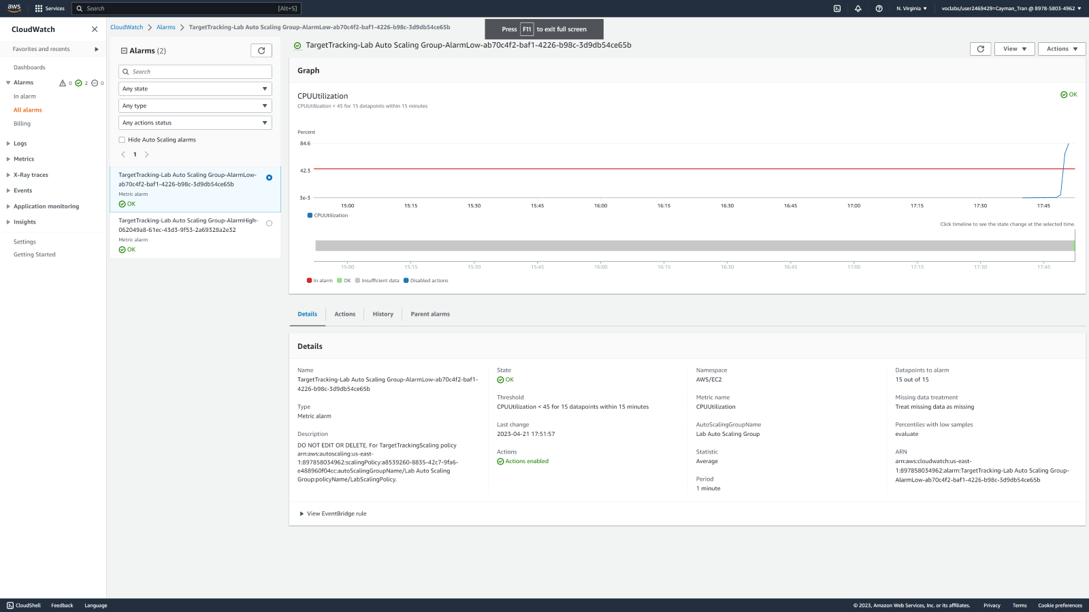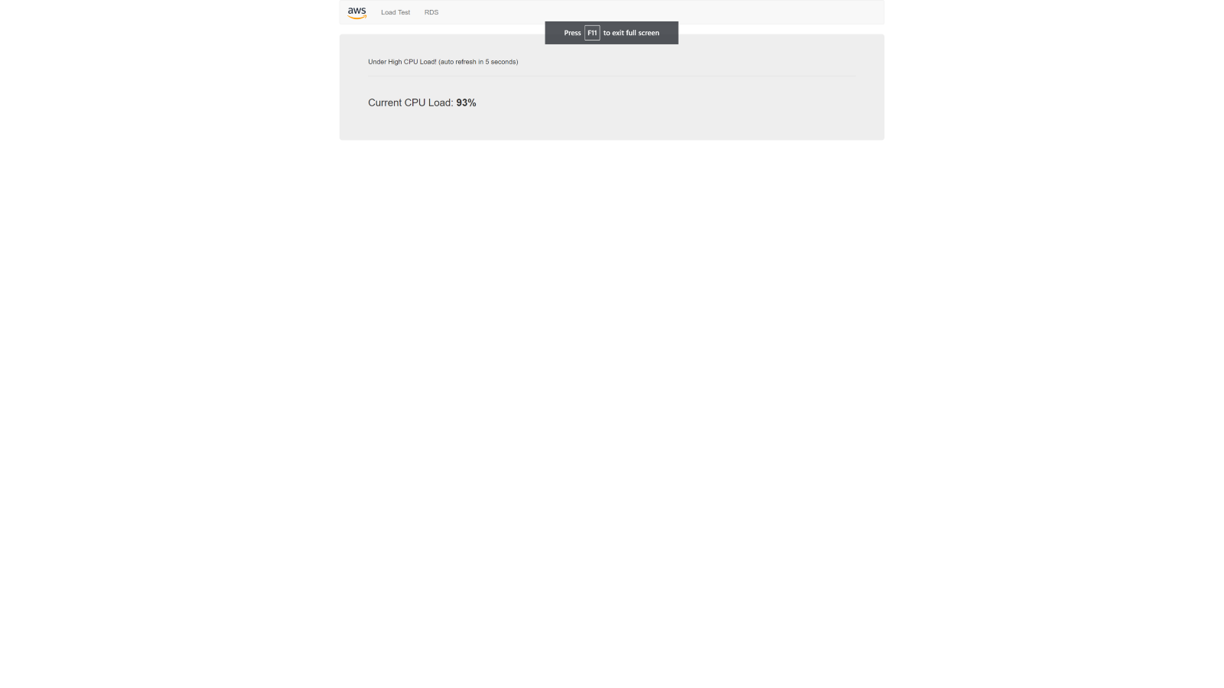

CPU Load is very high.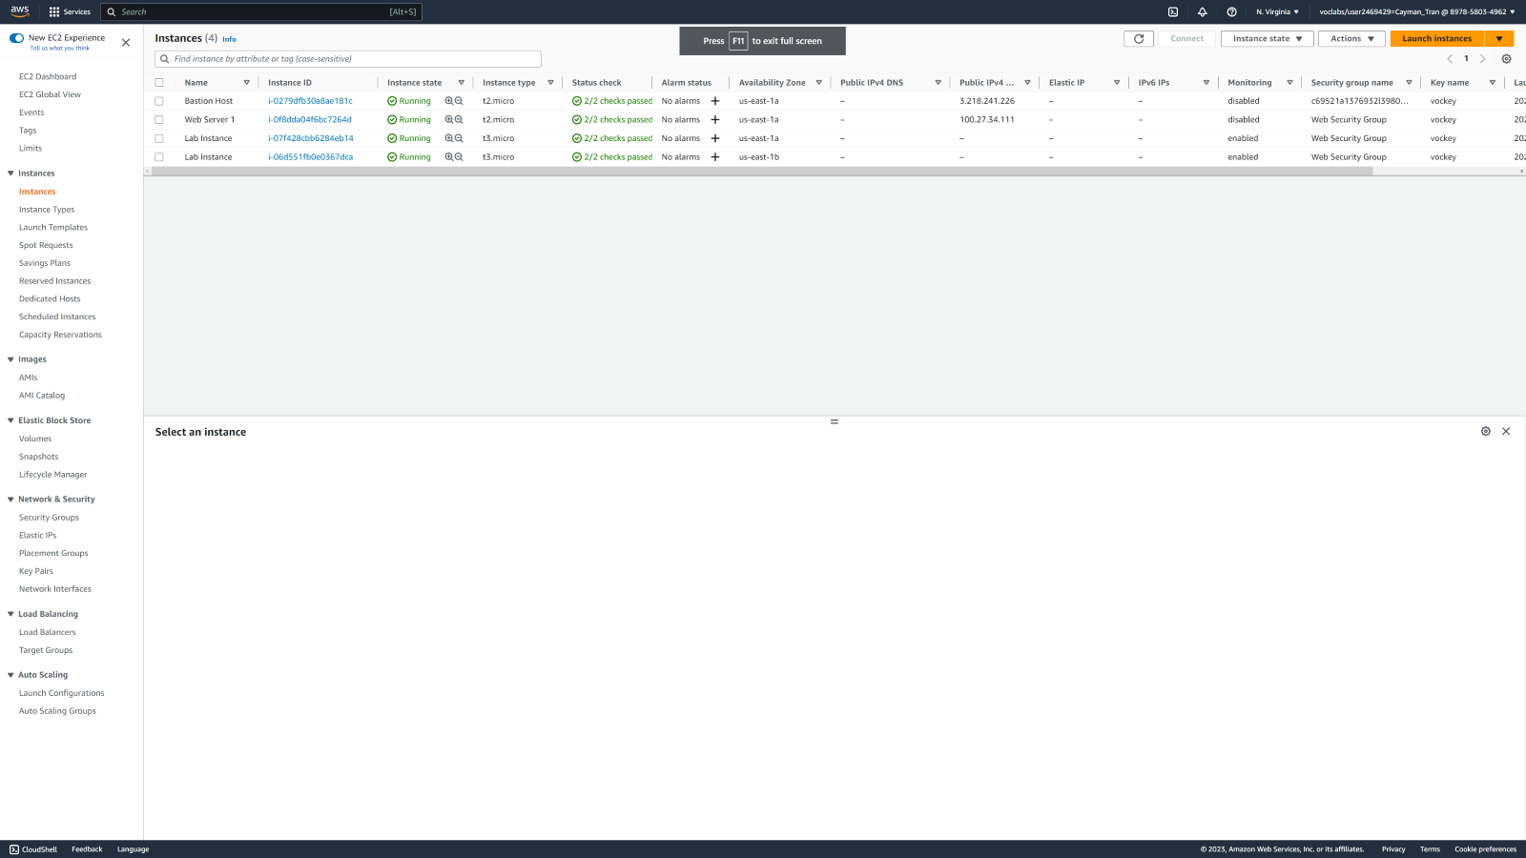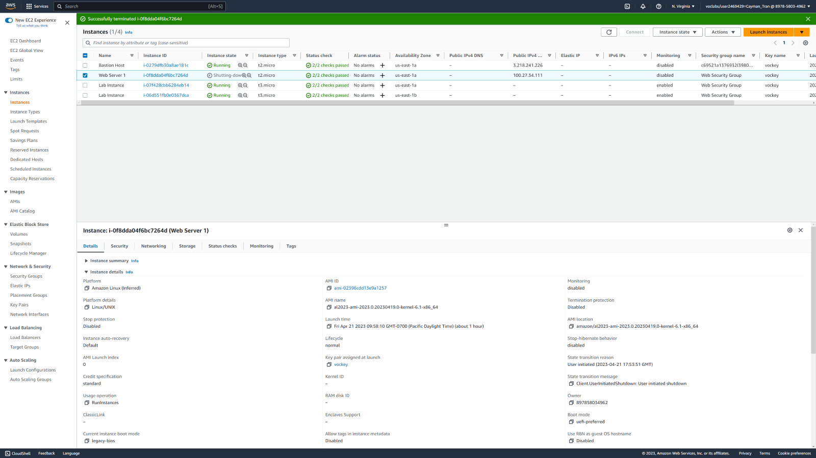

Terminating Web Server Instance.

**CONCLUSION**

In conclusion, AWS Academy Cloud Foundations Modules 7-10 offer a comprehensive introduction to important cloud computing concepts and AWS services. They cover essential cloud computing concepts and AWS services, including storage, databases, cloud architecture, and auto scaling and monitoring. I gained practical knowledge and skills in designing and deploying resilient applications on the AWS cloud using best practices, tools, and services like Elastic Load Balancing, CloudWatch, and more.

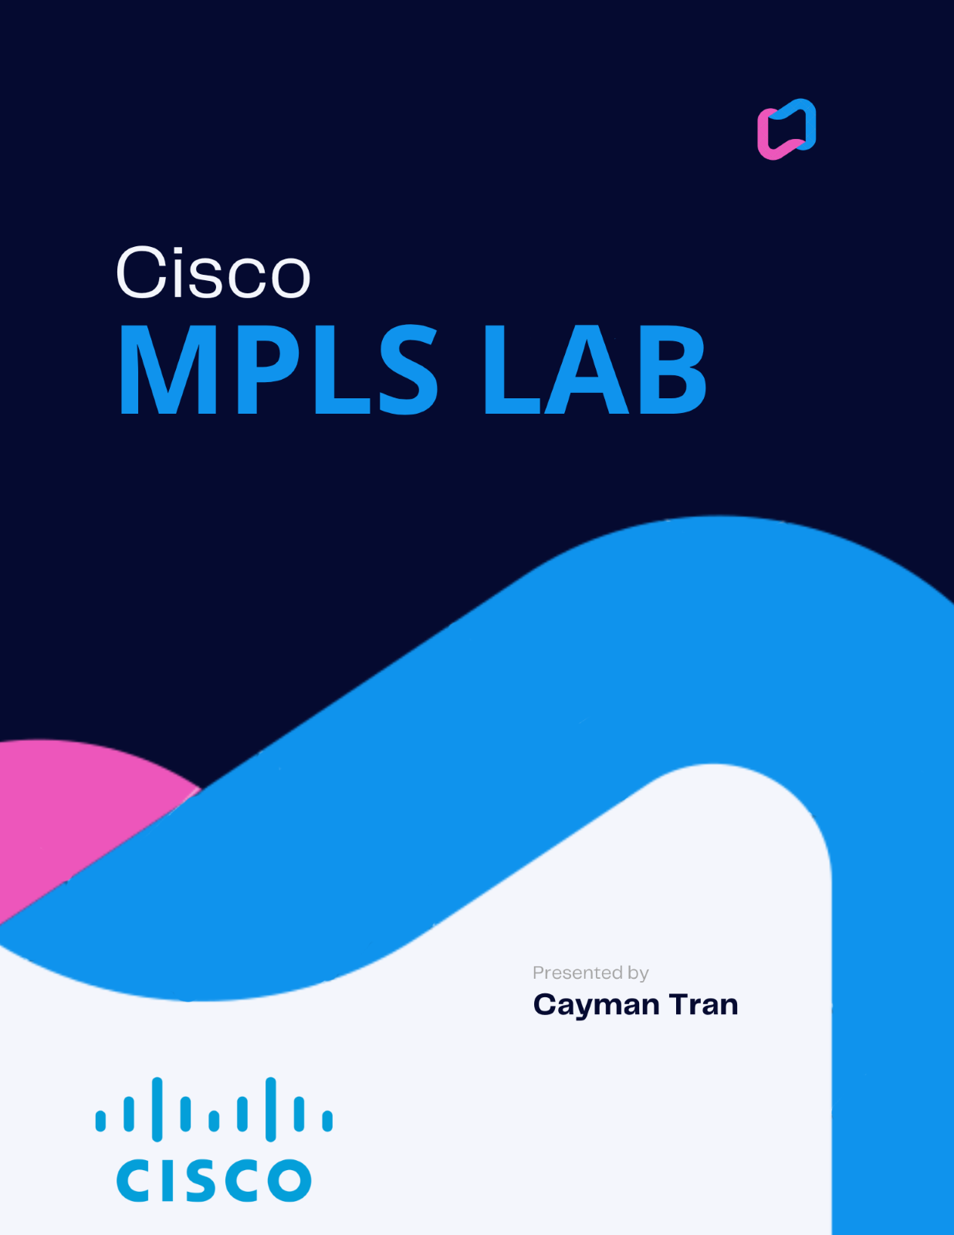

**NETWORK TOPOLOGY**

MPLS 3 ROUTERS + 2 PCS

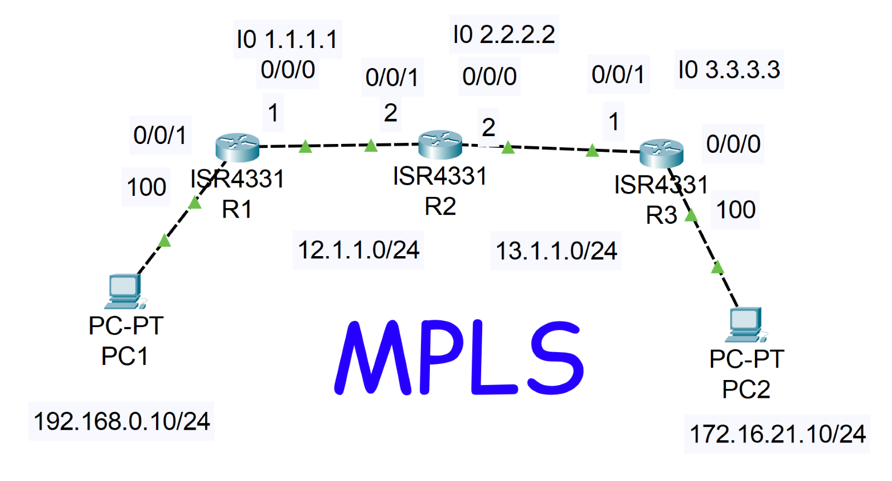

BACKGROUND INFORMATION

Multiprotocol Label Switching (MPLS) is a protocol-agnostic networking technology that efficiently forwards data packets based on labels. It was developed as a solution to address the limitations of traditional IP routing, such as slow convergence and lack of traffic engineering capabilities. MPLS operates at the network layer of the OSI model and provides a flexible and scalable approach to packet forwarding.

In MPLS, routers add a label to each incoming packet, creating a "label-switched path" through the network. The labels are used to make forwarding decisions, allowing routers to quickly route packets along predetermined paths without having to examine the packet's destination IP address at every hop. This label-based forwarding mechanism significantly improves the speed and efficiency of packet forwarding.

One of the essential components of MPLS is the Label Distribution Protocol (LDP), which establishes and maintains label-switched paths across the network. LDP enables routers to exchange label information and build a forwarding table, ensuring consistent forwarding behavior throughout the MPLS network.

MPLS can be deployed in various network environments, including service provider networks and enterprise networks. It offers several key benefits, such as traffic engineering, QoS support, and VPN capabilities. Traffic engineering allows network operators to control the flow of traffic and optimize network utilization by assigning different paths to different types of traffic.

SUMMARY

In this lab, I implemented MPLS. I used OSPF for the three routers, configured IPs, added router ids to the OSPF, set network areas and tested pings.

COMMANDS

Some new commands are:

neighbor *(ipv4 or ipv6 address)*

mpls *(ipv4 or ipv6 address)* – enables MPLS

show mpls forwarding-table – displays MPLS forwarding table

mpls label protocol tdp – switches from LDP to TDP

mpls label range 200 8191 static 16 199 – configure static label range for MPLS

mpls static binding ipv4 *(ipv4 or ipv6 address)* *(ipv4 or ipv6 subnet)* output *(ipv4 or ipv6 address)* 22 – configure static MPLS binding for ipv4 traffic

CONFIGURATIONS

R1

hostname R1

boot-start-marker

boot-end-marker

vrf definition Mgmt-intf

address-family ipv4

exit-address-family

address-family ipv6

*Jun 6 18:48:03.070: %SYS-5-CONFIG_I: Configured from console exit-address-family

no aaa new-model

no ip domain lookup

subscriber templating

vtp domain cisco

vtp mode transparent

mpls label protocol ldp

mpls label range 20 30

multilink bundle-name authenticated

license udi pid ISR4321/K9 sn FDO220523GF

license boot level appxk9

no license smart enable

diagnostic bootup level minimal

spanning-tree extend system-id

redundancy

mode none

interface Loopback0

ip address 1.1.1.1 255.255.255.0

interface GigabitEthernet0/0/0

ip address 12.1.1.1 255.255.255.0

negotiation auto

mpls ip

interface GigabitEthernet0/0/1

ip address 192.168.0.100 255.255.255.0

negotiation auto

mpls ip

interface Serial0/1/0

no ip address

shutdown

interface Serial0/1/1

no ip address

shutdown

interface GigabitEthernet0/2/0

no ip address

shutdown

negotiation auto

interface GigabitEthernet0/2/1

no ip address

shutdown

negotiation auto

interface GigabitEthernet0

vrf forwarding Mgmt-intf

no ip address

shutdown

negotiation auto

router ospf 10

router-id 1.1.1.1

network 1.1.1.1 0.0.0.0 area 0

network 12.1.1.0 0.0.0.255 area 0

network 192.168.0.0 0.0.0.255 area 0

ip forward-protocol nd

ip http server

ip http authentication local

ip http secure-server

ip tftp source-interface GigabitEthernet0

mpls ldp router-id Loopback0 force

control-plane

line con 0

transport input none

stopbits 1

line aux 0

stopbits 1

line vty 0 4

login

wsma agent exec

wsma agent config

wsma agent filesys

wsma agent notify

end

R2

hostname R2

boot-start-marker

boot-end-marker

vrf definition Mgmt-intf

address-family ipv4

exit-address-family

address-family ipv6

exit-address-family

no aaa new-model

login on-success log

subscriber templating

vtp domain cisco

vtp mode transparent

mpls label protocol ldp

mpls label range 60 90

multilink bundle-name authenticated

crypto pki trustpoint TP-self-signed-2189345785

enrollment selfsigned

subject-name cn=IOS-Self-Signed-Certificate-2189345785

revocation-check none

rsakeypair TP-self-signed-2189345785

license udi pid ISR4321/K9 sn FDO21482DXE

license boot level appxk9

no license smart enable

diagnostic bootup level minimal

spanning-tree extend system-id

redundancy

mode none

interface Loopback0

ip address 2.2.2.2 255.255.255.0

interface GigabitEthernet0/0/0

ip address 13.1.1.2 255.255.255.0

negotiation auto

mpls ip

interface GigabitEthernet0/0/1

ip address 12.1.1.2 255.255.255.0

negotiation auto

mpls ip

interface Serial0/1/0

no ip address

shutdown

interface Serial0/1/1

no ip address

shutdown

interface GigabitEthernet0/2/0

no ip address

shutdown

negotiation auto

interface GigabitEthernet0/2/1

no ip address

shutdown

negotiation auto

interface GigabitEthernet0

vrf forwarding Mgmt-intf

no ip address

shutdown

negotiation auto

router ospf 10

router-id 2.2.2.2

network 2.2.2.2 0.0.0.0 area 0

network 12.1.1.0 0.0.0.255 area 0

network 13.1.1.0 0.0.0.255 area 0

ip forward-protocol nd

ip http server

ip http authentication local

ip http secure-server

ip tftp source-interface GigabitEthernet0

mpls ldp router-id Loopback0 force

control-plane

line con 0

transport input none

stopbits 1

line aux 0

stopbits 1

line vty 0 4

login

end

R3

hostname R3

boot-start-marker

boot-end-marker

vrf definition Mgmt-intf

address-family ipv4

exit-address-family

address-family ipv6

exit-address-family

no aaa new-model

login on-success log

subscriber templating

vtp domain cisco

vtp mode transparent

mpls label protocol ldp

mpls label range 100 120

multilink bundle-name authenticated

crypto pki trustpoint TP-self-signed-2557841031

enrollment selfsigned

subject-name cn=IOS-Self-Signed-Certificate-2557841031

revocation-check none

rsakeypair TP-self-signed-2557841031

license udi pid ISR4321/K9 sn FDO21500G1N

license boot level appxk9

no license smart enable

diagnostic bootup level minimal

spanning-tree extend system-id

redundancy

mode none

interface Loopback0

ip address 3.3.3.3 255.255.255.0

interface GigabitEthernet0/0/0

ip address 172.16.21.100 255.255.255.0

negotiation auto

mpls ip

interface GigabitEthernet0/0/1

ip address 13.1.1.1 255.255.255.0

negotiation auto

mpls ip

interface Serial0/1/0

no ip address

shutdown

interface Serial0/1/1

no ip address

shutdown

interface GigabitEthernet0/2/0

no ip address

shutdown

negotiation auto

interface GigabitEthernet0/2/1

no ip address

shutdown

negotiation auto

interface GigabitEthernet0

vrf forwarding Mgmt-intf

no ip address

shutdown

negotiation auto

router ospf 10

network 3.3.3.3 0.0.0.0 area 0

network 13.1.1.0 0.0.0.255 area 0

network 172.16.21.0 0.0.0.255 area 0

ip forward-protocol nd

ip http server

ip http authentication local

ip http secure-server

ip tftp source-interface GigabitEthernet0

mpls ldp router-id Loopback0 force

control-plane

line con 0

transport input none

stopbits 1

line aux 0

stopbits 1

line vty 0 4

login

end

**PROBLEMS I ENCOUNTERED**

When I was running pings, the PCs would not ping itself, so I turned off all other ports and wifi, and turned off an on the ethernet that was connected to the router. It then worked.

**CONCLUSION**

In summary, Multiprotocol Label Switching (MPLS) is a versatile networking technology that offers fast and efficient packet forwarding through the use of labels. It provides traffic engineering, QoS support, and VPN capabilities, making it a valuable solution for modern networks seeking optimized performance and scalability.